Vaccine-and-metabolism.R
Tom
2020-03-08
#Library
library (nlme)
library (MuMIn)
library (car)
## Loading required package: carData
library (emmeans)
## Welcome to emmeans.
## NOTE -- Important change from versions <= 1.41:
## Indicator predictors are now treated as 2-level factors by default.
## To revert to old behavior, use emm_options(cov.keep = character(0))
library (dunn.test)
library (MASS)
library (rcompanion)
library (ggplot2)
library (ggpubr)
## Loading required package: magrittr
library (sjPlot)
## Registered S3 methods overwritten by 'lme4':
## method from
## cooks.distance.influence.merMod car
## influence.merMod car
## dfbeta.influence.merMod car
## dfbetas.influence.merMod car
## #refugeeswelcome
library (sjmisc)
library (snakecase)
#### Data files ####
Growth <- read.csv ("Growth.csv", header = T)
Prev <- read.csv ("Prevalences.csv", header = T)
Immunity <- read.csv ("Immunity.csv", header = T)
Growth$Tank <- factor(Growth$Tank)
Growth$Temp <- factor(Growth$Temp)
Growth$Group <- factor(Growth$Group, levels = c("Unvac-12-60", "Vac-12-60", "Unvac-12-70", "Vac-12-70", "Unvac-12-80", "Vac-12-80","Unvac-12-100", "Vac-12-100","Unvac-17-60", "Vac-17-60", "Unvac-17-70","Vac-17-70", "Unvac-17-80","Vac-17-80", "Unvac-17-100","Vac-17-100"))
str(Growth)
## 'data.frame': 5523 obs. of 19 variables:
## $ Fish : int 10 18 20 23 29 41 43 49 77 88 ...
## $ Tank : Factor w/ 16 levels "1","2","3","4",..: 13 NA 16 7 2 3 16 7 10 15 ...
## $ Full_set : int 0 0 0 0 0 1 0 0 0 0 ...
## $ Day : int 0 0 0 0 0 0 0 0 0 0 ...
## $ Time : int 0 0 0 0 0 0 0 0 0 0 ...
## $ Vaccinated : Factor w/ 2 levels "No","Yes": 1 1 1 1 1 1 1 1 1 1 ...
## $ Temp : Factor w/ 2 levels "12","17": 2 1 2 1 1 1 2 1 2 2 ...
## $ O2 : int 70 60 60 60 100 80 60 60 100 60 ...
## $ Group : Factor w/ 16 levels "Unvac-12-60",..: 11 1 9 1 7 5 9 1 15 9 ...
## $ Length : num 19 20 18 19 19 18.5 18.5 19.5 18 17.5 ...
## $ Mass : int 82 92 78 80 78 80 76 80 74 68 ...
## $ K_factor : num 1.2 1.15 1.34 1.17 1.14 1.26 1.2 1.08 1.27 1.27 ...
## $ Initial_mass: int NA NA NA NA NA NA NA NA NA NA ...
## $ SGR : num NA NA NA NA NA NA NA NA NA NA ...
## $ TGC : num NA NA NA NA NA NA NA NA NA NA ...
## $ Sex : Factor w/ 3 levels "Female","Male",..: 3 3 3 3 3 3 3 3 3 3 ...
## $ Mature : int 0 0 0 0 0 0 0 0 0 0 ...
## $ Loser : int 0 0 0 0 0 0 0 0 0 0 ...
## $ Cataract : int 0 0 0 0 0 0 0 0 0 0 ...
## TGC calculation in "Growth.csv".
# We have used the formula of Cho (1992). Aquaculture 100, 107-123. TGC = (Wt1/3 - Wi1/3) / (temp (°C) x days) × 1000. Where Wt is the terminal weight and Wi is the initial weight.
#### Plot themes ####
PlotTheme <- theme(panel.background = element_rect (fill = "white", colour = "white"))+ # removes background and border
theme (axis.line = element_line (colour="black")) + # adds axis colour
theme (plot.title = element_text (hjust = 0.5)) + # center the title
theme (plot.title = element_text (size = 15, face = "bold")) + # changes text size of title
theme (plot.title = element_text (margin = margin (t = 0, r = 0, b = 30, l = 0))) + # changes distance of title to graph
theme (axis.text = element_text (size = 8)) + # changes text size of the axis
theme (axis.title = element_text (size = 11, face = "bold")) + # changes text size and style of the axis
theme (axis.title.y = element_text (margin = margin (t = 0, r = 10, b = 0, l = 0))) + # changes distance of y axis
theme (axis.title.x = element_text (margin = margin (t = 10, r = 0, b = 0, l = 0))) + # changes distance of x axis
theme (plot.tag = element_text (size = 20, face = "bold", margin = margin (t = 5, r = 0, b = 0, l = 10))) # changes text size, style, and position of the tag
#### Function to calculate the mean and the standard deviation for each group ####
# data : a data frame
# varname : the name of a column containing the variable to be summariezed
# groupnames : vector of column names to be used asgrouping variables
data_summary <- function (data, varname, groupnames){
require (plyr)
summary_func <- function (x, col) {
c(mean = mean (x[[col]], na.rm = TRUE),
sd = sd(x[[col]], na.rm=TRUE))
}
data_sum <- ddply (data, groupnames, .fun=summary_func,
varname)
data_sum <- rename (data_sum, c("mean" = varname))
return (data_sum)
}
#### Compare tanks with random mortality from same group ####
# Extract the releavnt data for Oct 2016
Data1 <- subset (Growth, O2==100 & Temp==12 & Time==0 & Mass>0 & Sex!="Undetermined" & Fish!=1502)
# Oct 2016 - plot the data
M1_dot_plot <- ggdotplot (Data1, "Tank", "Mass", fill = "Tank", add = "mean_sd", size = 0.4) + PlotTheme
M1_dot_plot
## `stat_bindot()` using `bins = 30`. Pick better value with `binwidth`.
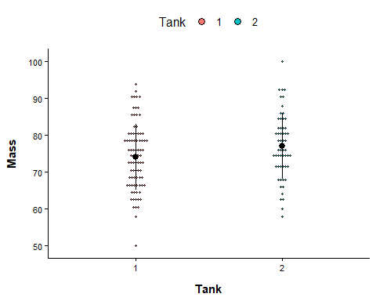
# Oct 2016 tank comparison model
M1 <- glm (Mass ~ Tank, data = Data1)
par (mfrow =c(2,2))
plot (M1)
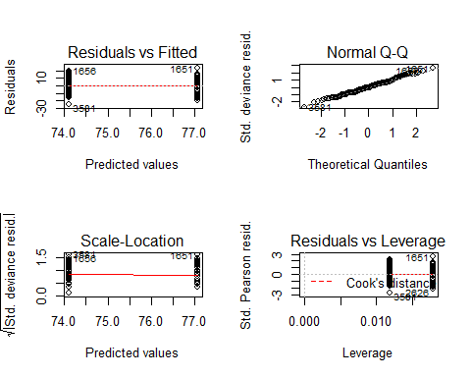
par (mfrow =c(1,1))
Anova (M1) # not significant
## Analysis of Deviance Table (Type II tests)
##
## Response: Mass
## LR Chisq Df Pr(>Chisq)
## Tank 3.6665 1 0.05552 .
## ---
## Signif. codes: 0 '***' 0.001 '**' 0.01 '*' 0.05 '.' 0.1 ' ' 1
r.squaredGLMM (M1)
## Warning: 'r.squaredGLMM' now calculates a revised statistic. See the help page.
## R2m R2c
## [1,] 0.02569983 0.02569983
M1_null <- glm (Mass ~1, data = Data1)
BIC (M1, M1_null) # null model is better
## df BIC
## M1 3 1022.820
## M1_null 2 1021.549
# Extract the relevant data for Nov 2016
Data2 <- subset (Growth, O2==100 & Temp==12 & Day==51 & Mass>0 & Sex!="Undetermined" & Fish!=1502)
# Nov 2016 - plot the data
M2_dot_plot <- ggdotplot (Data2, "Tank", "Mass", fill = "Tank", add = "mean_sd", size = 0.4) + PlotTheme
M2_dot_plot
## `stat_bindot()` using `bins = 30`. Pick better value with `binwidth`.
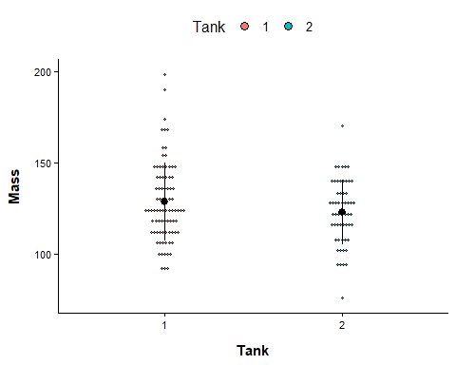
# Nov 2016 tank comparison model
M2 <- glm (Mass ~ factor(Tank), data=Data2)
par (mfrow =c(2,2))
plot (M2)
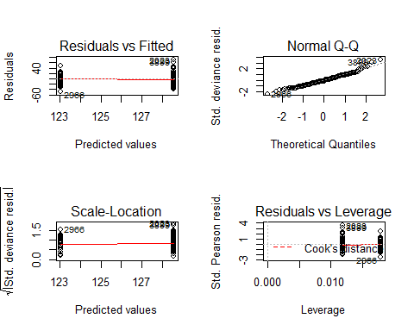
par (mfrow =c(1,1))
Anova (M2) # not significant
## Analysis of Deviance Table (Type II tests)
##
## Response: Mass
## LR Chisq Df Pr(>Chisq)
## factor(Tank) 2.5784 1 0.1083
r.squaredGLMM (M2)
## R2m R2c
## [1,] 0.01821193 0.01821193
M2_null <- glm (Mass ~1, data = Data2)
BIC (M2, M2_null) # null model is better
## df BIC
## M2 3 1247.477
## M2_null 2 1245.127
# Extract the relevant data for Apr 2017
Data3 <- subset (Growth, O2==100 & Temp==12 & Time==2 & Mass>0 & Sex!="Undetermined" & Fish!=1502)
# Apr 2017 - plot the data
M3_dot_plot <- ggdotplot(Data3, "Tank", "Mass", fill = "Tank", add = "mean_sd", size = 0.4) + PlotTheme
M3_dot_plot
## `stat_bindot()` using `bins = 30`. Pick better value with `binwidth`.
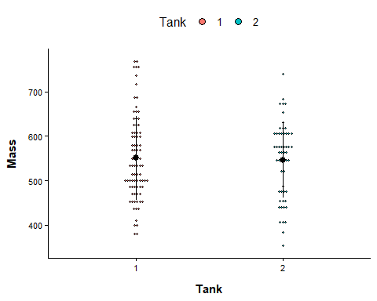
# Apr 2017 tank comparison model
M3 <- glm (Mass ~ factor (Tank), data = Data3) # not significant
par (mfrow =c(2,2))
plot (M3)
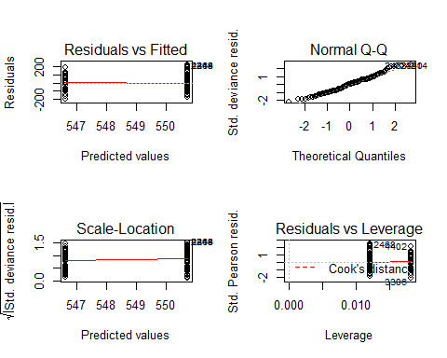
par (mfrow =c(1,1))
Anova (M3) # not significant
## Analysis of Deviance Table (Type II tests)
##
## Response: Mass
## LR Chisq Df Pr(>Chisq)
## factor(Tank) 0.066139 1 0.797
r.squaredGLMM (M3)
## R2m R2c
## [1,] 0.0004825369 0.0004825369
M3_null <- glm (Mass ~1, data = Data3)
BIC (M3, M3_null) # null model is better
## df BIC
## M3 3 1648.943
## M3_null 2 1644.083
#### Within time point body mass analysis ####
## October 2016
# extract the relevant data
Data4 <- subset (Growth, Day==0 & Mass>0 & Sex!="Undetermined")
# Oct 2016 - plot the data
M4_dot_plot <- ggdotplot (Data4, "Group", "Mass", add = "mean_sd", size = 0.1) + PlotTheme +
theme(axis.text.x = element_text(angle = 45, hjust = 1))
M4_dot_plot
## `stat_bindot()` using `bins = 30`. Pick better value with `binwidth`.
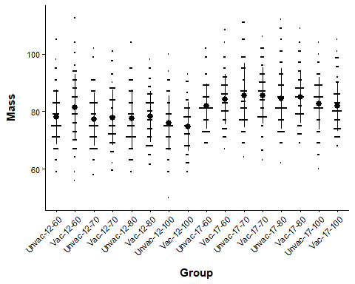
# Oct 2016 Vaccinated x environment model
M4 <- glm (Mass ~ factor(O2) * Temp + Sex, data = Data4)
par (mfrow =c(2,2))
plot (M4) # bit of a tail in qqplot
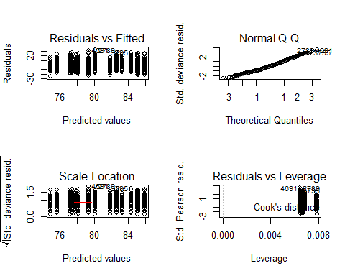
par (mfrow =c(1,1))
#log mass
M5 <- glm (log (Mass) ~ factor(O2) * Temp + Sex, data = Data4)
par (mfrow =c(2,2))
plot (M5)
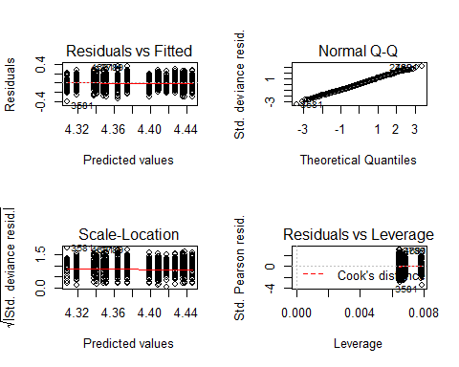
par (mfrow =c(1,1))
#compare qq plots
qqPlot (resid (M4), grid = FALSE, envelope = .95, line = "quartiles") # bit of a tail
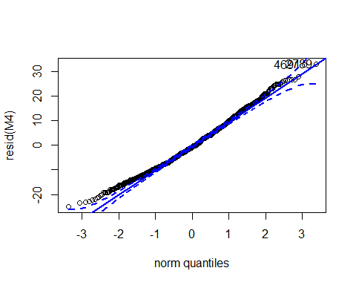
## 2789 4691
## 593 1185
qqPlot (resid (M5), grid = FALSE, envelope = .95, line = "quartiles") # logged is better
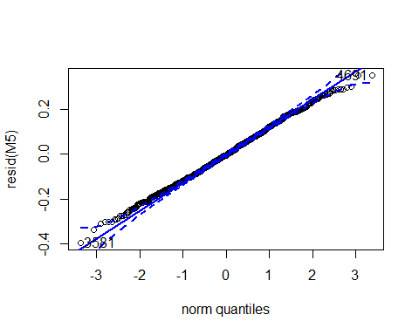
## 3581 4691
## 705 1185
# logged model output
Anova (M5, type = 3) # log transformed
## Analysis of Deviance Table (Type III tests)
##
## Response: log(Mass)
## LR Chisq Df Pr(>Chisq)
## factor(O2) 17.4772 3 0.0005637 ***
## Temp 11.6997 1 0.0006251 ***
## Sex 2.5831 1 0.1080070
## factor(O2):Temp 10.7952 3 0.0128865 *
## ---
## Signif. codes: 0 '***' 0.001 '**' 0.01 '*' 0.05 '.' 0.1 ' ' 1
Anova (M4, type = 3) # no transformation
## Analysis of Deviance Table (Type III tests)
##
## Response: Mass
## LR Chisq Df Pr(>Chisq)
## factor(O2) 16.9312 3 0.0007301 ***
## Temp 9.7607 1 0.0017829 **
## Sex 2.0392 1 0.1532902
## factor(O2):Temp 12.1103 3 0.0070148 **
## ---
## Signif. codes: 0 '***' 0.001 '**' 0.01 '*' 0.05 '.' 0.1 ' ' 1
r.squaredGLMM (M5)
## R2m R2c
## [1,] 0.117289 0.117289
M5_null <- glm (log (Mass) ~1, data = Data4)
BIC (M5, M5_null)
## df BIC
## M5 10 -1860.222
## M5_null 2 -1750.063
lsmeans (M5, pairwise ~ factor(O2) | Temp, type = "response") # opposite O2 effects in 12 and 17C
## $lsmeans
## Temp = 12:
## O2 response SE df asymp.LCL asymp.UCL
## 60 79.0 0.704 Inf 77.7 80.4
## 70 77.0 0.690 Inf 75.6 78.3
## 80 77.2 0.698 Inf 75.9 78.6
## 100 74.8 0.742 Inf 73.3 76.2
##
## Temp = 17:
## O2 response SE df asymp.LCL asymp.UCL
## 60 82.6 0.760 Inf 81.1 84.1
## 70 84.9 0.768 Inf 83.4 86.4
## 80 84.2 0.748 Inf 82.7 85.6
## 100 81.8 0.744 Inf 80.4 83.3
##
## Results are averaged over the levels of: Sex
## Confidence level used: 0.95
## Intervals are back-transformed from the log scale
##
## $contrasts
## Temp = 12:
## contrast ratio SE df z.ratio p.value
## 60 / 70 1.027 0.0130 Inf 2.103 0.1520
## 60 / 80 1.023 0.0130 Inf 1.819 0.2642
## 60 / 100 1.057 0.0141 Inf 4.172 0.0002
## 70 / 80 0.997 0.0127 Inf -0.274 0.9928
## 70 / 100 1.029 0.0138 Inf 2.173 0.1308
## 80 / 100 1.033 0.0139 Inf 2.425 0.0725
##
## Temp = 17:
## contrast ratio SE df z.ratio p.value
## 60 / 70 0.973 0.0126 Inf -2.148 0.1381
## 60 / 80 0.981 0.0126 Inf -1.494 0.4413
## 60 / 100 1.009 0.0131 Inf 0.714 0.8914
## 70 / 80 1.009 0.0128 Inf 0.679 0.9050
## 70 / 100 1.038 0.0133 Inf 2.881 0.0207
## 80 / 100 1.029 0.0131 Inf 2.230 0.1152
##
## Results are averaged over the levels of: Sex
## P value adjustment: tukey method for comparing a family of 4 estimates
## Tests are performed on the log scale
M5.Fig <- plot_model (M5, type = "pred", terms =c("O2","Temp")) +
labs (title = "M5", x = "Vaccinated", y = "Body mass", tag ="") +
theme (panel.background = element_rect (fill = "white", colour = "white")) +
theme (axis.line = element_line (colour = "black"))
## Model has log-transformed response. Back-transforming predictions to original response scale. Standard errors are still on the log-scale.
M5.Fig
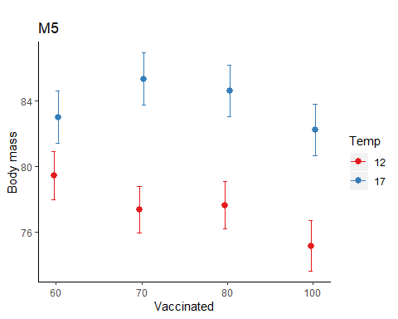
##November 2016
# extract the relevant data
Data5 <- subset (Growth, Day==51 & Mass>0 & Sex!="Undetermined")
# Nov 2016 - plot the data
M6_dot_plot <- ggdotplot (Data5, "Group", "Mass", add = "mean_sd", size = 0.1) + PlotTheme +
theme (axis.text.x = element_text (angle = 45, hjust = 1))
M6_dot_plot
## `stat_bindot()` using `bins = 30`. Pick better value with `binwidth`.
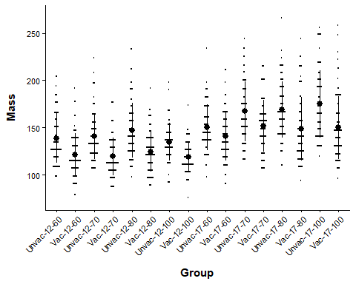
# Nov 2016 Vaccinated x environment model
M6 <- glm (Mass ~ factor(O2) * Temp * Vaccinated + Sex, data = Data5)
M7 <- glm (Mass ~ factor(O2) * Temp + Vaccinated + Sex, data = Data5)
BIC (M6, M7)
## df BIC
## M6 18 12615.04
## M7 11 12576.16
par (mfrow =c(2,2))
plot (M7)
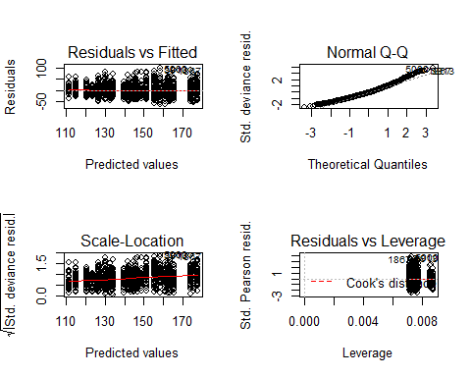
par (mfrow =c(1,1))
# Log mass
M8 <- glm (log (Mass) ~ factor(O2) * Temp * Vaccinated + Sex, data = Data5)
M9 <- glm (log (Mass) ~ factor(O2) * Temp + Vaccinated + Sex, data = Data5)
BIC (M8, M9)
## df BIC
## M8 18 -746.6450
## M9 11 -784.6924
par (mfrow =c(2,2))
plot (M9)
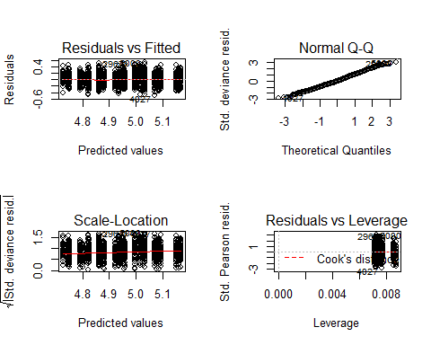
par (mfrow =c(1,1))
#compare qq plots
qqPlot (resid (M7), grid = FALSE, envelope = .95, line = "quartiles") # bit of a tail
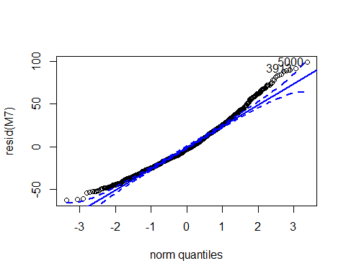
## 5000 3913
## 1150 719
qqPlot (resid (M9), grid = FALSE, envelope = .95, line = "quartiles") # logged is better
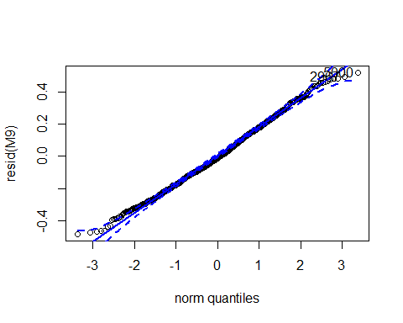
## 5000 2967
## 1150 429
# logged model output
Anova (M9, type = 3) # log transformed data
## Analysis of Deviance Table (Type III tests)
##
## Response: log(Mass)
## LR Chisq Df Pr(>Chisq)
## factor(O2) 10.487 3 0.01485 *
## Temp 36.125 1 1.851e-09 ***
## Vaccinated 191.418 1 < 2.2e-16 ***
## Sex 57.537 1 3.316e-14 ***
## factor(O2):Temp 21.609 3 7.866e-05 ***
## ---
## Signif. codes: 0 '***' 0.001 '**' 0.01 '*' 0.05 '.' 0.1 ' ' 1
Anova (M7, type = 3) # no transformation
## Analysis of Deviance Table (Type III tests)
##
## Response: Mass
## LR Chisq Df Pr(>Chisq)
## factor(O2) 9.632 3 0.02197 *
## Temp 27.950 1 1.245e-07 ***
## Vaccinated 170.588 1 < 2.2e-16 ***
## Sex 66.670 1 3.209e-16 ***
## factor(O2):Temp 25.689 3 1.108e-05 ***
## ---
## Signif. codes: 0 '***' 0.001 '**' 0.01 '*' 0.05 '.' 0.1 ' ' 1
r.squaredGLMM (M9)
## R2m R2c
## [1,] 0.3213381 0.3213381
M9_null <- glm (log (Mass) ~1, data = Data5)
BIC (M9, M9_null)
## df BIC
## M9 11 -784.6924
## M9_null 2 -329.8246
lsmeans (M9, pairwise ~ factor(O2) | Temp, type = "response") # O2 redcues growth in 17C, not 12C
## $lsmeans
## Temp = 12:
## O2 response SE df asymp.LCL asymp.UCL
## 60 128 1.70 Inf 125 131
## 70 128 1.71 Inf 125 132
## 80 133 1.80 Inf 130 137
## 100 125 1.85 Inf 122 129
##
## Temp = 17:
## O2 response SE df asymp.LCL asymp.UCL
## 60 143 1.98 Inf 140 147
## 70 157 2.12 Inf 153 161
## 80 155 2.06 Inf 151 160
## 100 158 2.14 Inf 154 162
##
## Results are averaged over the levels of: Vaccinated, Sex
## Confidence level used: 0.95
## Intervals are back-transformed from the log scale
##
## $contrasts
## Temp = 12:
## contrast ratio SE df z.ratio p.value
## 60 / 70 0.997 0.0188 Inf -0.169 0.9983
## 60 / 80 0.958 0.0182 Inf -2.256 0.1085
## 60 / 100 1.019 0.0203 Inf 0.967 0.7683
## 70 / 80 0.961 0.0183 Inf -2.082 0.1590
## 70 / 100 1.023 0.0204 Inf 1.124 0.6745
## 80 / 100 1.064 0.0213 Inf 3.093 0.0107
##
## Temp = 17:
## contrast ratio SE df z.ratio p.value
## 60 / 70 0.912 0.0176 Inf -4.745 <.0001
## 60 / 80 0.923 0.0176 Inf -4.217 0.0001
## 60 / 100 0.906 0.0175 Inf -5.076 <.0001
## 70 / 80 1.011 0.0191 Inf 0.582 0.9376
## 70 / 100 0.994 0.0190 Inf -0.340 0.9864
## 80 / 100 0.983 0.0186 Inf -0.925 0.7916
##
## Results are averaged over the levels of: Vaccinated, Sex
## P value adjustment: tukey method for comparing a family of 4 estimates
## Tests are performed on the log scale
lsmeans (M9, pairwise ~ Vaccinated, type = "response") # Vaccine effect
## $lsmeans
## Vaccinated response SE df asymp.LCL asymp.UCL
## No 150 1.033 Inf 148 152
## Yes 131 0.887 Inf 130 133
##
## Results are averaged over the levels of: O2, Temp, Sex
## Confidence level used: 0.95
## Intervals are back-transformed from the log scale
##
## $contrasts
## contrast ratio SE df z.ratio p.value
## No / Yes 1.14 0.011 Inf 13.835 <.0001
##
## Results are averaged over the levels of: O2, Temp, Sex
## Tests are performed on the log scale
lsmeans (M9, pairwise ~ factor(O2) | Temp | Vaccinated, type="response") # O2 redcues growth in 17C, not 12C
## $lsmeans
## Temp = 12, Vaccinated = No:
## O2 response SE df asymp.LCL asymp.UCL
## 60 137 1.93 Inf 133 140
## 70 137 1.95 Inf 133 141
## 80 143 2.05 Inf 139 147
## 100 134 2.09 Inf 130 138
##
## Temp = 17, Vaccinated = No:
## O2 response SE df asymp.LCL asymp.UCL
## 60 153 2.24 Inf 149 158
## 70 168 2.42 Inf 163 173
## 80 166 2.34 Inf 162 171
## 100 169 2.44 Inf 164 174
##
## Temp = 12, Vaccinated = Yes:
## O2 response SE df asymp.LCL asymp.UCL
## 60 120 1.69 Inf 116 123
## 70 120 1.70 Inf 117 123
## 80 125 1.78 Inf 121 128
## 100 117 1.82 Inf 114 121
##
## Temp = 17, Vaccinated = Yes:
## O2 response SE df asymp.LCL asymp.UCL
## 60 134 1.96 Inf 130 138
## 70 147 2.10 Inf 143 151
## 80 145 2.05 Inf 141 149
## 100 148 2.12 Inf 144 152
##
## Results are averaged over the levels of: Sex
## Confidence level used: 0.95
## Intervals are back-transformed from the log scale
##
## $contrasts
## Temp = 12, Vaccinated = No:
## contrast ratio SE df z.ratio p.value
## 60 / 70 0.997 0.0188 Inf -0.169 0.9983
## 60 / 80 0.958 0.0182 Inf -2.256 0.1085
## 60 / 100 1.019 0.0203 Inf 0.967 0.7683
## 70 / 80 0.961 0.0183 Inf -2.082 0.1590
## 70 / 100 1.023 0.0204 Inf 1.124 0.6745
## 80 / 100 1.064 0.0213 Inf 3.093 0.0107
##
## Temp = 17, Vaccinated = No:
## contrast ratio SE df z.ratio p.value
## 60 / 70 0.912 0.0176 Inf -4.745 <.0001
## 60 / 80 0.923 0.0176 Inf -4.217 0.0001
## 60 / 100 0.906 0.0175 Inf -5.076 <.0001
## 70 / 80 1.011 0.0191 Inf 0.582 0.9376
## 70 / 100 0.994 0.0190 Inf -0.340 0.9864
## 80 / 100 0.983 0.0186 Inf -0.925 0.7916
##
## Temp = 12, Vaccinated = Yes:
## contrast ratio SE df z.ratio p.value
## 60 / 70 0.997 0.0188 Inf -0.169 0.9983
## 60 / 80 0.958 0.0182 Inf -2.256 0.1085
## 60 / 100 1.019 0.0203 Inf 0.967 0.7683
## 70 / 80 0.961 0.0183 Inf -2.082 0.1590
## 70 / 100 1.023 0.0204 Inf 1.124 0.6745
## 80 / 100 1.064 0.0213 Inf 3.093 0.0107
##
## Temp = 17, Vaccinated = Yes:
## contrast ratio SE df z.ratio p.value
## 60 / 70 0.912 0.0176 Inf -4.745 <.0001
## 60 / 80 0.923 0.0176 Inf -4.217 0.0001
## 60 / 100 0.906 0.0175 Inf -5.076 <.0001
## 70 / 80 1.011 0.0191 Inf 0.582 0.9376
## 70 / 100 0.994 0.0190 Inf -0.340 0.9864
## 80 / 100 0.983 0.0186 Inf -0.925 0.7916
##
## Results are averaged over the levels of: Sex
## P value adjustment: tukey method for comparing a family of 4 estimates
## Tests are performed on the log scale
M9.Fig_Vaccinated <- plot_model (M9, type = "pred", terms =c("Vaccinated")) +
labs (title = "M9", x = "Vaccinated", y = "Body mass", tag ="A") +
theme (panel.background = element_rect (fill = "white", colour = "white")) +
theme (axis.line = element_line (colour = "black"))
## Model has log-transformed response. Back-transforming predictions to original response scale. Standard errors are still on the log-scale.
M9.Fig_Vaccinated
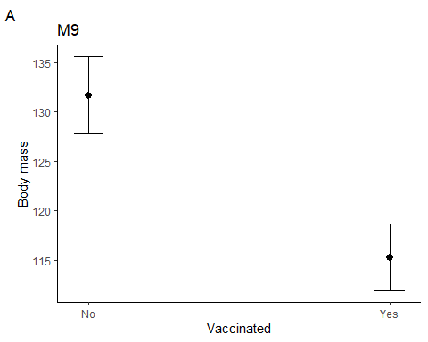
M9.Fig_tempxO2 <- plot_model (M9, type = "pred", terms =c("Temp","O2")) +
labs (title = "M9", x = "Temperature (C)", y = "Body mass", tag ="A") +
theme (panel.background = element_rect(fill = "white", colour = "white")) +
theme (axis.line = element_line (colour = "black"))
## Model has log-transformed response. Back-transforming predictions to original response scale. Standard errors are still on the log-scale.
M9.Fig_tempxO2
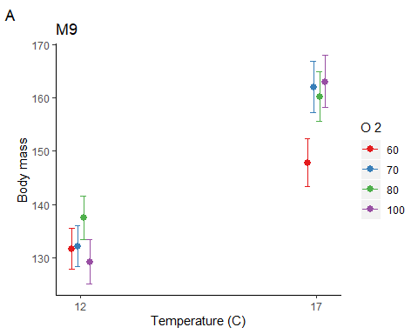
## April 2017
# extract the relevant data
Data6 <- subset (Growth, Day == 198 & Mass>0 & Sex!="Undetermined")
# Apr 2017 - plot the data
M10_dot_plot <- ggdotplot (Data6, "Group", "Mass", add = "mean_sd", size = 0.1) + PlotTheme +
theme (axis.text.x = element_text (angle = 45, hjust = 1))
M10_dot_plot
## `stat_bindot()` using `bins = 30`. Pick better value with `binwidth`.
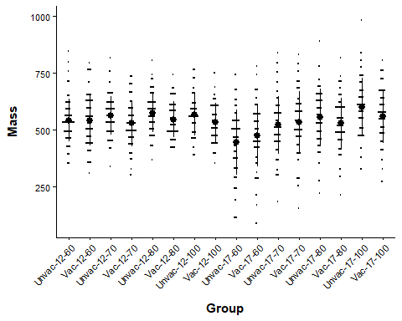
# Apr 2017 Vaccinated x environment model
M10 <- glm (Mass ~ factor(O2) * Temp * Vaccinated + Sex, data = Data6)
M11 <- glm (Mass ~ factor(O2) * Temp + Vaccinated + Sex, data = Data6)
BIC (M10, M11)
## df BIC
## M10 18 16356.94
## M11 11 16321.93
par (mfrow =c(2,2))
plot (M11)
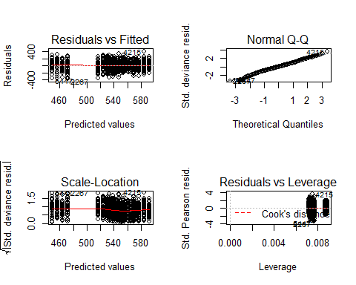
par (mfrow =c(1,1))
# Log mass
M12 <- glm (log (Mass) ~ factor(O2) * Temp * Vaccinated + Sex, data = Data6)
M13 <- glm (log (Mass) ~ factor(O2) * Temp + Vaccinated + Sex, data = Data6)
BIC (M12, M13)
## df BIC
## M12 18 91.63732
## M13 11 54.61370
par (mfrow =c(2,2))
plot (M13) # bad qqplot
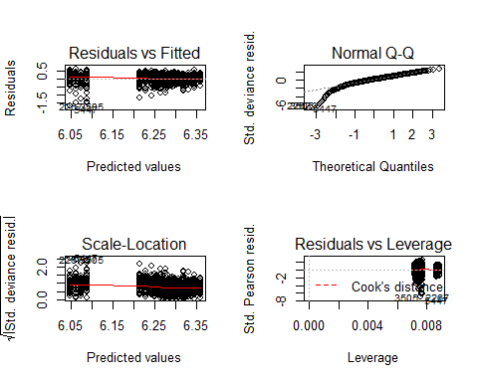
par (mfrow =c(1,1))
# tukey ladder of powers model
M12tuk <- glm (transformTukey (Mass) ~ factor(O2) * Temp * Vaccinated + Sex, data = Data6)
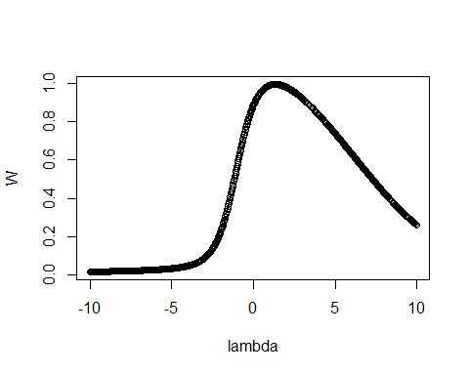
##
## lambda W Shapiro.p.value
## 453 1.3 0.9955 0.0005563
##
## if (lambda > 0){TRANS = x ^ lambda}
## if (lambda == 0){TRANS = log(x)}
## if (lambda < 0){TRANS = -1 * x ^ lambda}
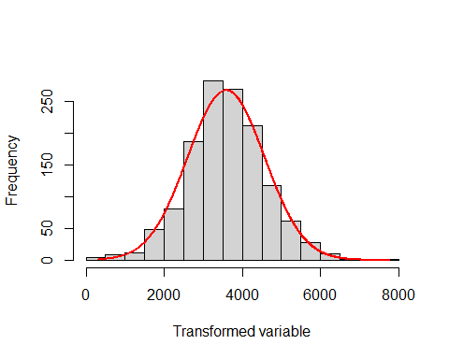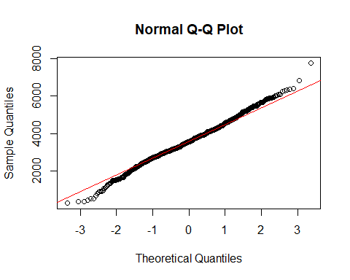
M13tuk <- glm (transformTukey (Mass) ~ factor(O2) * Temp + Vaccinated + Sex, data = Data6)
##
## lambda W Shapiro.p.value
## 453 1.3 0.9955 0.0005563
##
## if (lambda > 0){TRANS = x ^ lambda}
## if (lambda == 0){TRANS = log(x)}
## if (lambda < 0){TRANS = -1 * x ^ lambda}
BIC (M12tuk, M13tuk)
## df BIC
## M12tuk 18 22015.38
## M13tuk 11 21980.62
par (mfrow =c(2,2))
plot (M13tuk) # Looks normal
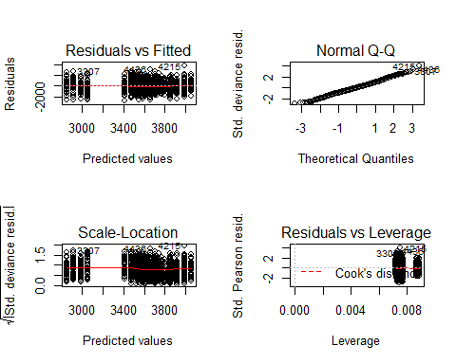
par (mfrow =c(1,1))
# tukey transofrmation output
Anova (M13tuk, type = 3) # tukey transformed data
## Analysis of Deviance Table (Type III tests)
##
## Response: transformTukey(Mass)
## LR Chisq Df Pr(>Chisq)
## factor(O2) 2.474 3 0.479954
## Temp 39.879 1 2.701e-10 ***
## Vaccinated 6.955 1 0.008357 **
## Sex 1.441 1 0.229972
## factor(O2):Temp 39.379 3 1.443e-08 ***
## ---
## Signif. codes: 0 '***' 0.001 '**' 0.01 '*' 0.05 '.' 0.1 ' ' 1
Anova (M11, type = 3) # No transformation
## Analysis of Deviance Table (Type III tests)
##
## Response: Mass
## LR Chisq Df Pr(>Chisq)
## factor(O2) 2.632 3 0.45189
## Temp 44.641 1 2.367e-11 ***
## Vaccinated 6.455 1 0.01106 *
## Sex 1.440 1 0.23018
## factor(O2):Temp 40.835 3 7.090e-09 ***
## ---
## Signif. codes: 0 '***' 0.001 '**' 0.01 '*' 0.05 '.' 0.1 ' ' 1
r.squaredGLMM (M13tuk)
## R2m R2c
## [1,] 0.07919157 0.07919157
M13tuk_null <- glm (transformTukey (Mass) ~1, data = Data6)
##
## lambda W Shapiro.p.value
## 453 1.3 0.9955 0.0005563
##
## if (lambda > 0){TRANS = x ^ lambda}
## if (lambda == 0){TRANS = log(x)}
## if (lambda < 0){TRANS = -1 * x ^ lambda}
BIC (M13tuk, M13tuk_null)
## df BIC
## M13tuk 11 21980.62
## M13tuk_null 2 22025.87
M13tuk.bt <- update (ref_grid (M13tuk), tran = make.tran ("power", 1.3)) # back transform the model
lsmeans (M13tuk.bt, pairwise ~ Vaccinated, type = "response") # Vaccine effect
## Note: Use 'contrast(regrid(object), ...)' to obtain contrasts of back-transformed estimates
## $lsmeans
## Vaccinated response SE df asymp.LCL asymp.UCL
## No 551 4.31 Inf 542 559
## Yes 535 4.29 Inf 526 543
##
## Results are averaged over the levels of: O2, Temp, Sex
## Confidence level used: 0.95
## Intervals are back-transformed from the mu^1.3 scale
##
## $contrasts
## contrast estimate SE df z.ratio p.value
## No - Yes 138 52.2 Inf 2.637 0.0084
##
## Results are averaged over the levels of: O2, Temp, Sex
## Note: contrasts are still on the mu^1.3 scale
lsmeans (M13tuk.bt, pairwise ~ factor(O2) | Temp, type = "response") # O2 effect only in 17C only
## Note: Use 'contrast(regrid(object), ...)' to obtain contrasts of back-transformed estimates
## $lsmeans
## Temp = 12:
## O2 response SE df asymp.LCL asymp.UCL
## 60 545 8.36 Inf 528 561
## 70 549 8.37 Inf 532 565
## 80 563 8.53 Inf 546 579
## 100 552 9.32 Inf 534 570
##
## Temp = 17:
## O2 response SE df asymp.LCL asymp.UCL
## 60 467 9.05 Inf 449 485
## 70 534 8.52 Inf 517 550
## 80 547 8.35 Inf 530 563
## 100 584 8.36 Inf 568 601
##
## Results are averaged over the levels of: Vaccinated, Sex
## Confidence level used: 0.95
## Intervals are back-transformed from the mu^1.3 scale
##
## $contrasts
## Temp = 12:
## contrast estimate SE df z.ratio p.value
## 60 - 70 -32.6 102 Inf -0.320 0.9887
## 60 - 80 -154.8 103 Inf -1.498 0.4385
## 60 - 100 -61.4 108 Inf -0.568 0.9416
## 70 - 80 -122.2 103 Inf -1.181 0.6389
## 70 - 100 -28.7 108 Inf -0.266 0.9934
## 80 - 100 93.5 109 Inf 0.854 0.8285
##
## Temp = 17:
## contrast estimate SE df z.ratio p.value
## 60 - 70 -557.7 104 Inf -5.358 <.0001
## 60 - 80 -669.0 103 Inf -6.464 <.0001
## 60 - 100 -998.2 105 Inf -9.549 <.0001
## 70 - 80 -111.3 102 Inf -1.087 0.6977
## 70 - 100 -440.5 103 Inf -4.257 0.0001
## 80 - 100 -329.3 103 Inf -3.201 0.0075
##
## Results are averaged over the levels of: Vaccinated, Sex
## Note: contrasts are still on the mu^1.3 scale
## P value adjustment: tukey method for comparing a family of 4 estimates
lsmeans (M13tuk.bt, pairwise ~ factor(O2) | Temp | Vaccinated, type = "response") # O2 effect only in 17C only
## Note: Use 'contrast(regrid(object), ...)' to obtain contrasts of back-transformed estimates
## $lsmeans
## Temp = 12, Vaccinated = No:
## O2 response SE df asymp.LCL asymp.UCL
## 60 553 8.87 Inf 535 570
## 70 557 8.87 Inf 539 574
## 80 571 9.02 Inf 553 588
## 100 560 9.79 Inf 541 579
##
## Temp = 17, Vaccinated = No:
## O2 response SE df asymp.LCL asymp.UCL
## 60 476 9.53 Inf 457 494
## 70 542 9.03 Inf 524 559
## 80 555 8.85 Inf 537 572
## 100 592 8.87 Inf 575 610
##
## Temp = 12, Vaccinated = Yes:
## O2 response SE df asymp.LCL asymp.UCL
## 60 537 8.92 Inf 519 554
## 70 541 8.93 Inf 523 558
## 80 555 9.07 Inf 537 573
## 100 544 9.81 Inf 525 563
##
## Temp = 17, Vaccinated = Yes:
## O2 response SE df asymp.LCL asymp.UCL
## 60 459 9.65 Inf 440 478
## 70 526 9.06 Inf 508 543
## 80 539 8.93 Inf 521 556
## 100 577 8.88 Inf 559 594
##
## Results are averaged over the levels of: Sex
## Confidence level used: 0.95
## Intervals are back-transformed from the mu^1.3 scale
##
## $contrasts
## Temp = 12, Vaccinated = No:
## contrast estimate SE df z.ratio p.value
## 60 - 70 -32.6 102 Inf -0.320 0.9887
## 60 - 80 -154.8 103 Inf -1.498 0.4385
## 60 - 100 -61.4 108 Inf -0.568 0.9416
## 70 - 80 -122.2 103 Inf -1.181 0.6389
## 70 - 100 -28.7 108 Inf -0.266 0.9934
## 80 - 100 93.5 109 Inf 0.854 0.8285
##
## Temp = 17, Vaccinated = No:
## contrast estimate SE df z.ratio p.value
## 60 - 70 -557.7 104 Inf -5.358 <.0001
## 60 - 80 -669.0 103 Inf -6.464 <.0001
## 60 - 100 -998.2 105 Inf -9.549 <.0001
## 70 - 80 -111.3 102 Inf -1.087 0.6977
## 70 - 100 -440.5 103 Inf -4.257 0.0001
## 80 - 100 -329.3 103 Inf -3.201 0.0075
##
## Temp = 12, Vaccinated = Yes:
## contrast estimate SE df z.ratio p.value
## 60 - 70 -32.6 102 Inf -0.320 0.9887
## 60 - 80 -154.8 103 Inf -1.498 0.4385
## 60 - 100 -61.4 108 Inf -0.568 0.9416
## 70 - 80 -122.2 103 Inf -1.181 0.6389
## 70 - 100 -28.7 108 Inf -0.266 0.9934
## 80 - 100 93.5 109 Inf 0.854 0.8285
##
## Temp = 17, Vaccinated = Yes:
## contrast estimate SE df z.ratio p.value
## 60 - 70 -557.7 104 Inf -5.358 <.0001
## 60 - 80 -669.0 103 Inf -6.464 <.0001
## 60 - 100 -998.2 105 Inf -9.549 <.0001
## 70 - 80 -111.3 102 Inf -1.087 0.6977
## 70 - 100 -440.5 103 Inf -4.257 0.0001
## 80 - 100 -329.3 103 Inf -3.201 0.0075
##
## Results are averaged over the levels of: Sex
## Note: contrasts are still on the mu^1.3 scale
## P value adjustment: tukey method for comparing a family of 4 estimates
M13tuk.Fig_Vaccinated <- plot_model (M13tuk, type = "pred", terms =c("Vaccinated")) +
labs (title = "M13tuk", x = "Vaccinated", y = "Tukey transformed body mass", tag ="A") +
theme (panel.background = element_rect (fill = "white", colour = "white")) +
theme (axis.line = element_line (colour = "black"))
M13tuk.Fig_Vaccinated
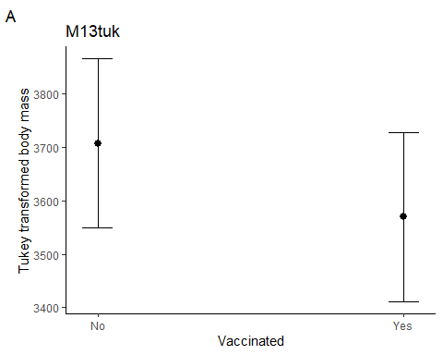
M13tuk.Fig_tempxO2 <- plot_model (M13tuk, type = "pred", terms =c("Temp","O2")) +
labs (title = "M13tuk", x = "Temperature (C)", y = "Tukey transformed body mass", tag ="A") +
theme (panel.background = element_rect(fill = "white", colour = "white"))+
theme (axis.line = element_line(colour = "black"))
M13tuk.Fig_tempxO2
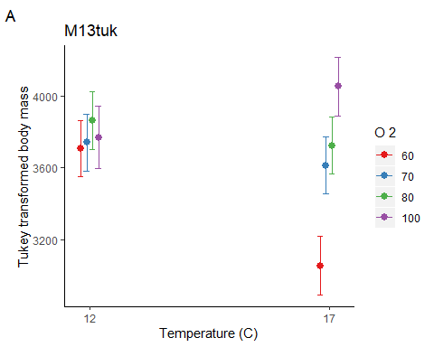
#### Within time point SGR analysis ####
## SGR November 2016
# extract the relevant data
Data10 <- subset (Growth, Day == 51 & Mass>0 & Initial_mass>0 & Sex!="Undetermined")
# Nov 2016 - plot the data
M23_dot_plot <- ggdotplot(Data10, "Group", "SGR", add = "mean_sd", size = 0.1) + PlotTheme +
theme (axis.text.x = element_text (angle = 45, hjust = 1))
M23_dot_plot
## `stat_bindot()` using `bins = 30`. Pick better value with `binwidth`.
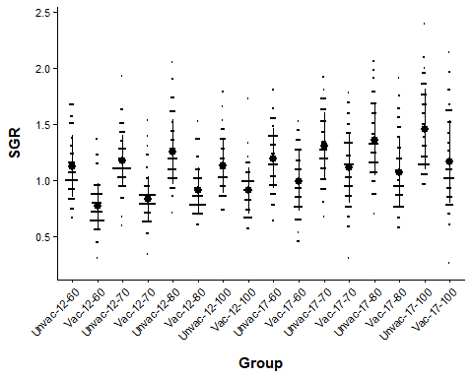
# Nov 2016 vaccinated x environment model
M23 <- glm (SGR ~ factor(O2) * Temp * Vaccinated + Initial_mass + Sex, data = Data10)
M24 <- glm (SGR ~ factor(O2) * Temp + Vaccinated + Initial_mass + Sex, data = Data10)
BIC (M23, M24)
## df BIC
## M23 19 355.1134
## M24 12 325.0683
par (mfrow =c(2,2))
plot (M24)
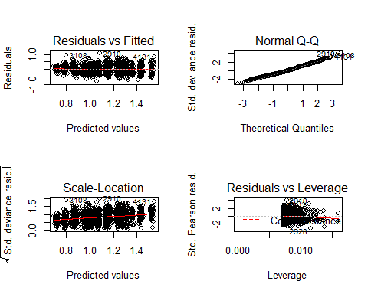
par (mfrow =c(1,1))
# model output
Anova (M24, type = 3)
## Analysis of Deviance Table (Type III tests)
##
## Response: SGR
## LR Chisq Df Pr(>Chisq)
## factor(O2) 20.80 3 0.0001161 ***
## Temp 24.94 1 5.918e-07 ***
## Vaccinated 379.41 1 < 2.2e-16 ***
## Initial_mass 1.27 1 0.2597865
## Sex 127.31 1 < 2.2e-16 ***
## factor(O2):Temp 16.94 3 0.0007256 ***
## ---
## Signif. codes: 0 '***' 0.001 '**' 0.01 '*' 0.05 '.' 0.1 ' ' 1
r.squaredGLMM (M24)
## R2m R2c
## [1,] 0.3637588 0.3637588
M24_null <- glm (SGR ~1, data = Data10)
BIC (M24, M24_null)
## df BIC
## M24 12 325.0683
## M24_null 2 859.5318
lsmeans (M24, pairwise ~ factor(O2) | Temp) # Temperature effect in both treatments
## $lsmeans
## Temp = 12:
## O2 lsmean SE df asymp.LCL asymp.UCL
## 60 0.946 0.0201 Inf 0.907 0.986
## 70 1.004 0.0204 Inf 0.964 1.044
## 80 1.077 0.0206 Inf 1.036 1.117
## 100 1.015 0.0228 Inf 0.970 1.059
##
## Temp = 17:
## O2 lsmean SE df asymp.LCL asymp.UCL
## 60 1.091 0.0209 Inf 1.050 1.133
## 70 1.216 0.0208 Inf 1.175 1.257
## 80 1.214 0.0202 Inf 1.174 1.254
## 100 1.304 0.0205 Inf 1.264 1.344
##
## Results are averaged over the levels of: Vaccinated, Sex
## Confidence level used: 0.95
##
## $contrasts
## Temp = 12:
## contrast estimate SE df z.ratio p.value
## 60 - 70 -0.05741 0.0285 Inf -2.011 0.1837
## 60 - 80 -0.13045 0.0287 Inf -4.545 <.0001
## 60 - 100 -0.06843 0.0303 Inf -2.261 0.1073
## 70 - 80 -0.07304 0.0287 Inf -2.541 0.0538
## 70 - 100 -0.01103 0.0302 Inf -0.365 0.9834
## 80 - 100 0.06202 0.0304 Inf 2.042 0.1726
##
## Temp = 17:
## contrast estimate SE df z.ratio p.value
## 60 - 70 -0.12469 0.0293 Inf -4.255 0.0001
## 60 - 80 -0.12263 0.0290 Inf -4.233 0.0001
## 60 - 100 -0.21233 0.0293 Inf -7.255 <.0001
## 70 - 80 0.00206 0.0286 Inf 0.072 0.9999
## 70 - 100 -0.08764 0.0291 Inf -3.014 0.0138
## 80 - 100 -0.08970 0.0287 Inf -3.122 0.0097
##
## Results are averaged over the levels of: Vaccinated, Sex
## P value adjustment: tukey method for comparing a family of 4 estimates
lsmeans (M24, pairwise ~ Vaccinated) # Vaccinated grow slower
## $lsmeans
## Vaccinated lsmean SE df asymp.LCL asymp.UCL
## No 1.250 0.0104 Inf 1.230 1.271
## Yes 0.966 0.0102 Inf 0.946 0.986
##
## Results are averaged over the levels of: O2, Temp, Sex
## Confidence level used: 0.95
##
## $contrasts
## contrast estimate SE df z.ratio p.value
## No - Yes 0.284 0.0146 Inf 19.479 <.0001
##
## Results are averaged over the levels of: O2, Temp, Sex
lsmeans (M24, pairwise ~ factor(O2) | Temp | Vaccinated) # Temperature effect in both treatments
## $lsmeans
## Temp = 12, Vaccinated = No:
## O2 lsmean SE df asymp.LCL asymp.UCL
## 60 1.088 0.0214 Inf 1.046 1.130
## 70 1.146 0.0217 Inf 1.103 1.188
## 80 1.219 0.0219 Inf 1.176 1.262
## 100 1.157 0.0241 Inf 1.109 1.204
##
## Temp = 17, Vaccinated = No:
## O2 lsmean SE df asymp.LCL asymp.UCL
## 60 1.233 0.0222 Inf 1.190 1.277
## 70 1.358 0.0220 Inf 1.315 1.401
## 80 1.356 0.0215 Inf 1.314 1.398
## 100 1.446 0.0219 Inf 1.403 1.489
##
## Temp = 12, Vaccinated = Yes:
## O2 lsmean SE df asymp.LCL asymp.UCL
## 60 0.804 0.0213 Inf 0.763 0.846
## 70 0.862 0.0216 Inf 0.819 0.904
## 80 0.935 0.0217 Inf 0.892 0.977
## 100 0.873 0.0238 Inf 0.826 0.919
##
## Temp = 17, Vaccinated = Yes:
## O2 lsmean SE df asymp.LCL asymp.UCL
## 60 0.950 0.0222 Inf 0.906 0.993
## 70 1.074 0.0220 Inf 1.031 1.117
## 80 1.072 0.0216 Inf 1.030 1.114
## 100 1.162 0.0217 Inf 1.119 1.204
##
## Results are averaged over the levels of: Sex
## Confidence level used: 0.95
##
## $contrasts
## Temp = 12, Vaccinated = No:
## contrast estimate SE df z.ratio p.value
## 60 - 70 -0.05741 0.0285 Inf -2.011 0.1837
## 60 - 80 -0.13045 0.0287 Inf -4.545 <.0001
## 60 - 100 -0.06843 0.0303 Inf -2.261 0.1073
## 70 - 80 -0.07304 0.0287 Inf -2.541 0.0538
## 70 - 100 -0.01103 0.0302 Inf -0.365 0.9834
## 80 - 100 0.06202 0.0304 Inf 2.042 0.1726
##
## Temp = 17, Vaccinated = No:
## contrast estimate SE df z.ratio p.value
## 60 - 70 -0.12469 0.0293 Inf -4.255 0.0001
## 60 - 80 -0.12263 0.0290 Inf -4.233 0.0001
## 60 - 100 -0.21233 0.0293 Inf -7.255 <.0001
## 70 - 80 0.00206 0.0286 Inf 0.072 0.9999
## 70 - 100 -0.08764 0.0291 Inf -3.014 0.0138
## 80 - 100 -0.08970 0.0287 Inf -3.122 0.0097
##
## Temp = 12, Vaccinated = Yes:
## contrast estimate SE df z.ratio p.value
## 60 - 70 -0.05741 0.0285 Inf -2.011 0.1837
## 60 - 80 -0.13045 0.0287 Inf -4.545 <.0001
## 60 - 100 -0.06843 0.0303 Inf -2.261 0.1073
## 70 - 80 -0.07304 0.0287 Inf -2.541 0.0538
## 70 - 100 -0.01103 0.0302 Inf -0.365 0.9834
## 80 - 100 0.06202 0.0304 Inf 2.042 0.1726
##
## Temp = 17, Vaccinated = Yes:
## contrast estimate SE df z.ratio p.value
## 60 - 70 -0.12469 0.0293 Inf -4.255 0.0001
## 60 - 80 -0.12263 0.0290 Inf -4.233 0.0001
## 60 - 100 -0.21233 0.0293 Inf -7.255 <.0001
## 70 - 80 0.00206 0.0286 Inf 0.072 0.9999
## 70 - 100 -0.08764 0.0291 Inf -3.014 0.0138
## 80 - 100 -0.08970 0.0287 Inf -3.122 0.0097
##
## Results are averaged over the levels of: Sex
## P value adjustment: tukey method for comparing a family of 4 estimates
M24.Fig_Vaccinated <- plot_model (M24, type = "pred", terms =c("Vaccinated")) +
labs (title = "M24", x = "Vaccinated", y = "Specific growth rate (% day-1)", tag ="A") +
theme (panel.background = element_rect (fill = "white", colour = "white")) +
theme (axis.line = element_line (colour = "black"))
M24.Fig_Vaccinated
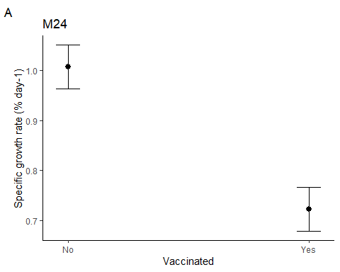
M24.Fig_tempxO2 <- plot_model (M24, type = "pred", terms =c("Temp","O2")) +
labs (title = "M24", x = "Temperature (C)", y = "Specific growth rate (% day-1)", tag ="A") +
theme (panel.background = element_rect (fill = "white", colour = "white")) +
theme (axis.line = element_line (colour = "black"))
M24.Fig_tempxO2
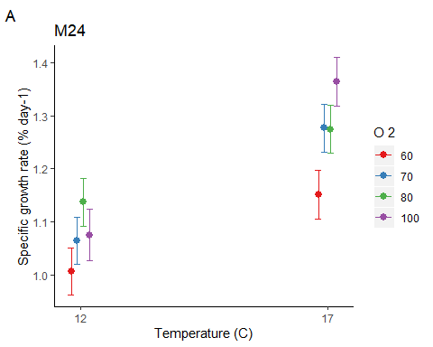
# run model without start mass
M23b <- glm (SGR ~ factor(O2) * Temp * Vaccinated + Sex, data = Data10)
M24b <- glm (SGR ~ factor(O2) * Temp + Vaccinated + Sex, data = Data10)
BIC (M23, M24)
## df BIC
## M23 19 355.1134
## M24 12 325.0683
par (mfrow =c(2,2))
plot (M24b)
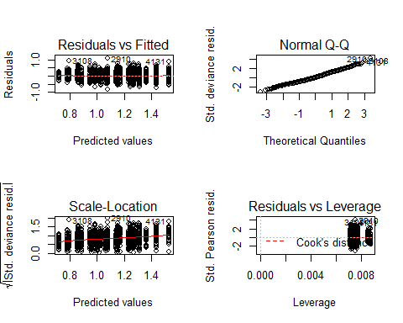
par (mfrow =c(1,1))
# model output
Anova (M24b, type = 3)
## Analysis of Deviance Table (Type III tests)
##
## Response: SGR
## LR Chisq Df Pr(>Chisq)
## factor(O2) 21.44 3 8.522e-05 ***
## Temp 24.17 1 8.828e-07 ***
## Vaccinated 381.82 1 < 2.2e-16 ***
## Sex 128.43 1 < 2.2e-16 ***
## factor(O2):Temp 16.56 3 0.0008699 ***
## ---
## Signif. codes: 0 '***' 0.001 '**' 0.01 '*' 0.05 '.' 0.1 ' ' 1
r.squaredGLMM (M24b)
## R2m R2c
## [1,] 0.3633254 0.3633254
M24b_null <- glm (SGR ~1, data = Data10)
BIC (M24b, M24b_null)
## df BIC
## M24b 11 319.1530
## M24b_null 2 859.5318
## SGR April 2017
# extract the relevant data
Data11 <- subset (Growth, Day==198 & Mass>0 & Initial_mass>0 & Sex!="Undetermined")
# Apr 2017 - plot the data
M27_dot_plot <- ggdotplot(Data11, "Group", "SGR", add = "mean_sd", size = 0.1) + PlotTheme +
theme (axis.text.x = element_text (angle = 45, hjust = 1))
M27_dot_plot
## `stat_bindot()` using `bins = 30`. Pick better value with `binwidth`.
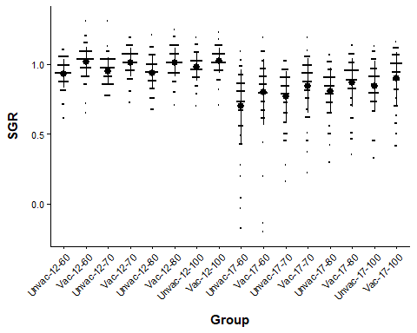
# Apr 2017 Vaccinated x environment model
M27 <- glm (SGR ~ factor(O2) * Temp * Vaccinated + Initial_mass + Sex, data = Data11)
M28 <- glm (SGR ~ factor(O2) * Temp + Vaccinated + Initial_mass + Sex, data = Data11)
BIC (M27, M28)
## df BIC
## M27 19 -1166.668
## M28 12 -1209.306
par (mfrow =c(2,2))
plot (M28) # bad qqplot
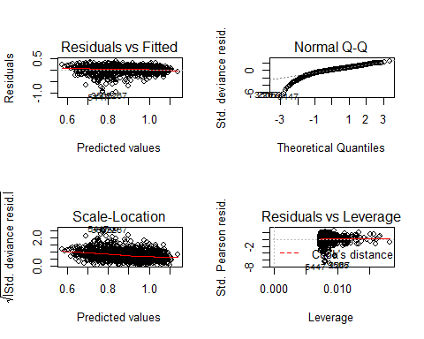
par (mfrow =c(1,1))
# logged data
M27log <- glm (log (SGR+1) ~ factor(O2) * Temp * Vaccinated + Initial_mass + Sex, data = Data11)
M28log <- glm (log (SGR+1) ~ factor(O2) * Temp + Vaccinated + Initial_mass + Sex, data = Data11)
BIC (M27log, M28log)
## df BIC
## M27log 19 -2451.423
## M28log 12 -2493.680
par (mfrow =c(2,2))
plot (M28log) # bad qqplot
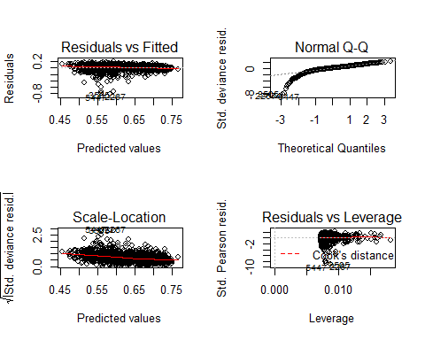
par (mfrow =c(1,1))
# tukey ladder or power
M27tuk <- glm (transformTukey (SGR+1) ~ factor(O2) * Temp * Vaccinated + Initial_mass + Sex, data = Data11)
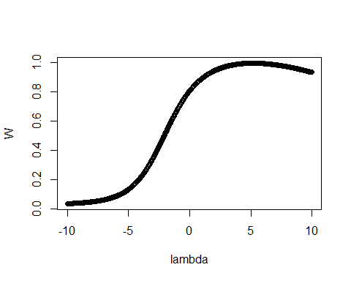
##
## lambda W Shapiro.p.value
## 605 5.1 0.9954 0.0004445
##
## if (lambda > 0){TRANS = x ^ lambda}
## if (lambda == 0){TRANS = log(x)}
## if (lambda < 0){TRANS = -1 * x ^ lambda}
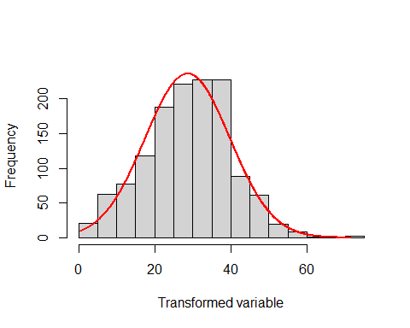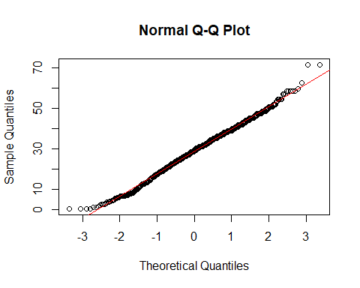
M28tuk <- glm (transformTukey (SGR+1) ~ factor(O2) * Temp + Vaccinated + Initial_mass + Sex, data = Data11)
##
## lambda W Shapiro.p.value
## 605 5.1 0.9954 0.0004445
##
## if (lambda > 0){TRANS = x ^ lambda}
## if (lambda == 0){TRANS = log(x)}
## if (lambda < 0){TRANS = -1 * x ^ lambda}
BIC (M27tuk, M28tuk)
## df BIC
## M27tuk 19 9521.843
## M28tuk 12 9478.968
par (mfrow =c(2,2))
plot (M28tuk) # looks good
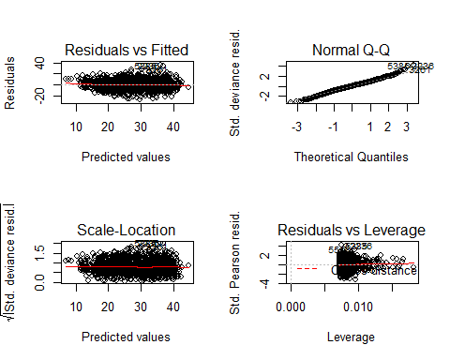
par (mfrow =c(1,1))
# box cox transformation
attach(Data11)
BoxSGR <- boxcox (SGR+1 ~1, lambda = seq (-6,6,0.1)) # Box cox
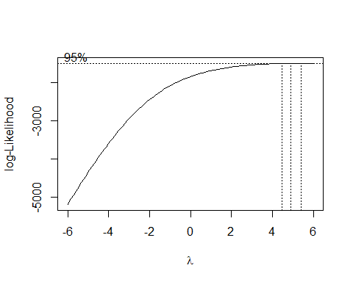
Cox <- data.frame (BoxSGR$x,BoxSGR$y) # Create a data frame with the results
Cox2 <- Cox[with(Cox,order(-Cox$BoxSGR.y)),] # Order the new data frame by decreasing y
Cox2 [1,] # Display the lambda with the greatest log likelihood
## BoxSGR.x BoxSGR.y
## 110 4.9 -1497.562
lambda <- Cox2[1,"BoxSGR.x"] # Extract the lambda
Data11$BoxSGR <- (SGR+1 ^ lambda-1) / lambda # Box-Cox transformation
M27box <- glm (BoxSGR ~ factor(O2) * Temp * Vaccinated + Initial_mass + Sex, data = Data11)
M28box <- glm (BoxSGR ~ factor(O2) * Temp + Vaccinated + Initial_mass + Sex, data = Data11)
BIC (M27box, M28box)
## df BIC
## M27box 19 -5368.606
## M28box 12 -5411.243
par (mfrow =c(2,2))
plot (M28box) # bad qqplot
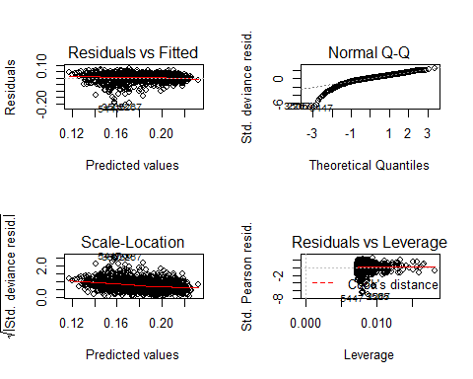
par (mfrow =c(1,1))
# tukey transformation output
Anova (M28tuk, type = 3) # transformed looks the same as the non-transformed
## Analysis of Deviance Table (Type III tests)
##
## Response: transformTukey(SGR + 1)
## LR Chisq Df Pr(>Chisq)
## factor(O2) 3.153 3 0.3686
## Temp 126.076 1 < 2.2e-16 ***
## Vaccinated 28.025 1 1.197e-07 ***
## Initial_mass 248.428 1 < 2.2e-16 ***
## Sex 16.167 1 5.799e-05 ***
## factor(O2):Temp 26.649 3 6.975e-06 ***
## ---
## Signif. codes: 0 '***' 0.001 '**' 0.01 '*' 0.05 '.' 0.1 ' ' 1
Anova (M28, type = 3) # no transformation
## Analysis of Deviance Table (Type III tests)
##
## Response: SGR
## LR Chisq Df Pr(>Chisq)
## factor(O2) 1.527 3 0.6762
## Temp 138.843 1 < 2.2e-16 ***
## Vaccinated 16.924 1 3.891e-05 ***
## Initial_mass 159.838 1 < 2.2e-16 ***
## Sex 17.542 1 2.810e-05 ***
## factor(O2):Temp 34.676 3 1.426e-07 ***
## ---
## Signif. codes: 0 '***' 0.001 '**' 0.01 '*' 0.05 '.' 0.1 ' ' 1
r.squaredGLMM (M28tuk)
## R2m R2c
## [1,] 0.4249349 0.4249349
M28tuk_null <- glm (transformTukey (SGR+1) ~1, data = Data11)
##
## lambda W Shapiro.p.value
## 605 5.1 0.9954 0.0004445
##
## if (lambda > 0){TRANS = x ^ lambda}
## if (lambda == 0){TRANS = log(x)}
## if (lambda < 0){TRANS = -1 * x ^ lambda}
BIC (M28tuk, M28tuk_null)
## df BIC
## M28tuk 12 9478.968
## M28tuk_null 2 10142.803
M28tuk.bt <- update(ref_grid (M28tuk), tran = make.tran ("power", param =c (5.15))) # back transform the model
lsmeans (M28tuk.bt, pairwise ~ factor(O2)|Temp, type = "response") # O2 effect in 17C only
## Note: Use 'contrast(regrid(object), ...)' to obtain contrasts of back-transformed estimates
## $lsmeans
## Temp = 12:
## O2 response SE df asymp.LCL asymp.UCL
## 60 0.952 0.00791 Inf 0.936 0.967
## 70 0.957 0.00784 Inf 0.942 0.972
## 80 0.963 0.00787 Inf 0.948 0.979
## 100 0.971 0.00854 Inf 0.954 0.988
##
## Temp = 17:
## O2 response SE df asymp.LCL asymp.UCL
## 60 0.803 0.01125 Inf 0.780 0.824
## 70 0.866 0.00973 Inf 0.846 0.884
## 80 0.886 0.00916 Inf 0.867 0.903
## 100 0.927 0.00864 Inf 0.909 0.943
##
## Results are averaged over the levels of: Vaccinated, Sex
## Confidence level used: 0.95
## Intervals are back-transformed from the mu^5.15(mu + 1) scale
##
## $contrasts
## Temp = 12:
## contrast estimate SE df z.ratio p.value
## 60 - 70 -0.443 0.911 Inf -0.487 0.9620
## 60 - 80 -0.957 0.924 Inf -1.035 0.7287
## 60 - 100 -1.627 0.965 Inf -1.685 0.3314
## 70 - 80 -0.513 0.925 Inf -0.555 0.9453
## 70 - 100 -1.183 0.967 Inf -1.224 0.6113
## 80 - 100 -0.670 0.981 Inf -0.683 0.9036
##
## Temp = 17:
## contrast estimate SE df z.ratio p.value
## 60 - 70 -4.018 0.942 Inf -4.266 0.0001
## 60 - 80 -5.422 0.935 Inf -5.802 <.0001
## 60 - 100 -8.476 0.948 Inf -8.938 <.0001
## 70 - 80 -1.404 0.915 Inf -1.534 0.4168
## 70 - 100 -4.457 0.925 Inf -4.821 <.0001
## 80 - 100 -3.054 0.919 Inf -3.322 0.0050
##
## Results are averaged over the levels of: Vaccinated, Sex
## Note: contrasts are still on the mu^5.15(mu + 1) scale
## P value adjustment: tukey method for comparing a family of 4 estimates
lsmeans (M28tuk.bt, pairwise ~ Vaccinated, type = "response") # Vaccinated grow quicker
## Note: Use 'contrast(regrid(object), ...)' to obtain contrasts of back-transformed estimates
## $lsmeans
## Vaccinated response SE df asymp.LCL asymp.UCL
## No 0.902 0.00463 Inf 0.892 0.910
## Yes 0.936 0.00424 Inf 0.927 0.944
##
## Results are averaged over the levels of: O2, Temp, Sex
## Confidence level used: 0.95
## Intervals are back-transformed from the mu^5.15(mu + 1) scale
##
## $contrasts
## contrast estimate SE df z.ratio p.value
## No - Yes -2.62 0.495 Inf -5.294 <.0001
##
## Results are averaged over the levels of: O2, Temp, Sex
## Note: contrasts are still on the mu^5.15(mu + 1) scale
lsmeans (M28tuk.bt, pairwise ~ factor(O2) | Temp | Vaccinated, type = "response") # O2 effect in 17C only
## Note: Use 'contrast(regrid(object), ...)' to obtain contrasts of back-transformed estimates
## $lsmeans
## Temp = 12, Vaccinated = No:
## O2 response SE df asymp.LCL asymp.UCL
## 60 0.936 0.00859 Inf 0.919 0.952
## 70 0.941 0.00851 Inf 0.924 0.958
## 80 0.948 0.00859 Inf 0.931 0.964
## 100 0.956 0.00914 Inf 0.938 0.973
##
## Temp = 17, Vaccinated = No:
## O2 response SE df asymp.LCL asymp.UCL
## 60 0.780 0.01268 Inf 0.755 0.804
## 70 0.846 0.01112 Inf 0.824 0.867
## 80 0.867 0.01042 Inf 0.846 0.887
## 100 0.909 0.00982 Inf 0.890 0.928
##
## Temp = 12, Vaccinated = Yes:
## O2 response SE df asymp.LCL asymp.UCL
## 60 0.968 0.00834 Inf 0.951 0.984
## 70 0.973 0.00827 Inf 0.956 0.989
## 80 0.979 0.00821 Inf 0.962 0.994
## 100 0.986 0.00888 Inf 0.969 1.003
##
## Temp = 17, Vaccinated = Yes:
## O2 response SE df asymp.LCL asymp.UCL
## 60 0.824 0.01138 Inf 0.801 0.846
## 70 0.884 0.00969 Inf 0.865 0.903
## 80 0.904 0.00920 Inf 0.885 0.921
## 100 0.943 0.00862 Inf 0.926 0.960
##
## Results are averaged over the levels of: Sex
## Confidence level used: 0.95
## Intervals are back-transformed from the mu^5.15(mu + 1) scale
##
## $contrasts
## Temp = 12, Vaccinated = No:
## contrast estimate SE df z.ratio p.value
## 60 - 70 -0.443 0.911 Inf -0.487 0.9620
## 60 - 80 -0.957 0.924 Inf -1.035 0.7287
## 60 - 100 -1.627 0.965 Inf -1.685 0.3314
## 70 - 80 -0.513 0.925 Inf -0.555 0.9453
## 70 - 100 -1.183 0.967 Inf -1.224 0.6113
## 80 - 100 -0.670 0.981 Inf -0.683 0.9036
##
## Temp = 17, Vaccinated = No:
## contrast estimate SE df z.ratio p.value
## 60 - 70 -4.018 0.942 Inf -4.266 0.0001
## 60 - 80 -5.422 0.935 Inf -5.802 <.0001
## 60 - 100 -8.476 0.948 Inf -8.938 <.0001
## 70 - 80 -1.404 0.915 Inf -1.534 0.4168
## 70 - 100 -4.457 0.925 Inf -4.821 <.0001
## 80 - 100 -3.054 0.919 Inf -3.322 0.0050
##
## Temp = 12, Vaccinated = Yes:
## contrast estimate SE df z.ratio p.value
## 60 - 70 -0.443 0.911 Inf -0.487 0.9620
## 60 - 80 -0.957 0.924 Inf -1.035 0.7287
## 60 - 100 -1.627 0.965 Inf -1.685 0.3314
## 70 - 80 -0.513 0.925 Inf -0.555 0.9453
## 70 - 100 -1.183 0.967 Inf -1.224 0.6113
## 80 - 100 -0.670 0.981 Inf -0.683 0.9036
##
## Temp = 17, Vaccinated = Yes:
## contrast estimate SE df z.ratio p.value
## 60 - 70 -4.018 0.942 Inf -4.266 0.0001
## 60 - 80 -5.422 0.935 Inf -5.802 <.0001
## 60 - 100 -8.476 0.948 Inf -8.938 <.0001
## 70 - 80 -1.404 0.915 Inf -1.534 0.4168
## 70 - 100 -4.457 0.925 Inf -4.821 <.0001
## 80 - 100 -3.054 0.919 Inf -3.322 0.0050
##
## Results are averaged over the levels of: Sex
## Note: contrasts are still on the mu^5.15(mu + 1) scale
## P value adjustment: tukey method for comparing a family of 4 estimates
M28tuk.Fig_Vaccinated <- plot_model (M28tuk, type = "pred", terms = c ("Vaccinated")) +
labs (title = "M28tuk", x = "Vaccinated", y = "Tukey transformed specific growth rate", tag ="A") +
theme (panel.background = element_rect (fill = "white", colour = "white")) +
theme (axis.line = element_line (colour = "black"))
M28tuk.Fig_Vaccinated
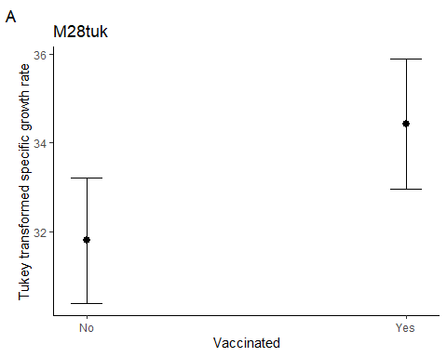
M28tuk.Fig_tempxO2 <- plot_model (M28tuk, type = "pred", terms =c ("Temp","O2")) +
labs (title = "M28tuk", x = "Temperature (C)", y = "Tukey transformed specific growth rate", tag ="A") +
theme (panel.background = element_rect (fill = "white", colour = "white")) +
theme (axis.line = element_line (colour = "black"))
M28tuk.Fig_tempxO2
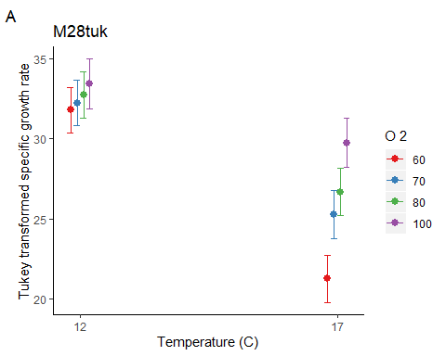
# non-transformed models
M28.Fig_Vaccinated <- plot_model (M28, type = "pred", terms =c("Vaccinated")) +
labs (title = "M28tuk", x = "Vaccinated", y = "SGR (%/day)", tag ="") +
theme (panel.background = element_rect (fill = "white", colour = "white")) +
theme (axis.line = element_line (colour="black"))
M28.Fig_Vaccinated
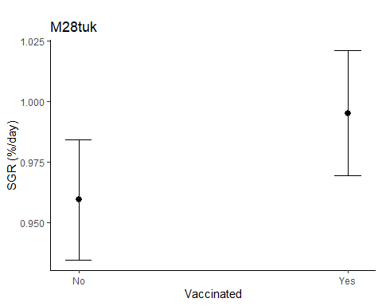
M28.Fig_tempxO2 <- plot_model (M28, type = "pred", terms =c("Temp","O2")) +
labs (title = "M28tuk", x = "Temperature (C)", y = "SGR (%/day)", tag ="") +
theme (panel.background = element_rect (fill = "white", colour = "white")) +
theme (axis.line = element_line (colour="black"))
M28.Fig_tempxO2
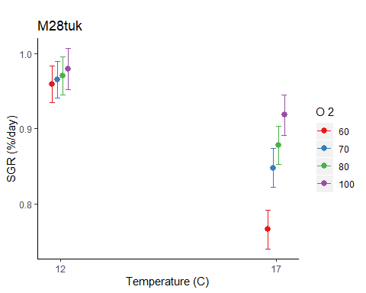
# run model without initial mass
M27btuk <- glm (transformTukey (SGR+1) ~ factor(O2) * Temp * Vaccinated + Sex, data = Data11)
##
## lambda W Shapiro.p.value
## 605 5.1 0.9954 0.0004445
##
## if (lambda > 0){TRANS = x ^ lambda}
## if (lambda == 0){TRANS = log(x)}
## if (lambda < 0){TRANS = -1 * x ^ lambda}
M28btuk <- glm (transformTukey (SGR+1) ~ factor(O2) * Temp + Vaccinated + Sex, data = Data11)
##
## lambda W Shapiro.p.value
## 605 5.1 0.9954 0.0004445
##
## if (lambda > 0){TRANS = x ^ lambda}
## if (lambda == 0){TRANS = log(x)}
## if (lambda < 0){TRANS = -1 * x ^ lambda}
BIC (M27btuk, M28btuk)
## df BIC
## M27btuk 18 9746.745
## M28btuk 11 9701.186
par (mfrow =c(2,2))
plot (M28btuk) # looks good
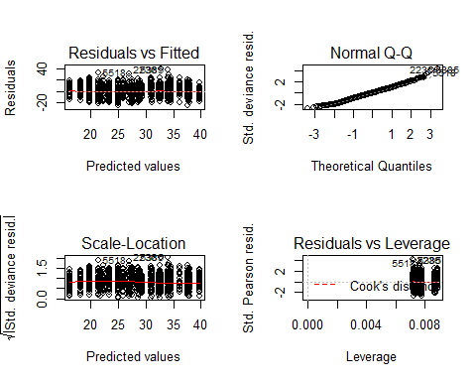
par (mfrow =c(1,1))
Anova (M28tuk, type = 3) # with initial mass
## Analysis of Deviance Table (Type III tests)
##
## Response: transformTukey(SGR + 1)
## LR Chisq Df Pr(>Chisq)
## factor(O2) 3.153 3 0.3686
## Temp 126.076 1 < 2.2e-16 ***
## Vaccinated 28.025 1 1.197e-07 ***
## Initial_mass 248.428 1 < 2.2e-16 ***
## Sex 16.167 1 5.799e-05 ***
## factor(O2):Temp 26.649 3 6.975e-06 ***
## ---
## Signif. codes: 0 '***' 0.001 '**' 0.01 '*' 0.05 '.' 0.1 ' ' 1
Anova (M28btuk, type = 3) # without initial mass
## Analysis of Deviance Table (Type III tests)
##
## Response: transformTukey(SGR + 1)
## LR Chisq Df Pr(>Chisq)
## factor(O2) 4.871 3 0.18147
## Temp 156.182 1 < 2.2e-16 ***
## Vaccinated 105.959 1 < 2.2e-16 ***
## Sex 49.079 1 2.459e-12 ***
## factor(O2):Temp 9.562 3 0.02268 *
## ---
## Signif. codes: 0 '***' 0.001 '**' 0.01 '*' 0.05 '.' 0.1 ' ' 1
r.squaredGLMM (M28btuk)
## R2m R2c
## [1,] 0.3166918 0.3166918
M28btuk_null <- glm (transformTukey (SGR+1) ~1, data = Data11)
##
## lambda W Shapiro.p.value
## 605 5.1 0.9954 0.0004445
##
## if (lambda > 0){TRANS = x ^ lambda}
## if (lambda == 0){TRANS = log(x)}
## if (lambda < 0){TRANS = -1 * x ^ lambda}
BIC (M28btuk, M28btuk_null)
## df BIC
## M28btuk 11 9701.186
## M28btuk_null 2 10142.803
#### Within time point TGC analysis ####
## TGC November 2016
# Nov 2016 - plot the data
M23c_dot_plot <- ggdotplot (Data10, "Group", "TGC", add = "mean_sd", size = 0.1) + PlotTheme +
theme (axis.text.x = element_text (angle = 45, hjust = 1))
M23c_dot_plot
## `stat_bindot()` using `bins = 30`. Pick better value with `binwidth`.
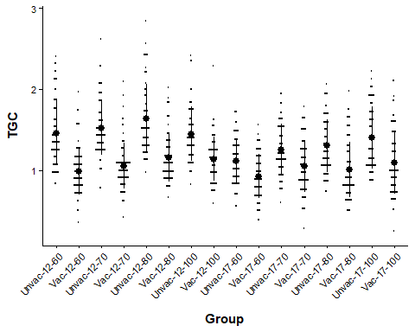
# Nov 2016 Vaccinated x environment model
M23c <- glm (TGC ~ factor(O2) * Temp * Vaccinated + Sex, data = Data10)
M24c <- glm (TGC ~ factor(O2) * Temp + Vaccinated + Sex, data = Data10)
BIC (M23c, M24c)
## df BIC
## M23c 18 826.8934
## M24c 11 820.8055
par (mfrow =c (2,2))
plot (M24c)
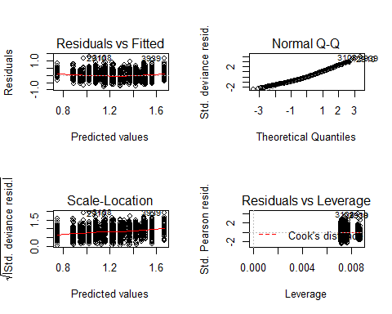
par (mfrow =c (1,1))
# model output
Anova (M24c, type = 3)
## Analysis of Deviance Table (Type III tests)
##
## Response: TGC
## LR Chisq Df Pr(>Chisq)
## factor(O2) 25.56 3 1.177e-05 ***
## Temp 34.27 1 4.802e-09 ***
## Vaccinated 386.62 1 < 2.2e-16 ***
## Sex 121.45 1 < 2.2e-16 ***
## factor(O2):Temp 16.32 3 0.0009763 ***
## ---
## Signif. codes: 0 '***' 0.001 '**' 0.01 '*' 0.05 '.' 0.1 ' ' 1
Anova (M24, type = 3)
## Analysis of Deviance Table (Type III tests)
##
## Response: SGR
## LR Chisq Df Pr(>Chisq)
## factor(O2) 20.80 3 0.0001161 ***
## Temp 24.94 1 5.918e-07 ***
## Vaccinated 379.41 1 < 2.2e-16 ***
## Initial_mass 1.27 1 0.2597865
## Sex 127.31 1 < 2.2e-16 ***
## factor(O2):Temp 16.94 3 0.0007256 ***
## ---
## Signif. codes: 0 '***' 0.001 '**' 0.01 '*' 0.05 '.' 0.1 ' ' 1
r.squaredGLMM (M24c)
## R2m R2c
## [1,] 0.3241796 0.3241796
M24c_null <- glm (TGC ~1, data = Data10)
BIC (M24c, M24c_null)
## df BIC
## M24c 11 820.8055
## M24c_null 2 1281.2918
lsmeans (M24c, pairwise ~ factor(O2) | Temp) # Temperature effect in both treatments
## $lsmeans
## Temp = 12:
## O2 lsmean SE df asymp.LCL asymp.UCL
## 60 1.22 0.0243 Inf 1.177 1.27
## 70 1.29 0.0244 Inf 1.246 1.34
## 80 1.40 0.0247 Inf 1.350 1.45
## 100 1.30 0.0270 Inf 1.243 1.35
##
## Temp = 17:
## O2 lsmean SE df asymp.LCL asymp.UCL
## 60 1.02 0.0252 Inf 0.971 1.07
## 70 1.16 0.0247 Inf 1.110 1.21
## 80 1.15 0.0242 Inf 1.107 1.20
## 100 1.24 0.0248 Inf 1.193 1.29
##
## Results are averaged over the levels of: Vaccinated, Sex
## Confidence level used: 0.95
##
## $contrasts
## Temp = 12:
## contrast estimate SE df z.ratio p.value
## 60 - 70 -0.06879 0.0344 Inf -2.000 0.1880
## 60 - 80 -0.17361 0.0346 Inf -5.018 <.0001
## 60 - 100 -0.07126 0.0363 Inf -1.963 0.2022
## 70 - 80 -0.10482 0.0347 Inf -3.021 0.0134
## 70 - 100 -0.00247 0.0364 Inf -0.068 0.9999
## 80 - 100 0.10235 0.0366 Inf 2.797 0.0265
##
## Temp = 17:
## contrast estimate SE df z.ratio p.value
## 60 - 70 -0.13861 0.0353 Inf -3.929 0.0005
## 60 - 80 -0.13424 0.0349 Inf -3.843 0.0007
## 60 - 100 -0.22124 0.0353 Inf -6.263 <.0001
## 70 - 80 0.00437 0.0346 Inf 0.126 0.9993
## 70 - 100 -0.08263 0.0350 Inf -2.363 0.0843
## 80 - 100 -0.08700 0.0346 Inf -2.514 0.0578
##
## Results are averaged over the levels of: Vaccinated, Sex
## P value adjustment: tukey method for comparing a family of 4 estimates
lsmeans (M24c, pairwise ~ Vaccinated) # Vaccinated grow slower
## $lsmeans
## Vaccinated lsmean SE df asymp.LCL asymp.UCL
## No 1.40 0.0126 Inf 1.37 1.42
## Yes 1.05 0.0123 Inf 1.03 1.07
##
## Results are averaged over the levels of: O2, Temp, Sex
## Confidence level used: 0.95
##
## $contrasts
## contrast estimate SE df z.ratio p.value
## No - Yes 0.346 0.0176 Inf 19.663 <.0001
##
## Results are averaged over the levels of: O2, Temp, Sex
lsmeans (M24c, pairwise ~ factor(O2) | Temp | Vaccinated )
## $lsmeans
## Temp = 12, Vaccinated = No:
## O2 lsmean SE df asymp.LCL asymp.UCL
## 60 1.398 0.0258 Inf 1.347 1.45
## 70 1.467 0.0260 Inf 1.416 1.52
## 80 1.571 0.0263 Inf 1.520 1.62
## 100 1.469 0.0285 Inf 1.413 1.53
##
## Temp = 17, Vaccinated = No:
## O2 lsmean SE df asymp.LCL asymp.UCL
## 60 1.193 0.0267 Inf 1.141 1.25
## 70 1.332 0.0263 Inf 1.280 1.38
## 80 1.327 0.0257 Inf 1.277 1.38
## 100 1.414 0.0264 Inf 1.363 1.47
##
## Temp = 12, Vaccinated = Yes:
## O2 lsmean SE df asymp.LCL asymp.UCL
## 60 1.052 0.0257 Inf 1.002 1.10
## 70 1.121 0.0259 Inf 1.070 1.17
## 80 1.226 0.0261 Inf 1.175 1.28
## 100 1.123 0.0283 Inf 1.068 1.18
##
## Temp = 17, Vaccinated = Yes:
## O2 lsmean SE df asymp.LCL asymp.UCL
## 60 0.847 0.0267 Inf 0.795 0.90
## 70 0.986 0.0261 Inf 0.935 1.04
## 80 0.982 0.0258 Inf 0.931 1.03
## 100 1.069 0.0262 Inf 1.017 1.12
##
## Results are averaged over the levels of: Sex
## Confidence level used: 0.95
##
## $contrasts
## Temp = 12, Vaccinated = No:
## contrast estimate SE df z.ratio p.value
## 60 - 70 -0.06879 0.0344 Inf -2.000 0.1880
## 60 - 80 -0.17361 0.0346 Inf -5.018 <.0001
## 60 - 100 -0.07126 0.0363 Inf -1.963 0.2022
## 70 - 80 -0.10482 0.0347 Inf -3.021 0.0134
## 70 - 100 -0.00247 0.0364 Inf -0.068 0.9999
## 80 - 100 0.10235 0.0366 Inf 2.797 0.0265
##
## Temp = 17, Vaccinated = No:
## contrast estimate SE df z.ratio p.value
## 60 - 70 -0.13861 0.0353 Inf -3.929 0.0005
## 60 - 80 -0.13424 0.0349 Inf -3.843 0.0007
## 60 - 100 -0.22124 0.0353 Inf -6.263 <.0001
## 70 - 80 0.00437 0.0346 Inf 0.126 0.9993
## 70 - 100 -0.08263 0.0350 Inf -2.363 0.0843
## 80 - 100 -0.08700 0.0346 Inf -2.514 0.0578
##
## Temp = 12, Vaccinated = Yes:
## contrast estimate SE df z.ratio p.value
## 60 - 70 -0.06879 0.0344 Inf -2.000 0.1880
## 60 - 80 -0.17361 0.0346 Inf -5.018 <.0001
## 60 - 100 -0.07126 0.0363 Inf -1.963 0.2022
## 70 - 80 -0.10482 0.0347 Inf -3.021 0.0134
## 70 - 100 -0.00247 0.0364 Inf -0.068 0.9999
## 80 - 100 0.10235 0.0366 Inf 2.797 0.0265
##
## Temp = 17, Vaccinated = Yes:
## contrast estimate SE df z.ratio p.value
## 60 - 70 -0.13861 0.0353 Inf -3.929 0.0005
## 60 - 80 -0.13424 0.0349 Inf -3.843 0.0007
## 60 - 100 -0.22124 0.0353 Inf -6.263 <.0001
## 70 - 80 0.00437 0.0346 Inf 0.126 0.9993
## 70 - 100 -0.08263 0.0350 Inf -2.363 0.0843
## 80 - 100 -0.08700 0.0346 Inf -2.514 0.0578
##
## Results are averaged over the levels of: Sex
## P value adjustment: tukey method for comparing a family of 4 estimates
M24c.Fig_Vaccinated <- plot_model (M24c, type = "pred", terms =c ("Vaccinated")) +
labs (title = "M24", x = "Vaccinated", y = "Thermal growth coefficient", tag ="A") +
theme (panel.background = element_rect (fill = "white", colour = "white")) +
theme (axis.line = element_line (colour = "black"))
M24c.Fig_Vaccinated
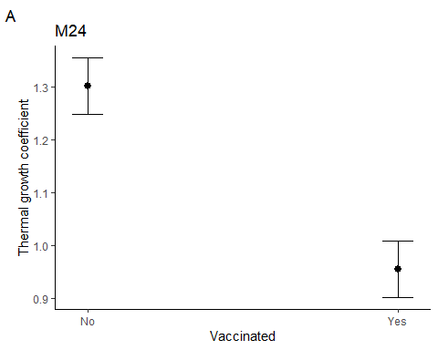
M24c.Fig_tempxO2 <- plot_model (M24c, type = "pred", terms =c ("Temp","O2")) +
labs (title = "M24", x = "Temperature (C)", y = "Thermal growth coefficient", tag ="A") +
theme (panel.background = element_rect (fill = "white", colour = "white")) +
theme (axis.line = element_line (colour="black"))
M24c.Fig_tempxO2
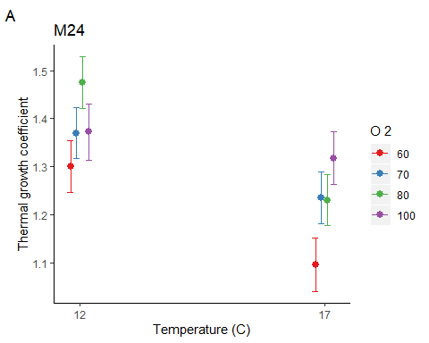
## TGC April 2017
# Apr 2017 - plot the data
M27c_dot_plot <- ggdotplot (Data11, "Group", "TGC", add = "mean_sd", size = 0.1) + PlotTheme +
theme (axis.text.x = element_text (angle = 45, hjust = 1))
M27c_dot_plot
## `stat_bindot()` using `bins = 30`. Pick better value with `binwidth`.
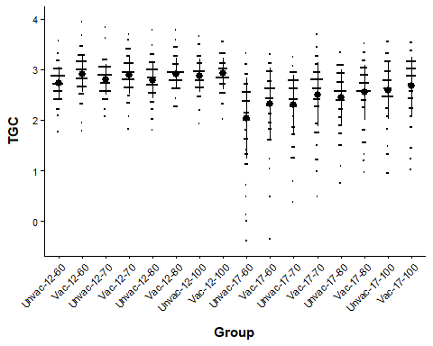
# Apr 2017 vaccinated x environment model
M27c <- glm (TGC ~ factor(O2) * Temp * Vaccinated + Sex, data = Data11)
M28c <- glm (TGC ~ factor(O2) * Temp + Vaccinated + Sex, data = Data11)
BIC (M27c, M28c)
## df BIC
## M27c 18 2035.161
## M28c 11 1992.069
par (mfrow =c (2,2))
plot (M28c) # bad qqplot
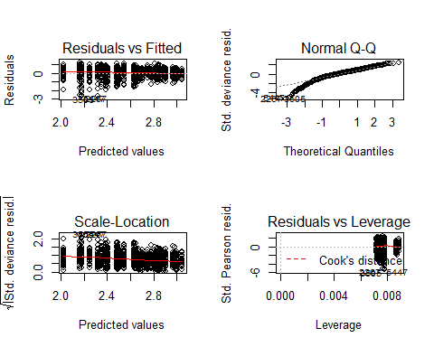
par (mfrow =c (1,1))
# logged data
M27clog <- glm (log (TGC+1) ~ factor(O2) * Temp * Vaccinated + Sex, data = Data11)
M28clog <- glm (log (TGC+1) ~ factor(O2) * Temp + Vaccinated + Sex, data = Data11)
BIC (M27clog, M28clog)
## df BIC
## M27clog 18 -664.0701
## M28clog 11 -706.6347
par (mfrow =c (2,2))
plot (M28clog) # bad qqplot
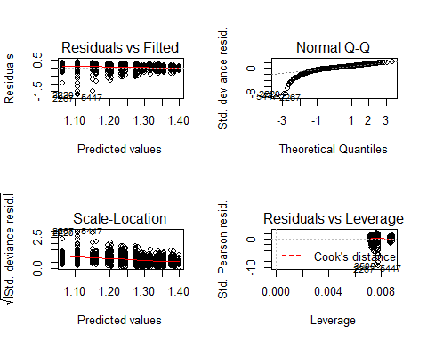
par (mfrow =c (1,1))
# tukey ladder or power
M27ctuk <- glm (transformTukey (TGC+1) ~ factor(O2) * Temp * Vaccinated + Sex, data = Data11)
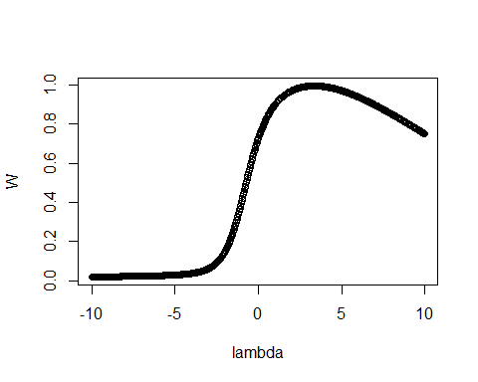
##
## lambda W Shapiro.p.value
## 534 3.325 0.9933 1.002e-05
##
## if (lambda > 0){TRANS = x ^ lambda}
## if (lambda == 0){TRANS = log(x)}
## if (lambda < 0){TRANS = -1 * x ^ lambda}
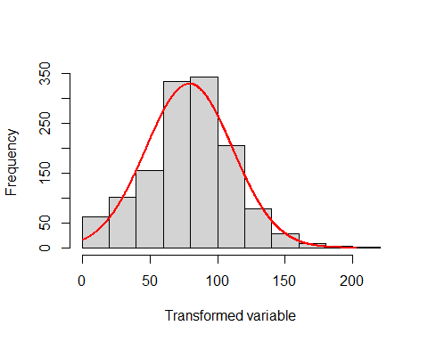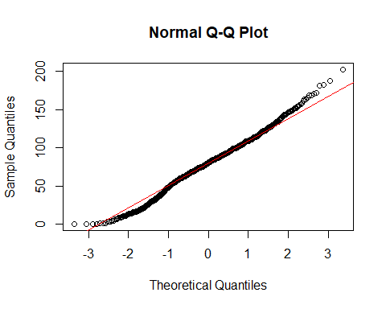
M28ctuk <- glm (transformTukey (TGC+1) ~ factor(O2) * Temp + Vaccinated + Sex, data = Data11)
##
## lambda W Shapiro.p.value
## 534 3.325 0.9933 1.002e-05
##
## if (lambda > 0){TRANS = x ^ lambda}
## if (lambda == 0){TRANS = log(x)}
## if (lambda < 0){TRANS = -1 * x ^ lambda}
BIC (M27ctuk, M28ctuk)
## df BIC
## M27ctuk 18 12728.34
## M28ctuk 11 12684.57
par (mfrow =c (2,2))
plot (M28ctuk) # looks good
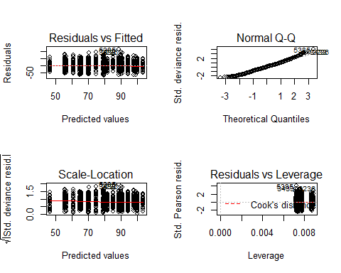
par (mfrow =c (1,1))
# box cox transformation
attach (Data11)
## The following object is masked _by_ .GlobalEnv:
##
## BoxSGR
## The following objects are masked from Data11 (pos = 3):
##
## Cataract, Day, Fish, Full_set, Group, Initial_mass, K_factor,
## Length, Loser, Mass, Mature, O2, Sex, SGR, Tank, Temp, TGC, Time,
## Vaccinated
BoxTGC <-boxcox (TGC+1 ~1, lambda = seq (-6, 6, 0.1)) # Box cox
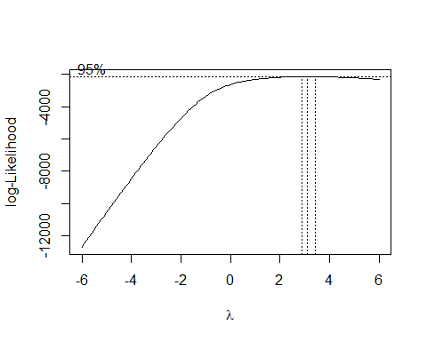
Cox <- data.frame (BoxTGC$x, BoxTGC$y) # Create a data frame with the results
Cox2 <- Cox [with (Cox, order (-Cox$BoxTGC.y)),] # Order the new data frame by decreasing y
Cox2 [1,] # Display the lambda with the greatest log likelihood
## BoxTGC.x BoxTGC.y
## 92 3.1 -2141.639
lambda <- Cox2 [1,"BoxTGC.x"] # Extract the lambda
Data11$BoxTGC <- (TGC+1^lambda-1) / lambda # Box-Cox transformation
M27cbox <- glm (BoxTGC ~ factor(O2) * Temp * Vaccinated + Sex, data = Data11)
M28cbox <- glm (BoxTGC ~ factor(O2) * Temp + Vaccinated + Sex, data = Data11)
BIC (M27cbox, M28cbox)
## df BIC
## M27cbox 18 -956.2664
## M28cbox 11 -999.3583
par (mfrow =c(2,2))
plot (M28cbox) # bad qqplot
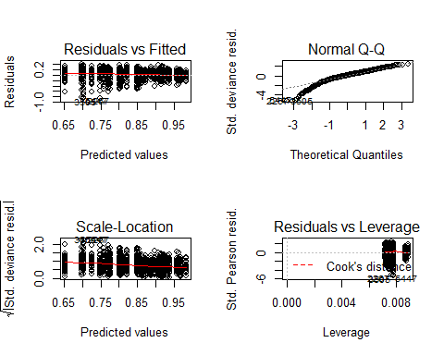
par (mfrow =c(1,1))
# tukey transformation output
Anova (M28ctuk, type = 3) # transformed looks the same as the non-transformed
## Analysis of Deviance Table (Type III tests)
##
## Response: transformTukey(TGC + 1)
## LR Chisq Df Pr(>Chisq)
## factor(O2) 3.193 3 0.3627667
## Temp 112.997 1 < 2.2e-16 ***
## Vaccinated 34.409 1 4.466e-09 ***
## Sex 33.797 1 6.117e-09 ***
## factor(O2):Temp 17.293 3 0.0006151 ***
## ---
## Signif. codes: 0 '***' 0.001 '**' 0.01 '*' 0.05 '.' 0.1 ' ' 1
Anova (M28c, type = 3) # no transformation
## Analysis of Deviance Table (Type III tests)
##
## Response: TGC
## LR Chisq Df Pr(>Chisq)
## factor(O2) 2.040 3 0.5641
## Temp 138.112 1 < 2.2e-16 ***
## Vaccinated 26.643 1 2.448e-07 ***
## Sex 30.492 1 3.352e-08 ***
## factor(O2):Temp 25.846 3 1.027e-05 ***
## ---
## Signif. codes: 0 '***' 0.001 '**' 0.01 '*' 0.05 '.' 0.1 ' ' 1
r.squaredGLMM (M28ctuk)
## R2m R2c
## [1,] 0.2099364 0.2099364
M28ctuk_null <- glm (transformTukey (TGC+1) ~1, data = Data11)
##
## lambda W Shapiro.p.value
## 534 3.325 0.9933 1.002e-05
##
## if (lambda > 0){TRANS = x ^ lambda}
## if (lambda == 0){TRANS = log(x)}
## if (lambda < 0){TRANS = -1 * x ^ lambda}
BIC (M28ctuk, M28ctuk_null)
## df BIC
## M28ctuk 11 12684.57
## M28ctuk_null 2 12933.31
M28ctuk.bt <- update (ref_grid (M28ctuk), tran = make.tran("power", param =c (3.325))) # back transform the model
lsmeans (M28ctuk.bt, pairwise ~ factor(O2) | Temp, type = "response") # O2 effect in 17C only
## Note: Use 'contrast(regrid(object), ...)' to obtain contrasts of back-transformed estimates
## $lsmeans
## Temp = 12:
## O2 response SE df asymp.LCL asymp.UCL
## 60 2.86 0.0283 Inf 2.80 2.91
## 70 2.87 0.0281 Inf 2.82 2.93
## 80 2.89 0.0286 Inf 2.83 2.94
## 100 2.93 0.0303 Inf 2.87 2.98
##
## Temp = 17:
## O2 response SE df asymp.LCL asymp.UCL
## 60 2.35 0.0408 Inf 2.27 2.43
## 70 2.52 0.0354 Inf 2.45 2.59
## 80 2.59 0.0334 Inf 2.52 2.65
## 100 2.73 0.0312 Inf 2.67 2.79
##
## Results are averaged over the levels of: Vaccinated, Sex
## Confidence level used: 0.95
## Intervals are back-transformed from the mu^3.325(mu + 1) scale
##
## $contrasts
## Temp = 12:
## contrast estimate SE df z.ratio p.value
## 60 - 70 -1.24 3.07 Inf -0.404 0.9778
## 60 - 80 -2.36 3.11 Inf -0.760 0.8722
## 60 - 100 -5.60 3.25 Inf -1.722 0.3121
## 70 - 80 -1.13 3.11 Inf -0.362 0.9838
## 70 - 100 -4.36 3.25 Inf -1.339 0.5378
## 80 - 100 -3.23 3.29 Inf -0.981 0.7601
##
## Temp = 17:
## contrast estimate SE df z.ratio p.value
## 60 - 70 -9.87 3.14 Inf -3.139 0.0092
## 60 - 80 -14.25 3.12 Inf -4.561 <.0001
## 60 - 100 -24.01 3.16 Inf -7.608 <.0001
## 70 - 80 -4.38 3.08 Inf -1.423 0.4850
## 70 - 100 -14.14 3.11 Inf -4.541 <.0001
## 80 - 100 -9.76 3.10 Inf -3.152 0.0088
##
## Results are averaged over the levels of: Vaccinated, Sex
## Note: contrasts are still on the mu^3.325(mu + 1) scale
## P value adjustment: tukey method for comparing a family of 4 estimates
lsmeans (M28ctuk.bt, pairwise ~ Vaccinated, type = "response") # Vaccinated grow quicker
## Note: Use 'contrast(regrid(object), ...)' to obtain contrasts of back-transformed estimates
## $lsmeans
## Vaccinated response SE df asymp.LCL asymp.UCL
## No 2.66 0.0165 Inf 2.63 2.69
## Yes 2.79 0.0150 Inf 2.76 2.82
##
## Results are averaged over the levels of: O2, Temp, Sex
## Confidence level used: 0.95
## Intervals are back-transformed from the mu^3.325(mu + 1) scale
##
## $contrasts
## contrast estimate SE df z.ratio p.value
## No - Yes -9.22 1.57 Inf -5.866 <.0001
##
## Results are averaged over the levels of: O2, Temp, Sex
## Note: contrasts are still on the mu^3.325(mu + 1) scale
lsmeans (M28ctuk.bt, pairwise ~ factor(O2) | Temp | Vaccinated, type = "response") #
## Note: Use 'contrast(regrid(object), ...)' to obtain contrasts of back-transformed estimates
## $lsmeans
## Temp = 12, Vaccinated = No:
## O2 response SE df asymp.LCL asymp.UCL
## 60 2.79 0.0313 Inf 2.73 2.85
## 70 2.81 0.0310 Inf 2.75 2.87
## 80 2.83 0.0315 Inf 2.76 2.89
## 100 2.87 0.0331 Inf 2.80 2.93
##
## Temp = 17, Vaccinated = No:
## O2 response SE df asymp.LCL asymp.UCL
## 60 2.26 0.0459 Inf 2.17 2.35
## 70 2.44 0.0397 Inf 2.36 2.52
## 80 2.51 0.0373 Inf 2.44 2.58
## 100 2.66 0.0346 Inf 2.59 2.73
##
## Temp = 12, Vaccinated = Yes:
## O2 response SE df asymp.LCL asymp.UCL
## 60 2.91 0.0290 Inf 2.86 2.97
## 70 2.93 0.0288 Inf 2.87 2.99
## 80 2.94 0.0292 Inf 2.89 3.00
## 100 2.98 0.0307 Inf 2.92 3.04
##
## Temp = 17, Vaccinated = Yes:
## O2 response SE df asymp.LCL asymp.UCL
## 60 2.43 0.0408 Inf 2.35 2.51
## 70 2.59 0.0358 Inf 2.52 2.66
## 80 2.66 0.0340 Inf 2.59 2.72
## 100 2.79 0.0317 Inf 2.73 2.85
##
## Results are averaged over the levels of: Sex
## Confidence level used: 0.95
## Intervals are back-transformed from the mu^3.325(mu + 1) scale
##
## $contrasts
## Temp = 12, Vaccinated = No:
## contrast estimate SE df z.ratio p.value
## 60 - 70 -1.24 3.07 Inf -0.404 0.9778
## 60 - 80 -2.36 3.11 Inf -0.760 0.8722
## 60 - 100 -5.60 3.25 Inf -1.722 0.3121
## 70 - 80 -1.13 3.11 Inf -0.362 0.9838
## 70 - 100 -4.36 3.25 Inf -1.339 0.5378
## 80 - 100 -3.23 3.29 Inf -0.981 0.7601
##
## Temp = 17, Vaccinated = No:
## contrast estimate SE df z.ratio p.value
## 60 - 70 -9.87 3.14 Inf -3.139 0.0092
## 60 - 80 -14.25 3.12 Inf -4.561 <.0001
## 60 - 100 -24.01 3.16 Inf -7.608 <.0001
## 70 - 80 -4.38 3.08 Inf -1.423 0.4850
## 70 - 100 -14.14 3.11 Inf -4.541 <.0001
## 80 - 100 -9.76 3.10 Inf -3.152 0.0088
##
## Temp = 12, Vaccinated = Yes:
## contrast estimate SE df z.ratio p.value
## 60 - 70 -1.24 3.07 Inf -0.404 0.9778
## 60 - 80 -2.36 3.11 Inf -0.760 0.8722
## 60 - 100 -5.60 3.25 Inf -1.722 0.3121
## 70 - 80 -1.13 3.11 Inf -0.362 0.9838
## 70 - 100 -4.36 3.25 Inf -1.339 0.5378
## 80 - 100 -3.23 3.29 Inf -0.981 0.7601
##
## Temp = 17, Vaccinated = Yes:
## contrast estimate SE df z.ratio p.value
## 60 - 70 -9.87 3.14 Inf -3.139 0.0092
## 60 - 80 -14.25 3.12 Inf -4.561 <.0001
## 60 - 100 -24.01 3.16 Inf -7.608 <.0001
## 70 - 80 -4.38 3.08 Inf -1.423 0.4850
## 70 - 100 -14.14 3.11 Inf -4.541 <.0001
## 80 - 100 -9.76 3.10 Inf -3.152 0.0088
##
## Results are averaged over the levels of: Sex
## Note: contrasts are still on the mu^3.325(mu + 1) scale
## P value adjustment: tukey method for comparing a family of 4 estimates
M28ctuk.Fig_Vaccinated <- plot_model (M28ctuk, type = "pred", terms =c ("Vaccinated")) +
labs (title = "M28ctuk", x = "Vaccinated", y = "Tukey transformed TGC", tag ="A") +
theme (panel.background = element_rect (fill = "white", colour = "white")) +
theme (axis.line = element_line (colour="black"))
M28ctuk.Fig_Vaccinated
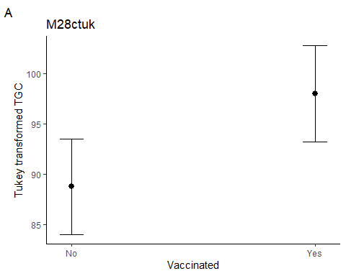
M28ctuk.Fig_tempxO2 <- plot_model (M28ctuk, type = "pred", terms =c ("Temp","O2"))+
labs (title = "M28ctuk", x = "Temperature (C)", y = "Tukey transformed specific growth rate", tag ="A")+
theme (panel.background = element_rect (fill = "white", colour = "white"))+
theme (axis.line = element_line (colour = "black"))
M28ctuk.Fig_tempxO2
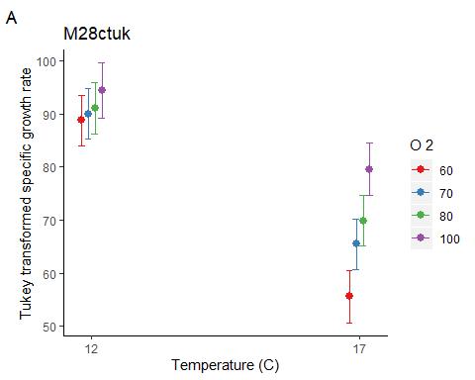
#### Within time point body mass analysis, but no mature or cataracts ####
## Body mass without mature or cataracts in November 2016
# extract the relevant data
Data12<-subset(Growth, Day==51 & Mature==0 & Cataract==0 & Mass>0 & Sex!="Undetermined")
#Nov 2016 - plot the data
M31_dot_plot <- ggdotplot(Data12, "Group", "Mass", add = "mean_sd", size = 0.1) + PlotTheme +
theme(axis.text.x = element_text(angle = 45, hjust = 1))
M31_dot_plot
## `stat_bindot()` using `bins = 30`. Pick better value with `binwidth`.
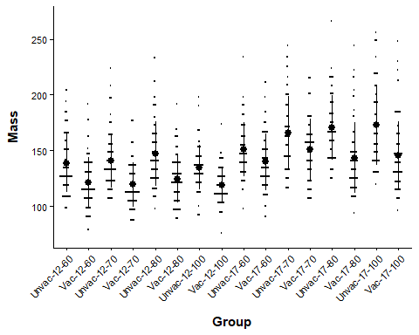
# Nov 2016 Vaccinated x environment model
M31 <- glm (log (Mass) ~ factor(O2) * Temp * Vaccinated + Sex, data = Data12)
M32 <- glm (log (Mass) ~ factor(O2) * Temp + Vaccinated + Sex, data = Data12)
BIC (M31, M32)
## df BIC
## M31 18 -710.5718
## M32 11 -748.1067
par (mfrow =c (2,2))
plot (M32)
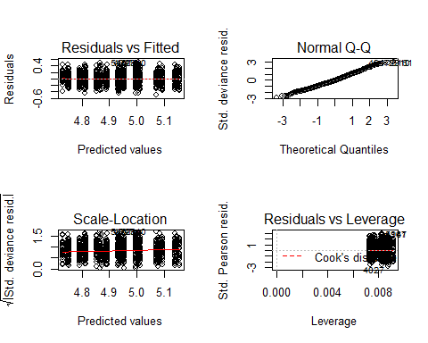
par (mfrow =c (1,1))
# model output
Anova (M9, type = 3) # model that includes mature/cataracts fish
## Analysis of Deviance Table (Type III tests)
##
## Response: log(Mass)
## LR Chisq Df Pr(>Chisq)
## factor(O2) 10.487 3 0.01485 *
## Temp 36.125 1 1.851e-09 ***
## Vaccinated 191.418 1 < 2.2e-16 ***
## Sex 57.537 1 3.316e-14 ***
## factor(O2):Temp 21.609 3 7.866e-05 ***
## ---
## Signif. codes: 0 '***' 0.001 '**' 0.01 '*' 0.05 '.' 0.1 ' ' 1
Anova (M32, type = 3) # model without mature/cataracts fish
## Analysis of Deviance Table (Type III tests)
##
## Response: log(Mass)
## LR Chisq Df Pr(>Chisq)
## factor(O2) 10.614 3 0.014006 *
## Temp 37.180 1 1.077e-09 ***
## Vaccinated 206.216 1 < 2.2e-16 ***
## Sex 39.916 1 2.652e-10 ***
## factor(O2):Temp 15.492 3 0.001441 **
## ---
## Signif. codes: 0 '***' 0.001 '**' 0.01 '*' 0.05 '.' 0.1 ' ' 1
r.squaredGLMM (M32)
## R2m R2c
## [1,] 0.3085394 0.3085394
M32_null <- glm (log (Mass) ~1, data = Data12)
BIC (M32, M32_null)
## df BIC
## M32 11 -748.1067
## M32_null 2 -350.1109
lsmeans (M32, pairwise ~ factor(O2) | Temp, type = "response") # O2 effects more apparent in 17C than 12C fish
## $lsmeans
## Temp = 12:
## O2 response SE df asymp.LCL asymp.UCL
## 60 128 1.68 Inf 125 131
## 70 128 1.70 Inf 125 132
## 80 133 1.79 Inf 130 137
## 100 125 1.84 Inf 122 129
##
## Temp = 17:
## O2 response SE df asymp.LCL asymp.UCL
## 60 144 2.09 Inf 140 148
## 70 157 2.31 Inf 152 161
## 80 154 2.18 Inf 150 158
## 100 155 2.21 Inf 151 160
##
## Results are averaged over the levels of: Vaccinated, Sex
## Confidence level used: 0.95
## Intervals are back-transformed from the log scale
##
## $contrasts
## Temp = 12:
## contrast ratio SE df z.ratio p.value
## 60 / 70 0.997 0.0186 Inf -0.155 0.9987
## 60 / 80 0.958 0.0180 Inf -2.273 0.1044
## 60 / 100 1.019 0.0201 Inf 0.965 0.7693
## 70 / 80 0.961 0.0181 Inf -2.113 0.1490
## 70 / 100 1.022 0.0202 Inf 1.109 0.6841
## 80 / 100 1.064 0.0212 Inf 3.107 0.0102
##
## Temp = 17:
## contrast ratio SE df z.ratio p.value
## 60 / 70 0.920 0.0190 Inf -4.055 0.0003
## 60 / 80 0.935 0.0189 Inf -3.315 0.0051
## 60 / 100 0.927 0.0188 Inf -3.737 0.0011
## 70 / 80 1.017 0.0208 Inf 0.817 0.8466
## 70 / 100 1.008 0.0207 Inf 0.386 0.9804
## 80 / 100 0.991 0.0199 Inf -0.437 0.9721
##
## Results are averaged over the levels of: Vaccinated, Sex
## P value adjustment: tukey method for comparing a family of 4 estimates
## Tests are performed on the log scale
lsmeans (M32, pairwise ~ Vaccinated, type = "response") # Unvaccinated are heavier
## $lsmeans
## Vaccinated response SE df asymp.LCL asymp.UCL
## No 150 1.076 Inf 148 152
## Yes 130 0.895 Inf 129 132
##
## Results are averaged over the levels of: O2, Temp, Sex
## Confidence level used: 0.95
## Intervals are back-transformed from the log scale
##
## $contrasts
## contrast ratio SE df z.ratio p.value
## No / Yes 1.15 0.0114 Inf 14.360 <.0001
##
## Results are averaged over the levels of: O2, Temp, Sex
## Tests are performed on the log scale
# Body mass without mature or cataracts April 2017
# extract the relevant data
Data13 <- subset (Growth, Day==198 & Mature==0 & Cataract==0 & Mass>0 & Sex!="Undetermined")
# Apr 2017 - plot the data
M33_dot_plot <- ggdotplot (Data13, "Group", "Mass", add = "mean_sd", size = 0.1) + PlotTheme +
theme (axis.text.x = element_text (angle = 45, hjust = 1))
M33_dot_plot
## `stat_bindot()` using `bins = 30`. Pick better value with `binwidth`.
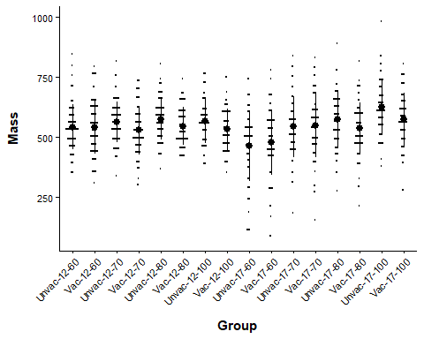
# Apr 2017 Vaccinated x environment model
M33 <- glm (Mass ~ factor(O2) * Temp * Vaccinated + Sex, data = Data13)
M34 <- glm (Mass ~ factor(O2) * Temp + Vaccinated + Sex, data = Data13)
BIC (M33, M34)
## df BIC
## M33 18 15197.09
## M34 11 15159.45
par (mfrow =c (2,2))
plot (M34) # qqplot has a tail
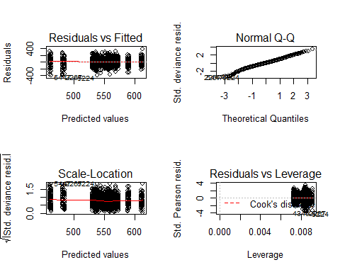
par (mfrow =c (1,1))
#tukey ladder of powers
M33tuk <- glm (transformTukey (Mass) ~ factor(O2) * Temp * Vaccinated + Sex, data = Data13)
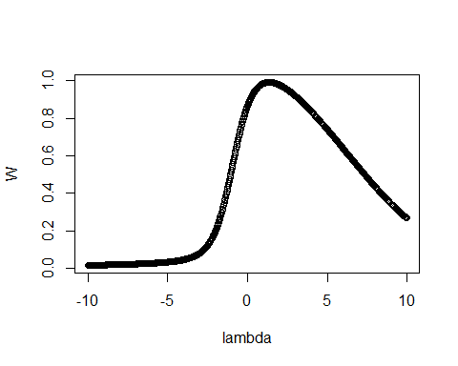
##
## lambda W Shapiro.p.value
## 455 1.35 0.9925 5.991e-06
##
## if (lambda > 0){TRANS = x ^ lambda}
## if (lambda == 0){TRANS = log(x)}
## if (lambda < 0){TRANS = -1 * x ^ lambda}
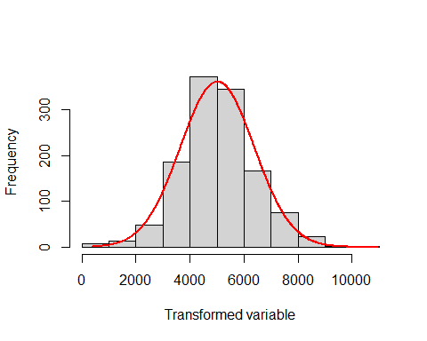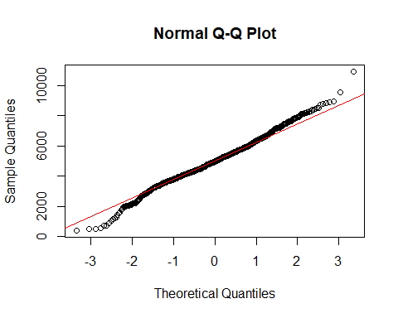
M34tuk <- glm (transformTukey (Mass) ~ factor(O2) * Temp + Vaccinated + Sex, data = Data13)
##
## lambda W Shapiro.p.value
## 455 1.35 0.9925 5.991e-06
##
## if (lambda > 0){TRANS = x ^ lambda}
## if (lambda == 0){TRANS = log(x)}
## if (lambda < 0){TRANS = -1 * x ^ lambda}
BIC (M33tuk, M34tuk)
## df BIC
## M33tuk 18 21357.81
## M34tuk 11 21320.57
par (mfrow =c (2,2))
plot (M34tuk) # Improved qqplot
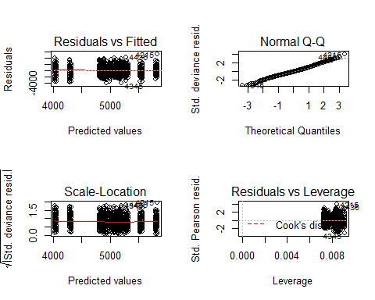
par (mfrow =c (1,1))
Anova (M13tuk, type = 3) # model that includes mature/cataracts fish
## Analysis of Deviance Table (Type III tests)
##
## Response: transformTukey(Mass)
## LR Chisq Df Pr(>Chisq)
## factor(O2) 2.474 3 0.479954
## Temp 39.879 1 2.701e-10 ***
## Vaccinated 6.955 1 0.008357 **
## Sex 1.441 1 0.229972
## factor(O2):Temp 39.379 3 1.443e-08 ***
## ---
## Signif. codes: 0 '***' 0.001 '**' 0.01 '*' 0.05 '.' 0.1 ' ' 1
Anova (M34tuk, type = 3) # model without mature/cataracts fish transformed
## Analysis of Deviance Table (Type III tests)
##
## Response: transformTukey(Mass)
## LR Chisq Df Pr(>Chisq)
## factor(O2) 2.587 3 0.4597814
## Temp 27.749 1 1.381e-07 ***
## Vaccinated 12.448 1 0.0004184 ***
## Sex 0.156 1 0.6931719
## factor(O2):Temp 44.668 3 1.089e-09 ***
## ---
## Signif. codes: 0 '***' 0.001 '**' 0.01 '*' 0.05 '.' 0.1 ' ' 1
Anova (M34, type = 3) # model without mature/cataracts fish transformed, but not transformed
## Analysis of Deviance Table (Type III tests)
##
## Response: Mass
## LR Chisq Df Pr(>Chisq)
## factor(O2) 2.810 3 0.4218095
## Temp 32.411 1 1.248e-08 ***
## Vaccinated 11.814 1 0.0005879 ***
## Sex 0.172 1 0.6785771
## factor(O2):Temp 46.608 3 4.211e-10 ***
## ---
## Signif. codes: 0 '***' 0.001 '**' 0.01 '*' 0.05 '.' 0.1 ' ' 1
r.squaredGLMM (M34tuk)
## R2m R2c
## [1,] 0.08527485 0.08527485
M34tuk_null <- glm (transformTukey (Mass) ~1, data = Data13)
##
## lambda W Shapiro.p.value
## 455 1.35 0.9925 5.991e-06
##
## if (lambda > 0){TRANS = x ^ lambda}
## if (lambda == 0){TRANS = log(x)}
## if (lambda < 0){TRANS = -1 * x ^ lambda}
BIC (M34tuk, M34tuk_null)
## df BIC
## M34tuk 11 21320.57
## M34tuk_null 2 21367.43
lsmeans (M34tuk, pairwise ~ factor(O2) | Temp) # O2 effect only in 17C only
## Note: Use 'contrast(regrid(object), ...)' to obtain contrasts of back-transformed estimates
## $lsmeans
## Temp = 12:
## O2 lsmean SE df asymp.LCL asymp.UCL
## 60 4950 99.4 Inf 4756 5145
## 70 4999 99.7 Inf 4803 5194
## 80 5170 102.4 Inf 4969 5370
## 100 5037 111.2 Inf 4819 5255
##
## Temp = 17:
## O2 lsmean SE df asymp.LCL asymp.UCL
## 60 4175 108.5 Inf 3963 4388
## 70 5045 110.5 Inf 4828 5261
## 80 5130 107.1 Inf 4920 5340
## 100 5678 107.4 Inf 5467 5888
##
## Results are averaged over the levels of: Vaccinated, Sex
## Results are given on the transformTukey (not the response) scale.
## Confidence level used: 0.95
##
## $contrasts
## Temp = 12:
## contrast estimate SE df z.ratio p.value
## 60 - 70 -48.5 141 Inf -0.344 0.9860
## 60 - 80 -219.3 143 Inf -1.537 0.4151
## 60 - 100 -86.8 149 Inf -0.582 0.9375
## 70 - 80 -170.8 143 Inf -1.196 0.6295
## 70 - 100 -38.3 149 Inf -0.257 0.9941
## 80 - 100 132.5 151 Inf 0.877 0.8168
##
## Temp = 17:
## contrast estimate SE df z.ratio p.value
## 60 - 70 -869.5 155 Inf -5.617 <.0001
## 60 - 80 -954.7 152 Inf -6.265 <.0001
## 60 - 100 -1502.2 153 Inf -9.842 <.0001
## 70 - 80 -85.2 154 Inf -0.554 0.9455
## 70 - 100 -632.7 154 Inf -4.107 0.0002
## 80 - 100 -547.6 152 Inf -3.612 0.0017
##
## Results are averaged over the levels of: Vaccinated, Sex
## Note: contrasts are still on the transformTukey scale
## P value adjustment: tukey method for comparing a family of 4 estimates
lsmeans (M34tuk, pairwise ~ Vaccinated) # Vaccinated fish weigh less
## Note: Use 'contrast(regrid(object), ...)' to obtain contrasts of back-transformed estimates
## $lsmeans
## Vaccinated lsmean SE df asymp.LCL asymp.UCL
## No 5155 53.9 Inf 5049 5260
## Yes 4891 51.9 Inf 4790 4993
##
## Results are averaged over the levels of: O2, Temp, Sex
## Results are given on the transformTukey (not the response) scale.
## Confidence level used: 0.95
##
## $contrasts
## contrast estimate SE df z.ratio p.value
## No - Yes 263 74.6 Inf 3.528 0.0004
##
## Results are averaged over the levels of: O2, Temp, Sex
## Note: contrasts are still on the transformTukey scale
#### Within time point SGR analysis, but no mature/cataracts ####
## SGR without mature or cataracts fish in November 2016
# extract the relevant data
Data16 <- subset (Growth, Day==51 & Mature==0 & Cataract==0 & Mass>0 & Initial_mass>0 & Sex!="Undetermined")
# Nov 2016 - plot the data
M39_dot_plot <- ggdotplot(Data16, "Group", "SGR", add = "mean_sd", size = 0.1) + PlotTheme +
theme(axis.text.x = element_text(angle = 45, hjust = 1))
M39_dot_plot
## `stat_bindot()` using `bins = 30`. Pick better value with `binwidth`.
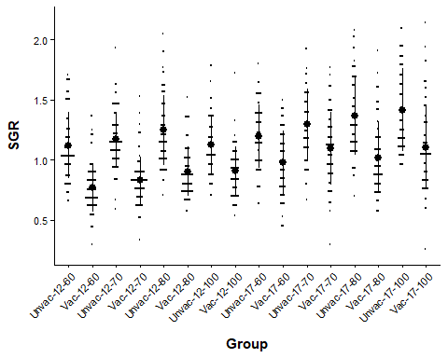
# Nov 2016 Vaccinated x environment model
M39 <- glm (SGR ~ factor(O2) * Temp * Vaccinated + Initial_mass + Sex, data = Data16)
M40 <- glm (SGR ~ factor(O2) * Temp + Vaccinated + Initial_mass + Sex, data = Data16)
BIC (M39, M40)
## df BIC
## M39 19 294.3634
## M40 12 262.5309
par (mfrow =c (2,2))
plot (M40)
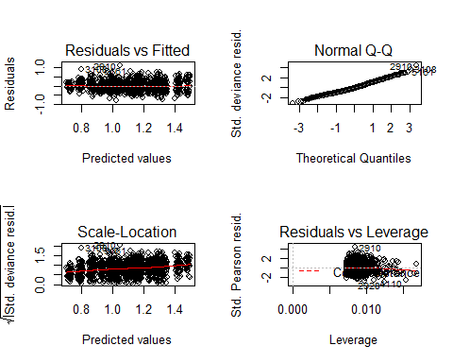
par (mfrow =c (1,1))
# model output
Anova (M24, type = 3) # model that includes mature/deformed/cataracts fish
## Analysis of Deviance Table (Type III tests)
##
## Response: SGR
## LR Chisq Df Pr(>Chisq)
## factor(O2) 20.80 3 0.0001161 ***
## Temp 24.94 1 5.918e-07 ***
## Vaccinated 379.41 1 < 2.2e-16 ***
## Initial_mass 1.27 1 0.2597865
## Sex 127.31 1 < 2.2e-16 ***
## factor(O2):Temp 16.94 3 0.0007256 ***
## ---
## Signif. codes: 0 '***' 0.001 '**' 0.01 '*' 0.05 '.' 0.1 ' ' 1
Anova (M40, type = 3) # model without mature/deformed/cataracts fish
## Analysis of Deviance Table (Type III tests)
##
## Response: SGR
## LR Chisq Df Pr(>Chisq)
## factor(O2) 21.65 3 7.704e-05 ***
## Temp 25.51 1 4.392e-07 ***
## Vaccinated 404.78 1 < 2.2e-16 ***
## Initial_mass 0.89 1 0.34604
## Sex 90.27 1 < 2.2e-16 ***
## factor(O2):Temp 10.81 3 0.01278 *
## ---
## Signif. codes: 0 '***' 0.001 '**' 0.01 '*' 0.05 '.' 0.1 ' ' 1
r.squaredGLMM (M40)
## R2m R2c
## [1,] 0.3543954 0.3543954
M40_null <- glm (SGR~1, data = Data16)
BIC (M40, M40_null)
## df BIC
## M40 12 262.5309
## M40_null 2 739.6045
lsmeans (M40, pairwise ~ factor(O2) | Temp)
## $lsmeans
## Temp = 12:
## O2 lsmean SE df asymp.LCL asymp.UCL
## 60 0.946 0.0197 Inf 0.908 0.985
## 70 1.003 0.0200 Inf 0.964 1.043
## 80 1.077 0.0202 Inf 1.037 1.117
## 100 1.016 0.0224 Inf 0.972 1.060
##
## Temp = 17:
## O2 lsmean SE df asymp.LCL asymp.UCL
## 60 1.095 0.0218 Inf 1.052 1.138
## 70 1.214 0.0224 Inf 1.170 1.257
## 80 1.199 0.0214 Inf 1.157 1.241
## 100 1.262 0.0214 Inf 1.221 1.304
##
## Results are averaged over the levels of: Vaccinated, Sex
## Confidence level used: 0.95
##
## $contrasts
## Temp = 12:
## contrast estimate SE df z.ratio p.value
## 60 - 70 -0.0571 0.0280 Inf -2.036 0.1749
## 60 - 80 -0.1306 0.0282 Inf -4.635 <.0001
## 60 - 100 -0.0693 0.0297 Inf -2.331 0.0910
## 70 - 80 -0.0736 0.0282 Inf -2.607 0.0452
## 70 - 100 -0.0123 0.0297 Inf -0.413 0.9762
## 80 - 100 0.0613 0.0298 Inf 2.056 0.1679
##
## Temp = 17:
## contrast estimate SE df z.ratio p.value
## 60 - 70 -0.1186 0.0310 Inf -3.826 0.0008
## 60 - 80 -0.1044 0.0303 Inf -3.443 0.0032
## 60 - 100 -0.1674 0.0304 Inf -5.508 <.0001
## 70 - 80 0.0142 0.0306 Inf 0.464 0.9669
## 70 - 100 -0.0489 0.0308 Inf -1.589 0.3850
## 80 - 100 -0.0631 0.0301 Inf -2.097 0.1540
##
## Results are averaged over the levels of: Vaccinated, Sex
## P value adjustment: tukey method for comparing a family of 4 estimates
## SGR without deformed fish in April 2017
# extract the relevant data
Data17 <- subset (Growth, Day==198 & Mature==0 & Cataract==0 & Mass>0 & Initial_mass>0 & Sex!="Undetermined")
# Apr 2017 - plot the data
M41_dot_plot <- ggdotplot(Data17, "Group", "SGR", add = "mean_sd", size = 0.1) + PlotTheme +
theme(axis.text.x = element_text(angle = 45, hjust = 1))
M41_dot_plot
## `stat_bindot()` using `bins = 30`. Pick better value with `binwidth`.
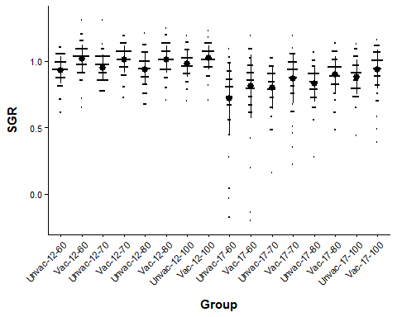
# compare the models
M41 <- glm (SGR ~ factor(O2) * Temp * Vaccinated + Initial_mass + Sex, data = Data17)
M42 <- glm (SGR ~ factor(O2) * Temp + Vaccinated + Initial_mass + Sex, data = Data17)
BIC (M41, M42)
## df BIC
## M41 19 -1264.522
## M42 12 -1309.135
par (mfrow =c (2,2))
plot (M42) # bad qqplot
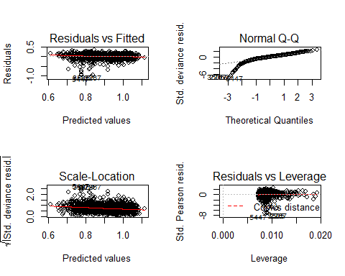
par (mfrow =c (1,1))
# tukey ladder of powers
M41tuk <- glm (transformTukey (SGR+1) ~ factor(O2) * Temp * Vaccinated + Initial_mass + Sex, data = Data17)
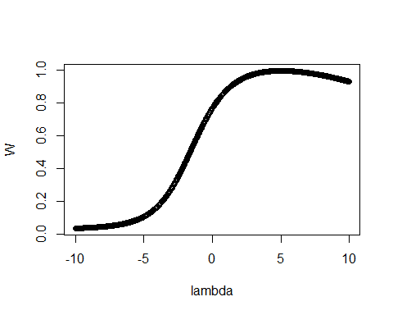
##
## lambda W Shapiro.p.value
## 600 4.975 0.9971 0.02151
##
## if (lambda > 0){TRANS = x ^ lambda}
## if (lambda == 0){TRANS = log(x)}
## if (lambda < 0){TRANS = -1 * x ^ lambda}
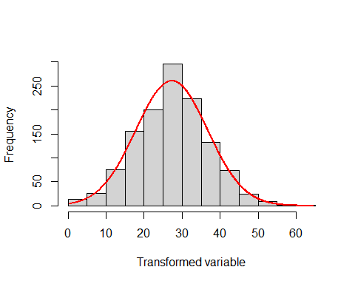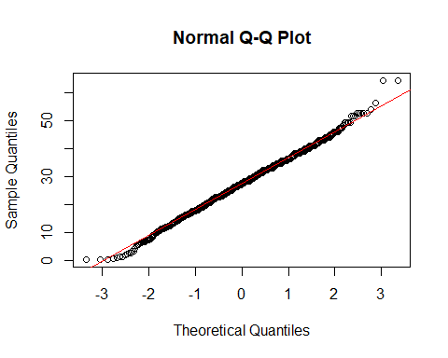
M42tuk <- glm (transformTukey (SGR+1) ~ factor(O2) * Temp + Vaccinated + Initial_mass + Sex, data = Data17)
##
## lambda W Shapiro.p.value
## 600 4.975 0.9971 0.02151
##
## if (lambda > 0){TRANS = x ^ lambda}
## if (lambda == 0){TRANS = log(x)}
## if (lambda < 0){TRANS = -1 * x ^ lambda}
BIC (M41tuk, M42tuk)
## df BIC
## M41tuk 19 8567.826
## M42tuk 12 8523.982
par (mfrow =c (2,2))
plot (M42tuk)
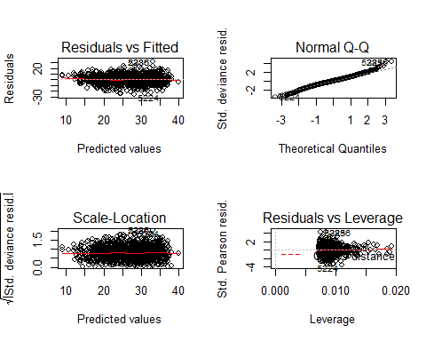
par (mfrow =c (1,1))
# model output
Anova (M28tuk, type = 3) # model that includes mature/cataracts fish
## Analysis of Deviance Table (Type III tests)
##
## Response: transformTukey(SGR + 1)
## LR Chisq Df Pr(>Chisq)
## factor(O2) 3.153 3 0.3686
## Temp 126.076 1 < 2.2e-16 ***
## Vaccinated 28.025 1 1.197e-07 ***
## Initial_mass 248.428 1 < 2.2e-16 ***
## Sex 16.167 1 5.799e-05 ***
## factor(O2):Temp 26.649 3 6.975e-06 ***
## ---
## Signif. codes: 0 '***' 0.001 '**' 0.01 '*' 0.05 '.' 0.1 ' ' 1
Anova (M42tuk, type = 3) # model without mature/cataracts fish
## Analysis of Deviance Table (Type III tests)
##
## Response: transformTukey(SGR + 1)
## LR Chisq Df Pr(>Chisq)
## factor(O2) 3.385 3 0.336046
## Temp 112.225 1 < 2.2e-16 ***
## Vaccinated 30.596 1 3.177e-08 ***
## Initial_mass 196.023 1 < 2.2e-16 ***
## Sex 7.317 1 0.006831 **
## factor(O2):Temp 30.585 3 1.039e-06 ***
## ---
## Signif. codes: 0 '***' 0.001 '**' 0.01 '*' 0.05 '.' 0.1 ' ' 1
Anova (M42, type = 3) # model without mature/cataracts fish, but not transformed
## Analysis of Deviance Table (Type III tests)
##
## Response: SGR
## LR Chisq Df Pr(>Chisq)
## factor(O2) 1.924 3 0.588359
## Temp 136.089 1 < 2.2e-16 ***
## Vaccinated 20.907 1 4.822e-06 ***
## Initial_mass 115.556 1 < 2.2e-16 ***
## Sex 6.702 1 0.009632 **
## factor(O2):Temp 44.767 3 1.037e-09 ***
## ---
## Signif. codes: 0 '***' 0.001 '**' 0.01 '*' 0.05 '.' 0.1 ' ' 1
r.squaredGLMM (M42tuk)
## R2m R2c
## [1,] 0.3859309 0.3859309
M42tuk_null <- glm (transformTukey (SGR+1) ~1, data = Data17)
##
## lambda W Shapiro.p.value
## 600 4.975 0.9971 0.02151
##
## if (lambda > 0){TRANS = x ^ lambda}
## if (lambda == 0){TRANS = log(x)}
## if (lambda < 0){TRANS = -1 * x ^ lambda}
BIC (M42tuk, M42tuk_null)
## df BIC
## M42tuk 12 8523.982
## M42tuk_null 2 9058.447
lsmeans (M42tuk, pairwise ~ factor(O2) | Temp) # O2 effect only in 17C only
## Note: Use 'contrast(regrid(object), ...)' to obtain contrasts of back-transformed estimates
## $lsmeans
## Temp = 12:
## O2 lsmean SE df asymp.LCL asymp.UCL
## 60 29.1 0.571 Inf 28.0 30.2
## 70 29.5 0.573 Inf 28.4 30.7
## 80 29.9 0.582 Inf 28.8 31.1
## 100 30.6 0.642 Inf 29.4 31.9
##
## Temp = 17:
## O2 lsmean SE df asymp.LCL asymp.UCL
## 60 20.2 0.620 Inf 18.9 21.4
## 70 24.1 0.643 Inf 22.8 25.3
## 80 25.0 0.618 Inf 23.8 26.2
## 100 28.3 0.624 Inf 27.1 29.5
##
## Results are averaged over the levels of: Vaccinated, Sex
## Results are given on the transformTukey(mu + 1) (not the response) scale.
## Confidence level used: 0.95
##
## $contrasts
## Temp = 12:
## contrast estimate SE df z.ratio p.value
## 60 - 70 -0.415 0.797 Inf -0.521 0.9541
## 60 - 80 -0.799 0.809 Inf -0.987 0.7566
## 60 - 100 -1.499 0.845 Inf -1.774 0.2860
## 70 - 80 -0.384 0.810 Inf -0.473 0.9649
## 70 - 100 -1.084 0.846 Inf -1.280 0.5755
## 80 - 100 -0.700 0.859 Inf -0.815 0.8475
##
## Temp = 17:
## contrast estimate SE df z.ratio p.value
## 60 - 70 -3.902 0.887 Inf -4.400 0.0001
## 60 - 80 -4.854 0.871 Inf -5.576 <.0001
## 60 - 100 -8.155 0.874 Inf -9.329 <.0001
## 70 - 80 -0.952 0.871 Inf -1.092 0.6942
## 70 - 100 -4.252 0.873 Inf -4.873 <.0001
## 80 - 100 -3.300 0.859 Inf -3.842 0.0007
##
## Results are averaged over the levels of: Vaccinated, Sex
## Note: contrasts are still on the transformTukey(mu + 1) scale
## P value adjustment: tukey method for comparing a family of 4 estimates
lsmeans (M42tuk, pairwise ~ Vaccinated) # Vaccinated grow quicker
## Note: Use 'contrast(regrid(object), ...)' to obtain contrasts of back-transformed estimates
## $lsmeans
## Vaccinated lsmean SE df asymp.LCL asymp.UCL
## No 25.8 0.319 Inf 25.2 26.5
## Yes 28.4 0.303 Inf 27.8 28.9
##
## Results are averaged over the levels of: O2, Temp, Sex
## Results are given on the transformTukey(mu + 1) (not the response) scale.
## Confidence level used: 0.95
##
## $contrasts
## contrast estimate SE df z.ratio p.value
## No - Yes -2.51 0.453 Inf -5.531 <.0001
##
## Results are averaged over the levels of: O2, Temp, Sex
## Note: contrasts are still on the transformTukey(mu + 1) scale
#### Cataract and growth ####
## Body mass
# extract the relevant data
Data18 <- subset (Growth, Vaccinated=="No" & Temp==17 & Full_set==1 & Mature==0 & Sex!="Undetermined")
table(Data18$Cataract<0.5)
##
## FALSE TRUE
## 96 825
str(Data18)
## 'data.frame': 921 obs. of 19 variables:
## $ Fish : int 15 24 25 26 35 37 39 54 64 67 ...
## $ Tank : Factor w/ 16 levels "1","2","3","4",..: 16 16 16 13 13 10 16 12 16 13 ...
## $ Full_set : int 1 1 1 1 1 1 1 1 1 1 ...
## $ Day : int 0 0 0 0 0 0 0 0 0 0 ...
## $ Time : int 0 0 0 0 0 0 0 0 0 0 ...
## $ Vaccinated : Factor w/ 2 levels "No","Yes": 1 1 1 1 1 1 1 1 1 1 ...
## $ Temp : Factor w/ 2 levels "12","17": 2 2 2 2 2 2 2 2 2 2 ...
## $ O2 : int 60 60 60 70 70 100 60 80 60 70 ...
## $ Group : Factor w/ 16 levels "Unvac-12-60",..: 9 9 9 11 11 15 9 13 9 11 ...
## $ Length : num 19 19 18 19.5 19 21 19 19 19.5 19.5 ...
## $ Mass : int 80 88 72 84 82 104 82 82 88 83 ...
## $ K_factor : num 1.17 1.28 1.23 1.13 1.2 1.12 1.2 1.2 1.19 1.12 ...
## $ Initial_mass: int NA NA NA NA NA NA NA NA NA NA ...
## $ SGR : num NA NA NA NA NA NA NA NA NA NA ...
## $ TGC : num NA NA NA NA NA NA NA NA NA NA ...
## $ Sex : Factor w/ 3 levels "Female","Male",..: 1 1 1 1 1 1 1 1 1 1 ...
## $ Mature : int 0 0 0 0 0 0 0 0 0 0 ...
## $ Loser : int 0 0 0 0 0 0 0 0 0 0 ...
## $ Cataract : int 0 0 1 0 0 0 0 0 0 0 ...
Data18$Day <- as.numeric(Data18$Day)
Data18$Cataract <- as.factor(Data18$Cataract)
Data18$Time <- as.factor(Data18$Time)
Data18$Sex <- factor(Data18$Sex)
Data18$Group <- factor(Data18$Group)
str(Data18)
## 'data.frame': 921 obs. of 19 variables:
## $ Fish : int 15 24 25 26 35 37 39 54 64 67 ...
## $ Tank : Factor w/ 16 levels "1","2","3","4",..: 16 16 16 13 13 10 16 12 16 13 ...
## $ Full_set : int 1 1 1 1 1 1 1 1 1 1 ...
## $ Day : num 0 0 0 0 0 0 0 0 0 0 ...
## $ Time : Factor w/ 3 levels "0","1","2": 1 1 1 1 1 1 1 1 1 1 ...
## $ Vaccinated : Factor w/ 2 levels "No","Yes": 1 1 1 1 1 1 1 1 1 1 ...
## $ Temp : Factor w/ 2 levels "12","17": 2 2 2 2 2 2 2 2 2 2 ...
## $ O2 : int 60 60 60 70 70 100 60 80 60 70 ...
## $ Group : Factor w/ 4 levels "Unvac-17-60",..: 1 1 1 2 2 4 1 3 1 2 ...
## $ Length : num 19 19 18 19.5 19 21 19 19 19.5 19.5 ...
## $ Mass : int 80 88 72 84 82 104 82 82 88 83 ...
## $ K_factor : num 1.17 1.28 1.23 1.13 1.2 1.12 1.2 1.2 1.19 1.12 ...
## $ Initial_mass: int NA NA NA NA NA NA NA NA NA NA ...
## $ SGR : num NA NA NA NA NA NA NA NA NA NA ...
## $ TGC : num NA NA NA NA NA NA NA NA NA NA ...
## $ Sex : Factor w/ 2 levels "Female","Male": 1 1 1 1 1 1 1 1 1 1 ...
## $ Mature : int 0 0 0 0 0 0 0 0 0 0 ...
## $ Loser : int 0 0 0 0 0 0 0 0 0 0 ...
## $ Cataract : Factor w/ 2 levels "0","1": 1 1 2 1 1 1 1 1 1 1 ...
# summary table
Cataract_summary <- data_summary (Data18, varname="Mass", groupnames =c ("Cataract", "Time", "Group"))
## Loading required package: plyr
## Warning: package 'plyr' was built under R version 3.6.2
##
## Attaching package: 'plyr'
## The following object is masked from 'package:ggpubr':
##
## mutate
# line plots
Cataract_mass_line <- ggplot (Cataract_summary, aes (x = Time, y = Mass, group = Cataract, color = Cataract)) + PlotTheme +
geom_line() +
geom_errorbar (aes (ymin = Mass-sd, ymax = Mass+sd), width =.2, position = position_dodge(.1)) +
labs (title = "Cataracts", x = "Time", y = "Mass")
Cataract_mass_line + facet_grid (. ~ Group)
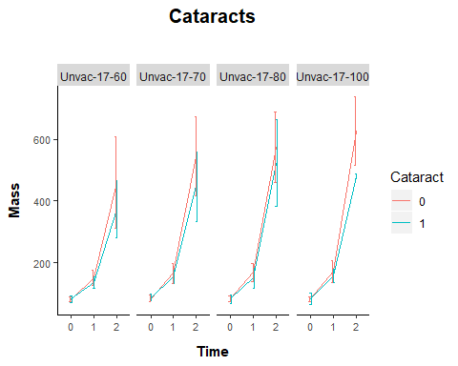
# compare models
M43 <-lme (Mass ~ Cataract * Time + Sex, random = ~1 | Group / Fish, method = "ML", data = Data18)
M44 <-lme (Mass ~ Cataract + Time + Sex, random = ~1 | Group / Fish, method ="ML", data = Data18)
BIC (M43, M44)
## df BIC
## M43 10 10709.71
## M44 8 10724.51
plot (M43) # Heteroskedasticity
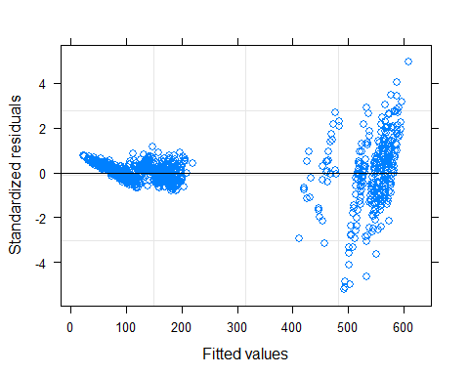
M43log <- lme (log (Mass) ~ Cataract * Time + Sex, random = ~1 | Group / Fish, method = "ML", data = Data18)
M44log <- lme (log (Mass) ~ Cataract + Time + Sex, random = ~1 | Group / Fish, method = "ML", data = Data18)
BIC (M43log, M44log)
## df BIC
## M43log 10 -232.2886
## M44log 8 -227.6525
plot ((M43log), grid = FALSE, main = "Mass, cataract")
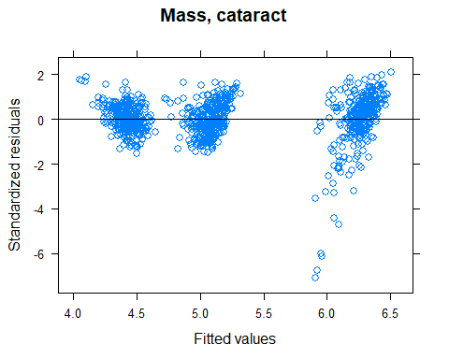
plot (M43log, resid(., type = "p") ~ fitted(.) | Cataract, ylim =c (-5,5), abline = 0, grid = FALSE, main = "Mass, cataract")
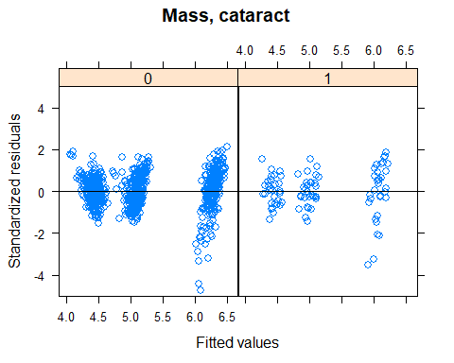
plot (M43log, resid(., type = "p") ~ fitted(.) | Time, ylim =c (-5,5), abline = 0, grid = FALSE, main = "Mass, cataract")
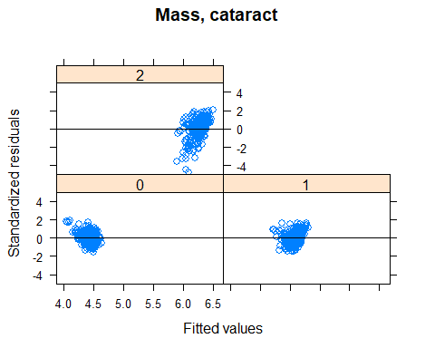
plot (M43log, resid(., type = "p") ~ fitted(.) | Sex, ylim =c (-5,5), abline = 0, grid = FALSE, main = "Mass, cataract")
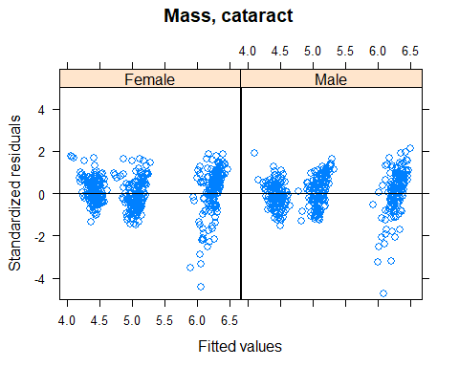
plot (M43log, resid(., type = "p") ~ fitted(.) | Group, ylim =c (-5,5), abline = 0, grid = FALSE, main = "Mass, cataract")
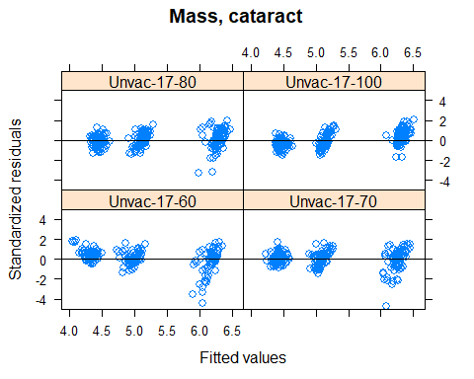
qqPlot (resid (M43log), grid = FALSE, envelope = .95, line = "quartiles")
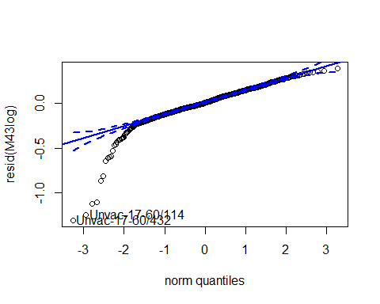
## Unvac-17-60/432 Unvac-17-60/114
## 376 345
qqPlot (resid (M43log), grid = FALSE, groups = Data18$Cataract, envelope =.95, line = "quartiles")
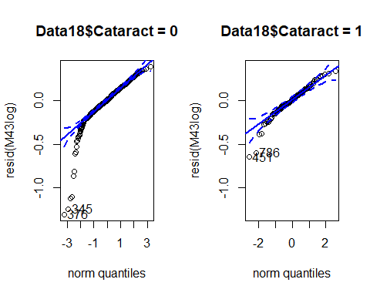
qqPlot (resid (M43log), grid = FALSE, groups = Data18$Time, envelope =.95, line = "quartiles")
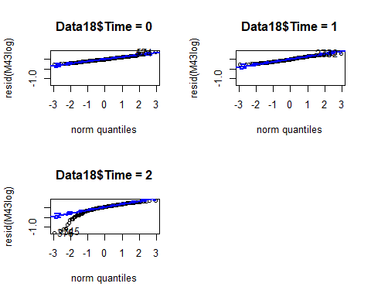
qqPlot (resid (M43log), grid = FALSE, groups = Data18$Sex, envelope =.95, line = "quartiles")
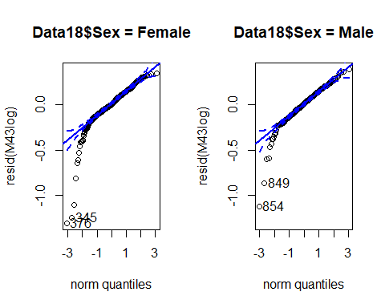
qqPlot (resid (M43log), grid = FALSE, groups = Data18$Group, envelope =.95, line = "quartiles")
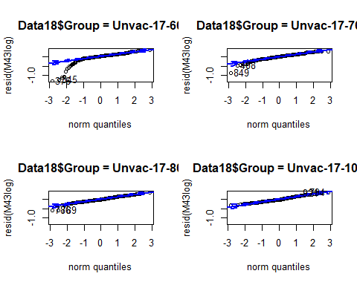
# model output
Anova (M43log, type = 3) # log transformation
## Analysis of Deviance Table (Type III tests)
##
## Response: log(Mass)
## Chisq Df Pr(>Chisq)
## (Intercept) 16364.0073 1 < 2.2e-16 ***
## Cataract 0.3482 1 0.55514
## Time 14455.4451 2 < 2.2e-16 ***
## Sex 4.1787 1 0.04093 *
## Cataract:Time 18.5621 2 9.318e-05 ***
## ---
## Signif. codes: 0 '***' 0.001 '**' 0.01 '*' 0.05 '.' 0.1 ' ' 1
Anova (M43, type = 3) # no transformation
## Analysis of Deviance Table (Type III tests)
##
## Response: Mass
## Chisq Df Pr(>Chisq)
## (Intercept) 40.3515 1 2.121e-10 ***
## Cataract 0.2274 1 0.6334
## Time 6121.2981 2 < 2.2e-16 ***
## Sex 3.0958 1 0.0785 .
## Cataract:Time 29.1195 2 4.751e-07 ***
## ---
## Signif. codes: 0 '***' 0.001 '**' 0.01 '*' 0.05 '.' 0.1 ' ' 1
r.squaredGLMM (M43log)
## R2m R2c
## [1,] 0.9235273 0.9462831
M43log_null <- lme (log (Mass) ~1, random = ~1 | Group / Fish, method = "ML", data = Data18)
BIC (M43log, M43log_null)
## df BIC
## M43log 10 -232.2886
## M43log_null 4 2206.3743
lsmeans (M43log, pairwise ~ Cataract | Time, type = "response") # Fish with cataracts smaller from Nov 16 onwards
## $lsmeans
## Time = 0:
## Cataract response SE df lower.CL upper.CL
## 0 83.1 2.80 3 74.7 92.5
## 1 85.1 4.14 3 72.9 99.3
##
## Time = 1:
## Cataract response SE df lower.CL upper.CL
## 0 162.3 5.46 3 145.8 180.6
## 1 149.2 7.27 3 127.8 174.3
##
## Time = 2:
## Cataract response SE df lower.CL upper.CL
## 0 531.0 17.87 3 477.1 591.1
## 1 441.3 21.49 3 377.9 515.2
##
## Results are averaged over the levels of: Sex
## Degrees-of-freedom method: containment
## Confidence level used: 0.95
## Intervals are back-transformed from the log scale
##
## $contrasts
## Time = 0:
## contrast ratio SE df t.ratio p.value
## 0 / 1 0.977 0.0386 301 -0.588 0.5571
##
## Time = 1:
## contrast ratio SE df t.ratio p.value
## 0 / 1 1.087 0.0430 301 2.113 0.0354
##
## Time = 2:
## contrast ratio SE df t.ratio p.value
## 0 / 1 1.203 0.0476 301 4.685 <.0001
##
## Results are averaged over the levels of: Sex
## Degrees-of-freedom method: containment
## Tests are performed on the log scale
M43log.Fig <- plot_model (M43log, type = "pred", terms =c ("Time","Cataract"))+
labs (title = "M43log", x = "Time", y = "Mass (g)", tag ="")+
theme (panel.background = element_rect (fill = "white", colour = "white"))+
theme (axis.line = element_line (colour="black"))
## Model has log-transformed response. Back-transforming predictions to original response scale. Standard errors are still on the log-scale.
M43log.Fig
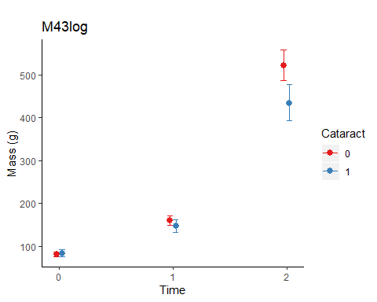
## glm within each time point
# Oct 2016
Data18b <- subset (Data18, Time==0)
M45 <- lme (Mass ~ Cataract + Sex, random = ~1 | Group, method = "ML", data = Data18b)
plot ((M45), grid = FALSE, main = "Mass, cataract")#Standardised residuals vs fitted values for whole model
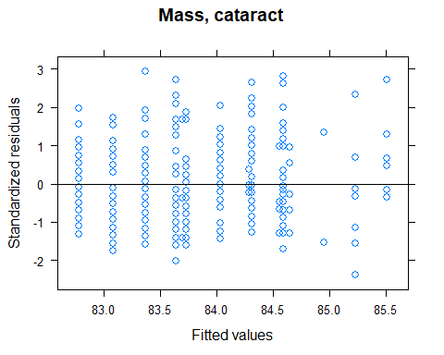
plot (M45, resid (., type = "p") ~ fitted(.) | Cataract, ylim =c (-5,5), abline = 0, grid = FALSE, main = "Mass, cataract")
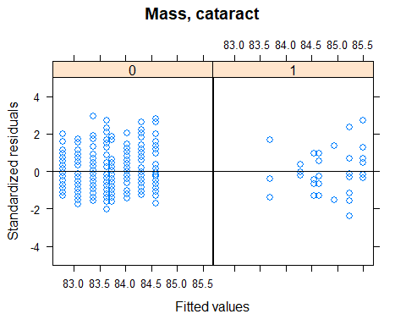
plot (M45, resid (., type = "p") ~ fitted(.) | Sex, ylim =c (-5,5), abline = 0, grid = FALSE, main = "Mass, cataract")
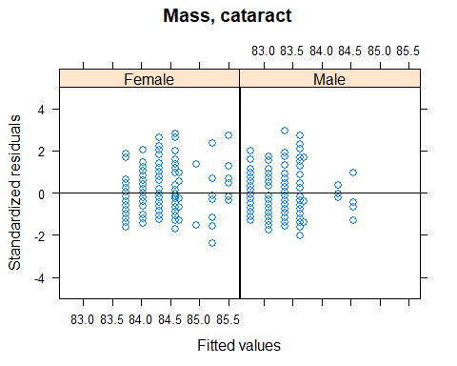
plot (M45, resid (., type = "p") ~ fitted(.) | Group, ylim =c (-5,5), abline = 0, grid = FALSE, main = "Mass, cataract")
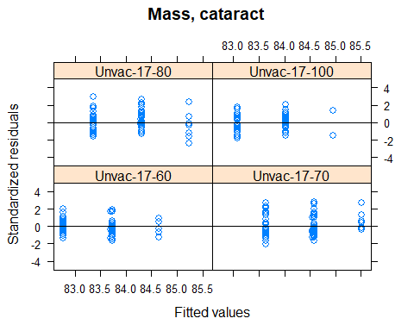
qqPlot (resid (M45), grid = FALSE, envelope = .95, line = "quartiles")
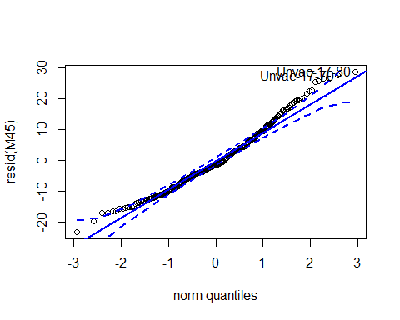
## Unvac-17-80 Unvac-17-70
## 271 162
qqPlot (resid (M45), grid = FALSE, groups = Data18b$Cataract, envelope =.95, line = "quartiles")
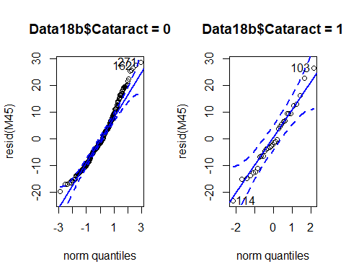
qqPlot (resid (M45), grid = FALSE, groups = Data18b$Sex, envelope =.95, line = "quartiles")
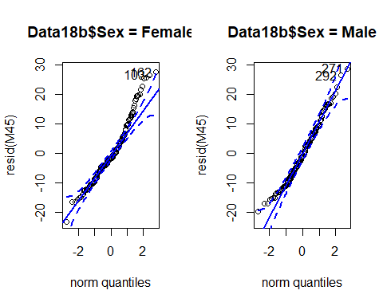
qqPlot (resid (M45), grid = FALSE, groups = Data18b$Group, envelope =.95, line = "quartiles")
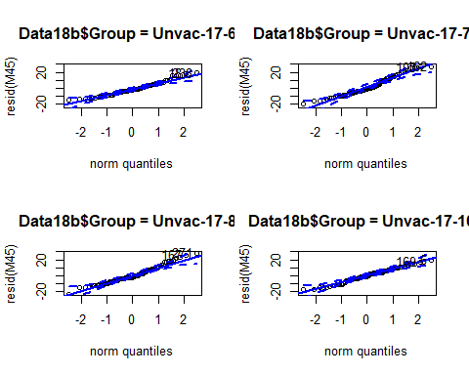
Anova (M45) # no effect of cataract or sex
## Analysis of Deviance Table (Type II tests)
##
## Response: Mass
## Chisq Df Pr(>Chisq)
## Cataract 0.2531 1 0.6149
## Sex 0.7173 1 0.3970
r.squaredGLMM (M45)
## R2m R2c
## [1,] 0.003319927 0.007613459
M45_null <- lme (Mass ~1, random = ~1 | Group, method = "ML", data = Data18b)
BIC (M45, M45_null) # null model is better
## df BIC
## M45 5 2298.253
## M45_null 3 2287.797
# Nov 2016
Data18c <- subset (Data18, Time==1)
M46 <- lme (Mass ~ Cataract + Sex, random = ~1 | Group, method = "ML", data = Data18c)
plot ((M46), grid = FALSE, main = "Mass, cataract") # Standardised residuals vs fitted values for whole model
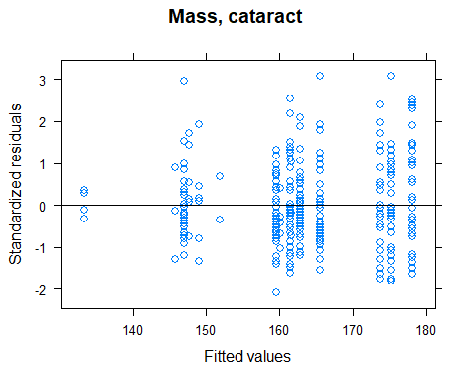
plot (M46, resid(., type = "p") ~ fitted(.) | Cataract, ylim =c (-5,5), abline = 0, grid = FALSE, main = "Mass, cataract")
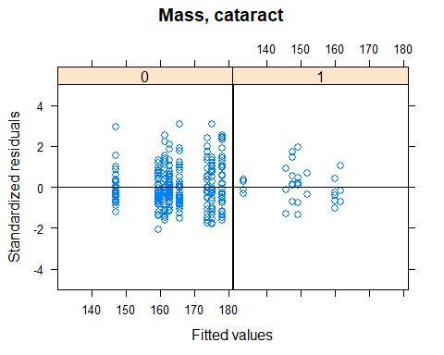
plot (M46, resid(., type = "p") ~ fitted(.) | Sex, ylim =c (-5,5), abline = 0, grid = FALSE, main = "Mass, cataract")
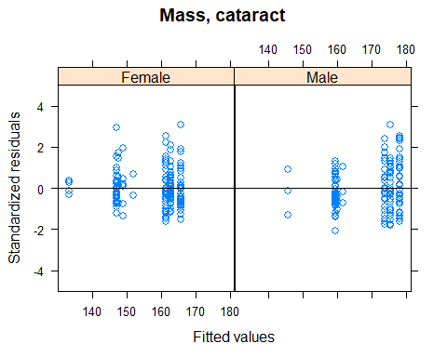
plot (M46, resid(., type = "p") ~ fitted(.) | Group, ylim =c (-5,5), abline = 0, grid = FALSE, main = "Mass, cataract")
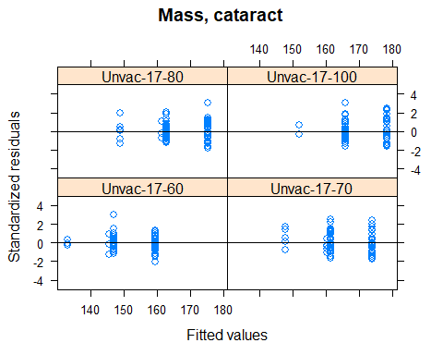
qqPlot (resid (M46), grid = FALSE, envelope = .95, line = "quartiles")
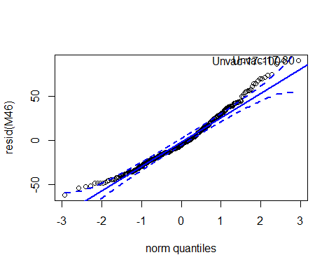
## Unvac-17-80 Unvac-17-100
## 182 6
qqPlot (resid (M46), grid = FALSE, groups = Data18c$Cataract, envelope =.95, line = "quartiles")
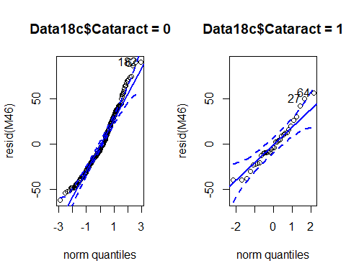
qqPlot (resid (M46), grid = FALSE, groups = Data18c$Sex, envelope =.95, line = "quartiles")
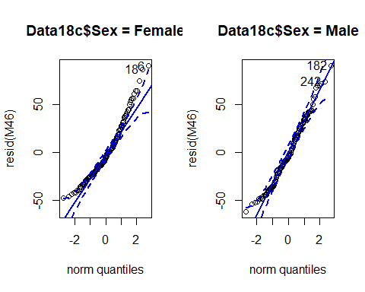
qqPlot (resid (M46), grid = FALSE, groups = Data18c$Group, envelope =.95, line = "quartiles")
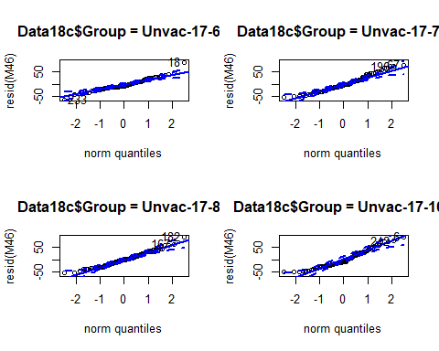
Anova (M46) # effect of cataract and sex
## Analysis of Deviance Table (Type II tests)
##
## Response: Mass
## Chisq Df Pr(>Chisq)
## Cataract 6.1279 1 0.0133068 *
## Sex 13.5413 1 0.0002334 ***
## ---
## Signif. codes: 0 '***' 0.001 '**' 0.01 '*' 0.05 '.' 0.1 ' ' 1
r.squaredGLMM (M46)
## R2m R2c
## [1,] 0.06011103 0.1224728
M46_null <- lme (Mass ~1, random = ~1 | Group, method = "ML", data = Data18c)
BIC (M46, M46_null) # null model is better
## df BIC
## M46 5 2982.902
## M46_null 3 2991.398
lsmeans (M46, pairwise ~ Cataract) # fish with cataracts are smaller
## $lsmeans
## Cataract lsmean SE df lower.CL upper.CL
## 0 165 4.32 3 152 179
## 1 152 6.59 3 131 173
##
## Results are averaged over the levels of: Sex
## Degrees-of-freedom method: containment
## Confidence level used: 0.95
##
## $contrasts
## contrast estimate SE df t.ratio p.value
## 0 - 1 13.7 5.58 301 2.463 0.0143
##
## Results are averaged over the levels of: Sex
## Degrees-of-freedom method: containment
# Apr 2017
Data18d <- subset (Data18, Time==2)
M47 <- lme (Mass ~ Cataract + Sex, random = ~1 | Group, method = "ML", data = Data18d)
plot ((M47), grid = FALSE, main = "Mass, cataract") # Standardised residuals vs fitted values for whole model
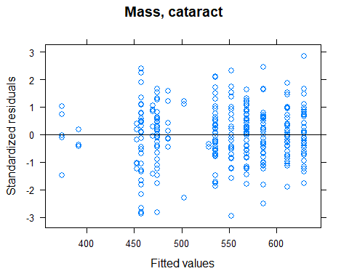
plot (M47, resid(., type = "p") ~ fitted(.) | Cataract, ylim =c (-5,5), abline = 0, grid = FALSE, main = "Mass, cataract")
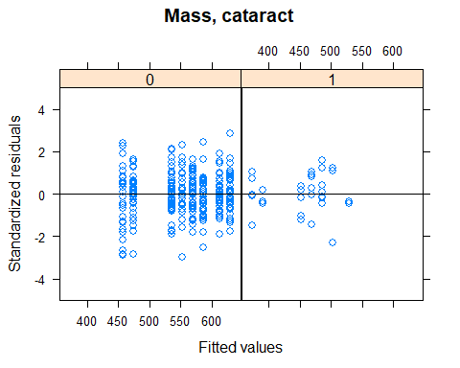
plot (M47, resid(., type = "p") ~ fitted(.) | Sex, ylim =c (-5,5), abline = 0, grid = FALSE, main = "Mass, cataract")
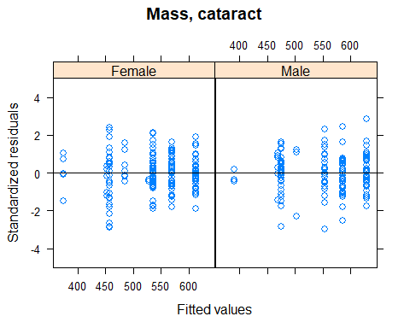
plot (M47, resid(., type = "p") ~ fitted(.) | Group, ylim =c (-5,5), abline = 0, grid = FALSE, main = "Mass, cataract")
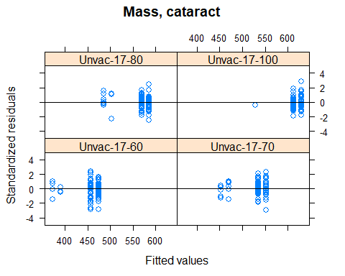
qqPlot (resid (M47), grid = FALSE, envelope = .95, line = "quartiles")
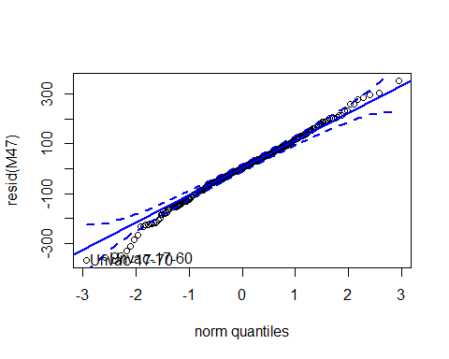
## Unvac-17-70 Unvac-17-60
## 235 42
qqPlot (resid (M47), grid = FALSE, groups = Data18d$Cataract, envelope =.95, line = "quartiles")
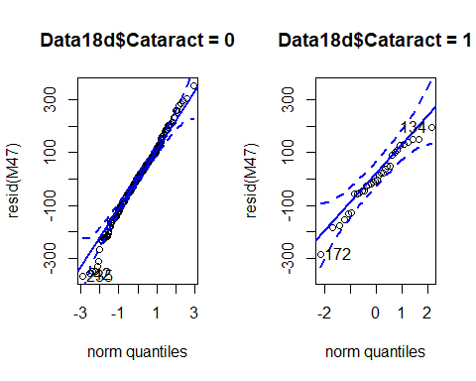
qqPlot (resid (M47), grid = FALSE, groups = Data18d$Sex, envelope =.95, line = "quartiles")
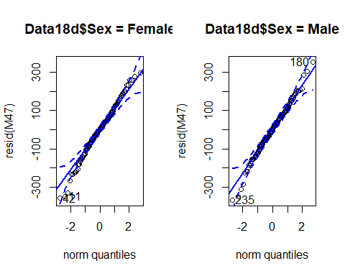
qqPlot (resid (M47), grid = FALSE, groups = Data18d$Group, envelope =.95, line = "quartiles")
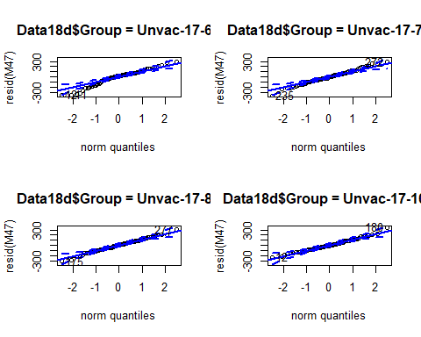
Anova (M47) # effect of cataract, but not sex
## Analysis of Deviance Table (Type II tests)
##
## Response: Mass
## Chisq Df Pr(>Chisq)
## Cataract 12.6762 1 0.0003703 ***
## Sex 1.4735 1 0.2247882
## ---
## Signif. codes: 0 '***' 0.001 '**' 0.01 '*' 0.05 '.' 0.1 ' ' 1
r.squaredGLMM (M47)
## R2m R2c
## [1,] 0.03848113 0.2134766
M47_null <- lme (Mass ~1, random = ~1 | Group, method = "ML", data = Data18d)
BIC (M47, M47_null) # null model is better
## df BIC
## M47 5 3868.834
## M47_null 3 3871.653
lsmeans (M47, pairwise ~ Cataract) # fish with cataracts are smaller
## $lsmeans
## Cataract lsmean SE df lower.CL upper.CL
## 0 552 30.2 3 456 648
## 1 469 36.8 3 352 586
##
## Results are averaged over the levels of: Sex
## Degrees-of-freedom method: containment
## Confidence level used: 0.95
##
## $contrasts
## contrast estimate SE df t.ratio p.value
## 0 - 1 83.2 23.5 301 3.543 0.0005
##
## Results are averaged over the levels of: Sex
## Degrees-of-freedom method: containment
#### Post-smolt maturation and growth ####
# Maturity and body mass
Data20 <- subset (Growth, Temp==17 & Full_set==1 & Sex=="Male" & Cataract==0)
str (Data20)
## 'data.frame': 966 obs. of 19 variables:
## $ Fish : int 8 30 47 55 63 71 74 82 86 92 ...
## $ Tank : Factor w/ 16 levels "1","2","3","4",..: 14 10 12 16 11 12 12 15 12 13 ...
## $ Full_set : int 1 1 1 1 1 1 1 1 1 1 ...
## $ Day : int 0 0 0 0 0 0 0 0 0 0 ...
## $ Time : int 0 0 0 0 0 0 0 0 0 0 ...
## $ Vaccinated : Factor w/ 2 levels "No","Yes": 1 1 1 1 1 1 1 1 1 1 ...
## $ Temp : Factor w/ 2 levels "12","17": 2 2 2 2 2 2 2 2 2 2 ...
## $ O2 : int 70 100 80 60 80 80 80 60 80 70 ...
## $ Group : Factor w/ 16 levels "Unvac-12-60",..: 11 15 13 9 13 13 13 9 13 11 ...
## $ Length : num 20 20 18 19 18 18.5 17.5 17.5 19 20 ...
## $ Mass : int 92 100 68 82 80 88 68 68 90 88 ...
## $ K_factor : num 1.15 1.25 1.17 1.2 1.37 1.39 1.27 1.27 1.31 1.1 ...
## $ Initial_mass: int NA NA NA NA NA NA NA NA NA NA ...
## $ SGR : num NA NA NA NA NA NA NA NA NA NA ...
## $ TGC : num NA NA NA NA NA NA NA NA NA NA ...
## $ Sex : Factor w/ 3 levels "Female","Male",..: 2 2 2 2 2 2 2 2 2 2 ...
## $ Mature : int 0 0 0 0 0 0 1 1 0 1 ...
## $ Loser : int 0 0 0 0 0 0 0 0 0 0 ...
## $ Cataract : int 0 0 0 0 0 0 0 0 0 0 ...
Data20$Mature <- as.factor (Data20$Mature)
Data20$Time <- as.factor (Data20$Time)
Data20$Group <- factor (Data20$Group)
table (Data20$Mature==0)
##
## FALSE TRUE
## 144 822
# summary table
Jack_summary <- data_summary (Data20, varname="Mass", groupnames =c ("Mature", "Time"))
# line plots
Jack_mass_line <- ggplot (Jack_summary, aes (x = Time, y = Mass, group = Mature, color = Mature)) + PlotTheme +
geom_line (position = position_dodge(.1)) +
geom_errorbar (aes (ymin = Mass-sd, ymax = Mass+sd), width = 0.2, position = position_dodge(.1)) +
labs (title = "Jacks", x="Time", y = "Mass")
Jack_mass_line
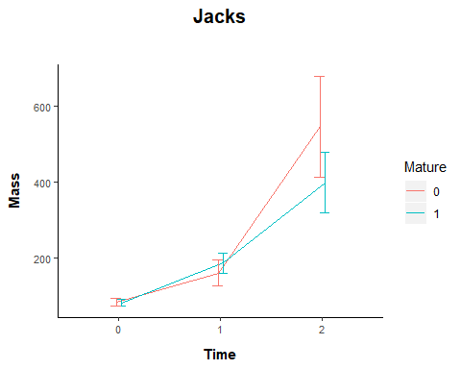
# model
M48 <- lme (Mass ~ Mature * Time, random = ~1 | Group / Fish, method = "ML", data = Data20)
plot ((M48), grid = FALSE, main = "Mass, maturity")
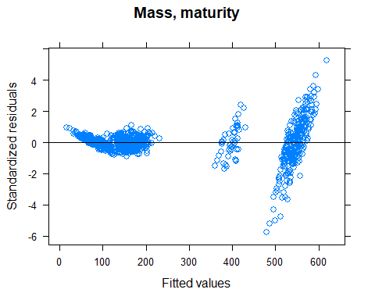
M48log <- lme (log (Mass) ~ Mature * Time, random = ~1 | Group / Fish, method = "ML", data = Data20)
plot ((M48log), grid = FALSE, main = "Mass, maturity")
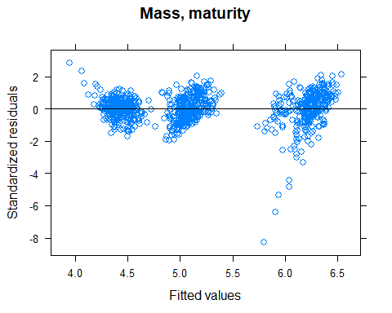
plot (M48log, resid(., type = "p") ~ fitted(.) | Mature, ylim =c (-5,5), abline = 0, grid = FALSE, main = "Mass, maturity")
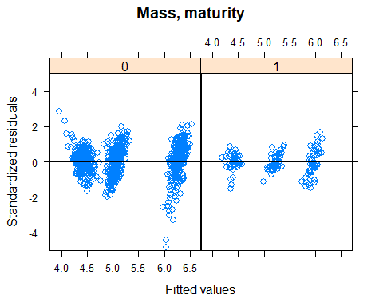
plot (M48log, resid(., type = "p") ~ fitted(.) | Time, ylim =c (-5,5), abline = 0, grid = FALSE, main = "Mass, maturity")
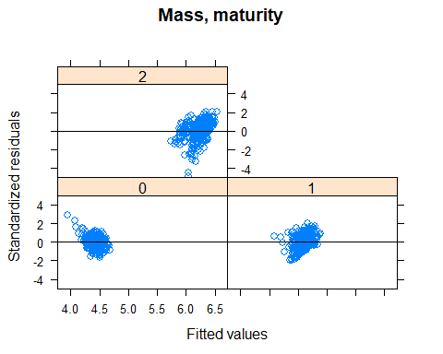
plot (M48log, resid(., type = "p") ~ fitted(.) | Group, ylim =c (-5,5), abline = 0, grid = FALSE, main = "Mass, maturity")
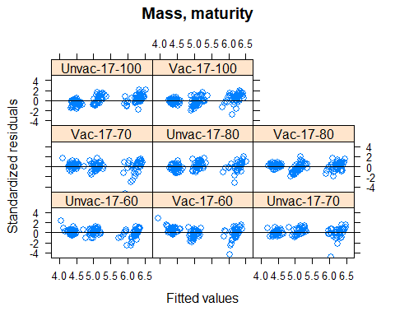
qqPlot (resid (M48log), grid = FALSE, envelope = .95, line = "quartiles")
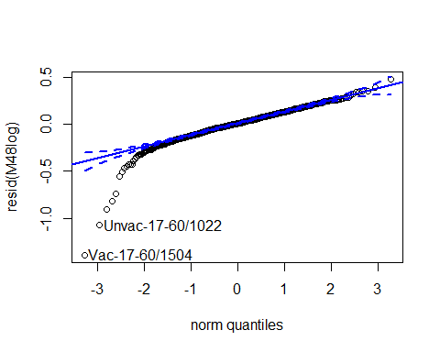
## Vac-17-60/1504 Unvac-17-60/1022
## 928 382
qqPlot (resid (M48log), grid = FALSE, groups = Data20$Mature, envelope =.95, line = "quartiles")
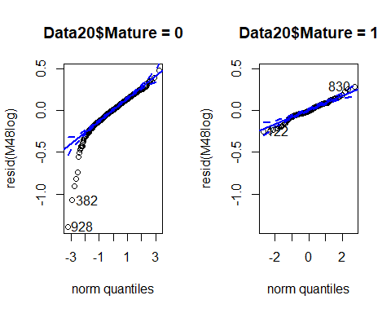
qqPlot (resid (M48log), grid = FALSE, groups = Data20$Time, envelope =.95, line = "quartiles")
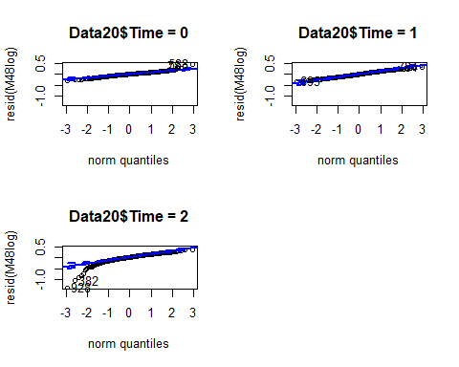
qqPlot (resid (M48log), grid = FALSE, groups = Data20$Group, envelope =.95, line = "quartiles")
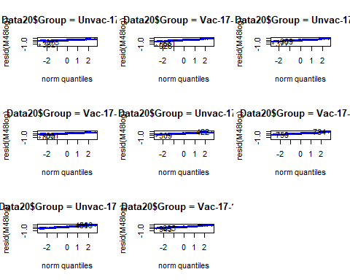
# model output
Anova (M48log, type = 3) # log transformation
## Analysis of Deviance Table (Type III tests)
##
## Response: log(Mass)
## Chisq Df Pr(>Chisq)
## (Intercept) 48262.0221 1 <2e-16 ***
## Mature 0.3986 1 0.5278
## Time 17118.9377 2 <2e-16 ***
## Mature:Time 158.7608 2 <2e-16 ***
## ---
## Signif. codes: 0 '***' 0.001 '**' 0.01 '*' 0.05 '.' 0.1 ' ' 1
Anova (M48, type = 3) # no transformation
## Analysis of Deviance Table (Type III tests)
##
## Response: Mass
## Chisq Df Pr(>Chisq)
## (Intercept) 135.0010 1 <2e-16 ***
## Mature 0.1008 1 0.7508
## Time 7104.4977 2 <2e-16 ***
## Mature:Time 152.2241 2 <2e-16 ***
## ---
## Signif. codes: 0 '***' 0.001 '**' 0.01 '*' 0.05 '.' 0.1 ' ' 1
r.squaredGLMM (M48log)
## R2m R2c
## [1,] 0.9263889 0.9534623
M48log_null <- lme (log (Mass) ~1, random = ~1 | Group / Fish, method = "ML", data = Data20)
BIC (M48log, M48log_null)
## df BIC
## M48log 9 -336.0366
## M48log_null 4 2280.7521
lsmeans (M48log, pairwise ~ Mature | Time, type = "response") # mature fish bigger in Nov 16, but smaller in Apr 17
## $lsmeans
## Time = 0:
## Mature response SE df lower.CL upper.CL
## 0 83.5 1.69 7 79.6 87.6
## 1 81.8 2.77 7 75.5 88.6
##
## Time = 1:
## Mature response SE df lower.CL upper.CL
## 0 157.8 3.19 7 150.5 165.5
## 1 184.6 6.25 7 170.4 200.0
##
## Time = 2:
## Mature response SE df lower.CL upper.CL
## 0 528.2 10.67 7 503.5 554.0
## 1 388.8 13.16 7 358.9 421.2
##
## Degrees-of-freedom method: containment
## Confidence level used: 0.95
## Intervals are back-transformed from the log scale
##
## $contrasts
## Time = 0:
## contrast ratio SE df t.ratio p.value
## 0 / 1 1.021 0.0331 313 0.629 0.5296
##
## Time = 1:
## contrast ratio SE df t.ratio p.value
## 0 / 1 0.855 0.0277 313 -4.840 <.0001
##
## Time = 2:
## contrast ratio SE df t.ratio p.value
## 0 / 1 1.358 0.0440 313 9.449 <.0001
##
## Degrees-of-freedom method: containment
## Tests are performed on the log scale
M48log.Fig <- plot_model (M48log, type = "pred", terms =c ("Time","Mature"))+
labs (title = "M45log", x = "Time", y = "Mass (g)", tag ="")+
theme (panel.background = element_rect (fill = "white", colour = "white"))+
theme (axis.line = element_line (colour="black"))
## Model has log-transformed response. Back-transforming predictions to original response scale. Standard errors are still on the log-scale.
M48log.Fig
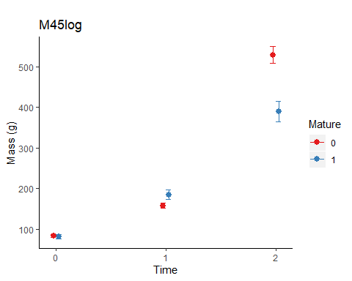
## lme within each time point
# Oct 2016
Data20b <- subset (Data20, Time==0)
M49 <-lme (Mass ~ Mature, random = ~1 | Group, method = "ML", data = Data20b)
plot ((M49), grid = FALSE, main = "Mass, mature")
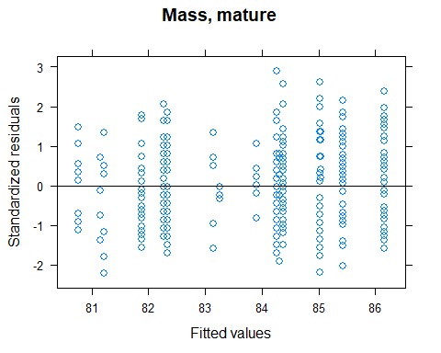
plot (M49, resid(., type = "p") ~ fitted(.) | Mature, ylim =c (-5,5), abline = 0, grid = FALSE, main = "Mass, mature")
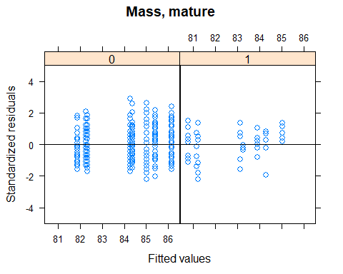
plot (M49, resid(., type = "p") ~ fitted(.) | Group, ylim =c (-5,5), abline = 0, grid = FALSE, main = "Mass, mature")
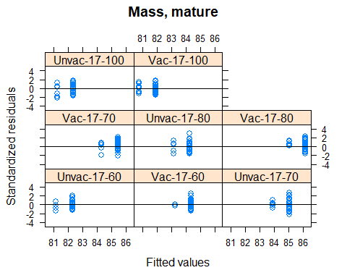
qqPlot (resid (M49), grid = FALSE, envelope = .95, line = "quartiles")
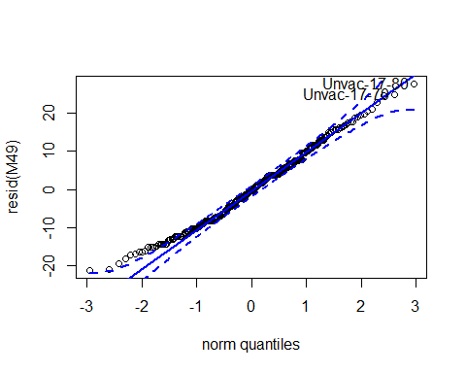
## Unvac-17-80 Unvac-17-70
## 110 135
qqPlot (resid (M49), grid = FALSE, groups = Data20b$Mature, envelope =.95, line = "quartiles")
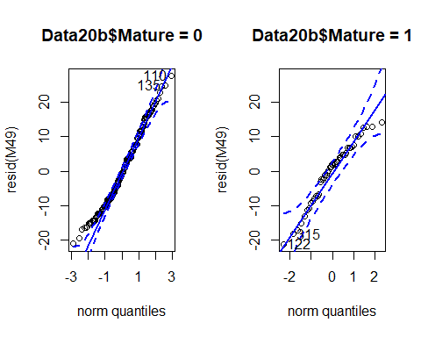
qqPlot (resid (M49), grid = FALSE, groups = Data20b$Group, envelope =.95, line = "quartiles")
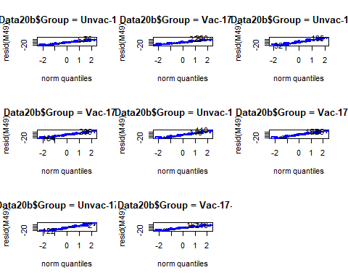
Anova (M49) # no eeffect
## Analysis of Deviance Table (Type II tests)
##
## Response: Mass
## Chisq Df Pr(>Chisq)
## Mature 0.5545 1 0.4565
r.squaredGLMM (M49)
## R2m R2c
## [1,] 0.001668795 0.04026482
M49_null <- lme (Mass ~1, random = ~1 | Group, method = "ML", data = Data20b)
BIC (M49, M49_null) # null model is better
## df BIC
## M49 4 2398.247
## M49_null 3 2393.026
# Nov 2016
Data20c <- subset (Data20, Time==1)
M50 <- lme (Mass ~ Mature, random = ~1 | Group, method ="ML", data = Data20c)
plot ((M50), grid = FALSE, main = "Mass, cataract")
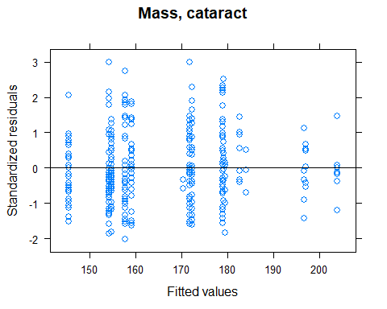
plot (M50, resid(., type = "p") ~ fitted(.) | Mature, ylim =c (-5,5), abline = 0, grid = FALSE, main = "Mass, mature")
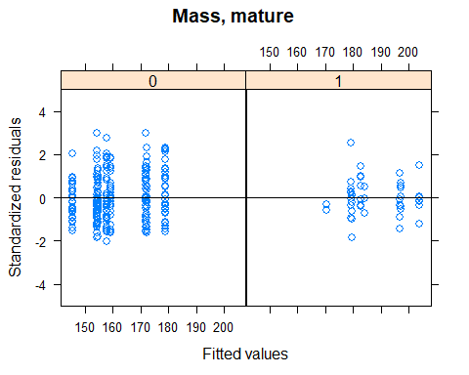
plot (M50, resid(., type = "p") ~ fitted(.) | Group, ylim =c (-5,5), abline = 0, grid = FALSE, main = "Mass, mature")
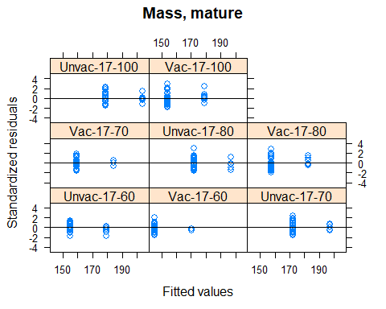
qqPlot (resid (M50), grid = FALSE, envelope = .95, line = "quartiles")
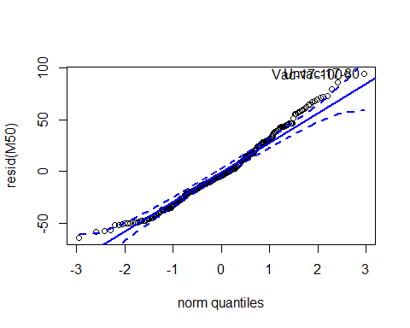
## Unvac-17-80 Vac-17-100
## 15 218
qqPlot (resid (M50), grid = FALSE, groups = Data20c$Mature, envelope =.95, line = "quartiles")
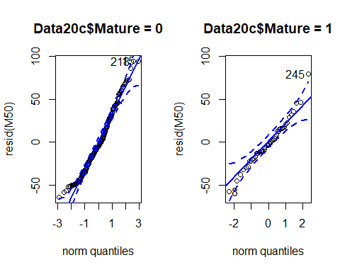
qqPlot (resid (M50), grid = FALSE, groups = Data20c$Group, envelope =.95, line = "quartiles")
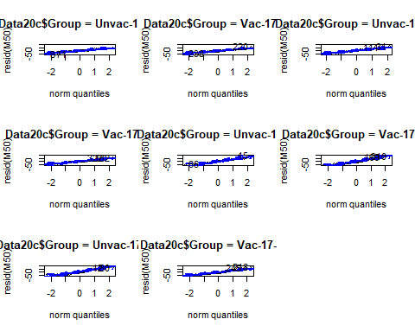
Anova (M50) # significant
## Analysis of Deviance Table (Type II tests)
##
## Response: Mass
## Chisq Df Pr(>Chisq)
## Mature 25.369 1 4.734e-07 ***
## ---
## Signif. codes: 0 '***' 0.001 '**' 0.01 '*' 0.05 '.' 0.1 ' ' 1
r.squaredGLMM (M50)
## R2m R2c
## [1,] 0.06562919 0.1769957
M50_null <- lme (Mass ~1, random = ~1 | Group, method ="ML", data = Data20c)
BIC (M50, M50_null)
## df BIC
## M50 4 3171.350
## M50_null 3 3189.995
# Apr 2017
Data20d <- subset (Data20, Time==2)
M51 <- lme (Mass ~ Mature, random = ~1 | Group, method = "ML", data = Data20d)
plot ((M51), grid = FALSE, main = "Mass, cataract")
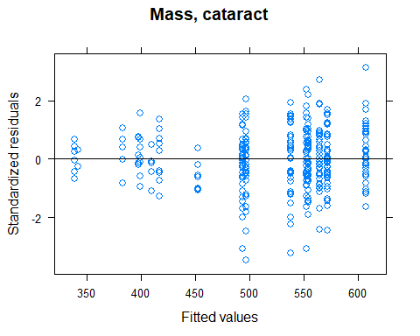
plot (M51, resid (., type = "p") ~ fitted(.) | Mature, ylim =c (-5,5), abline = 0, grid = FALSE, main = "Mass, mature")
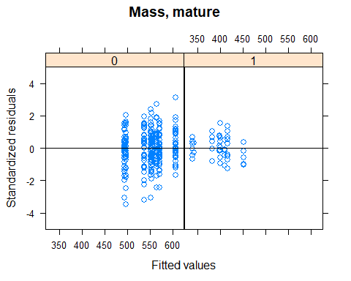
plot (M51, resid (., type = "p") ~ fitted(.) | Group, ylim =c (-5,5), abline = 0, grid = FALSE, main = "Mass, mature")
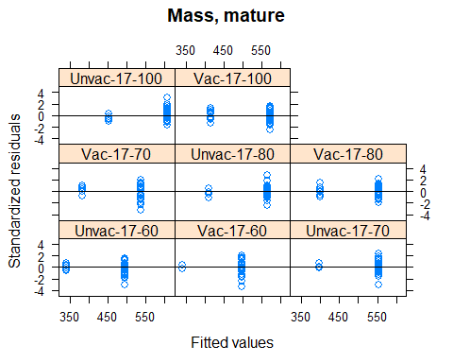
qqPlot (resid (M51), grid = FALSE, envelope = .95, line = "quartiles")
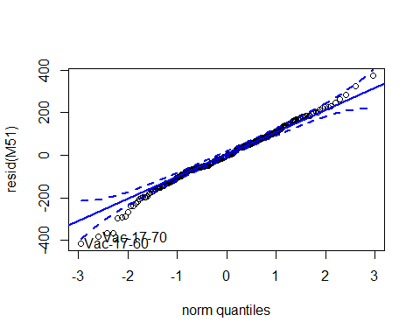
## Vac-17-60 Vac-17-70
## 284 176
qqPlot (resid (M51), grid = FALSE, groups = Data20d$Mature, envelope =.95, line = "quartiles")
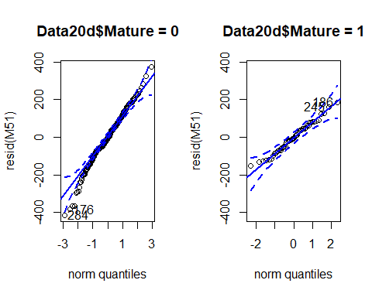
qqPlot (resid (M51), grid = FALSE, groups = Data20d$Group, envelope =.95, line = "quartiles")
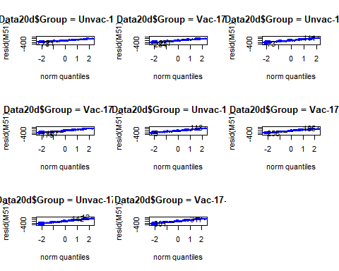
Anova (M51) # significant
## Analysis of Deviance Table (Type II tests)
##
## Response: Mass
## Chisq Df Pr(>Chisq)
## Mature 67.937 1 < 2.2e-16 ***
## ---
## Signif. codes: 0 '***' 0.001 '**' 0.01 '*' 0.05 '.' 0.1 ' ' 1
r.squaredGLMM (M51)
## R2m R2c
## [1,] 0.1615301 0.2433164
M51_null <- lme (Mass ~1, random = ~1 | Group, method = "ML", data = Data20d)
BIC (M51, M51_null)
## df BIC
## M51 4 4030.783
## M51_null 3 4086.236
# log the data
M51log <- lme (log (Mass) ~ Mature, random = ~1 | Group, method = "ML", data = Data20d)
plot ((M51log), grid = FALSE, main = "Mass, cataract")
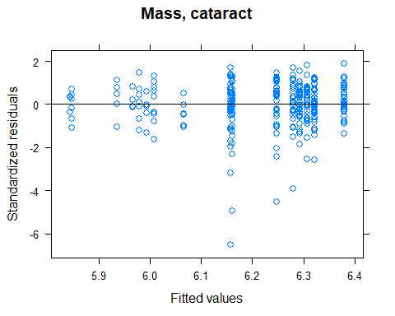
plot (M51log, resid(., type = "p") ~ fitted(.) | Mature, ylim=c(-5,5), abline = 0, grid = FALSE, main = "Mass, mature")
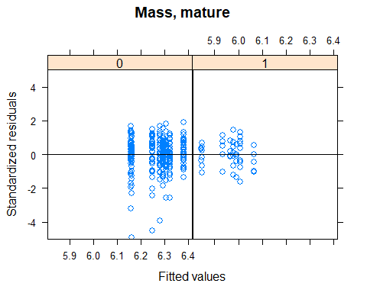
plot (M51log, resid(., type = "p") ~ fitted(.) | Group, ylim=c(-5,5), abline = 0, grid = FALSE, main = "Mass, mature")
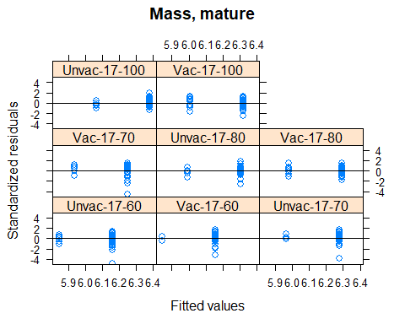
qqPlot (resid (M51log), grid = FALSE, envelope = .95, line = "quartiles") # not as good as the non-transformed
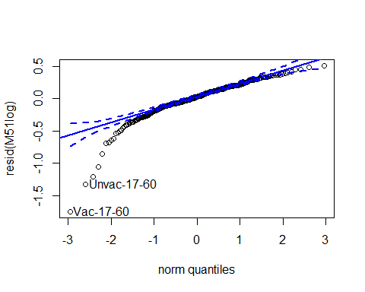
## Vac-17-60 Unvac-17-60
## 284 78
qqPlot (resid (M51log), grid = FALSE, groups = Data20d$Mature, envelope =.95, line = "quartiles")
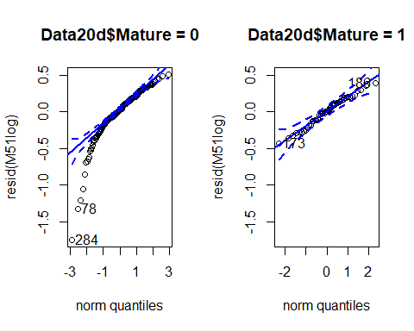
qqPlot (resid (M51log), grid = FALSE, groups = Data20d$Group, envelope =.95, line = "quartiles")
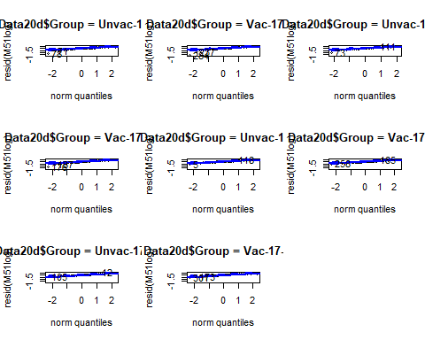
Anova (M51log) # significant
## Analysis of Deviance Table (Type II tests)
##
## Response: log(Mass)
## Chisq Df Pr(>Chisq)
## Mature 55.145 1 1.12e-13 ***
## ---
## Signif. codes: 0 '***' 0.001 '**' 0.01 '*' 0.05 '.' 0.1 ' ' 1
r.squaredGLMM (M51log)
## R2m R2c
## [1,] 0.1369808 0.209235
M51log_null <- lme (log (Mass) ~1, random = ~1 | Group, method ="ML", data = Data20d)
BIC (M51log, M51log_null)
## df BIC
## M51log 4 103.0631
## M51log_null 3 147.8409
#### Losers and growth ####
# Loser body mass
Data22 <- subset (Growth, Temp==17 & Full_set==1 & O2==60 & Mature==0 & Cataract==0 & Sex!="Undetermined")
str(Data22)
## 'data.frame': 432 obs. of 19 variables:
## $ Fish : int 15 24 39 64 114 141 185 243 432 468 ...
## $ Tank : Factor w/ 16 levels "1","2","3","4",..: 16 16 16 16 16 15 16 15 16 15 ...
## $ Full_set : int 1 1 1 1 1 1 1 1 1 1 ...
## $ Day : int 0 0 0 0 0 0 0 0 0 0 ...
## $ Time : int 0 0 0 0 0 0 0 0 0 0 ...
## $ Vaccinated : Factor w/ 2 levels "No","Yes": 1 1 1 1 1 1 1 1 1 1 ...
## $ Temp : Factor w/ 2 levels "12","17": 2 2 2 2 2 2 2 2 2 2 ...
## $ O2 : int 60 60 60 60 60 60 60 60 60 60 ...
## $ Group : Factor w/ 16 levels "Unvac-12-60",..: 9 9 9 9 9 9 9 9 9 9 ...
## $ Length : num 19 19 19 19.5 18.5 19 20.5 19 18.5 20 ...
## $ Mass : int 80 88 82 88 80 82 102 80 80 100 ...
## $ K_factor : num 1.17 1.28 1.2 1.19 1.26 1.2 1.18 1.17 1.26 1.25 ...
## $ Initial_mass: int NA NA NA NA NA NA NA NA NA NA ...
## $ SGR : num NA NA NA NA NA NA NA NA NA NA ...
## $ TGC : num NA NA NA NA NA NA NA NA NA NA ...
## $ Sex : Factor w/ 3 levels "Female","Male",..: 1 1 1 1 1 1 1 1 1 1 ...
## $ Mature : int 0 0 0 0 0 0 0 0 0 0 ...
## $ Loser : int 0 0 0 0 1 1 0 0 1 0 ...
## $ Cataract : int 0 0 0 0 0 0 0 0 0 0 ...
Data22$Loser <- as.factor(Data22$Loser)
Data22$Time <- as.factor(Data22$Time)
Data22$Sex <- factor(Data22$Sex)
Data22$Vaccinated <- factor(Data22$Vaccinated)
Data22$Fish <- factor(Data22$Fish)
# summary table
Loser_summary <- data_summary (Data22, varname="Mass", groupnames =c ("Loser", "Time"))
# line plots
Loser_mass_line <- ggplot (Loser_summary, aes (x = Time, y = Mass, group = Loser, color = Loser)) + PlotTheme +
geom_line (position = position_dodge (.1)) +
geom_errorbar (aes (ymin = Mass-sd, ymax = Mass+sd), width = .2, position = position_dodge (.1)) +
labs (title = "Cataracts", x = "Time", y = "Mass")
Loser_mass_line
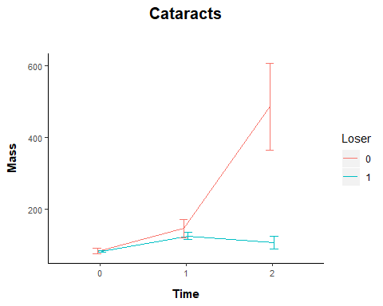
# model
M52 <- lme (Mass ~ Loser * Time + Sex + Vaccinated, random = ~1 | Fish, method = "ML", data = Data22)
M53 <- lme (Mass ~ Loser + Time + Sex + Vaccinated, random = ~1 | Fish, method = "ML", data = Data22)
BIC (M52, M53)
## df BIC
## M52 10 4953.100
## M53 8 5042.562
plot (M52) # heteroskedasticity
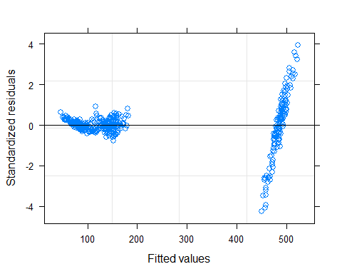
# log transform
M52log <- lme (log (Mass) ~ Loser * Time + Sex + Vaccinated, random = ~1 | Fish, method = "ML", data = Data22)
M53log <- lme (log (Mass) ~ Loser + Time + Sex + Vaccinated, random = ~1 | Fish, method = "ML", data = Data22)
BIC (M52log, M53log)
## df BIC
## M52log 10 -157.79214
## M53log 8 34.96565
plot ((M52log), grid = FALSE, main = "Body mass, losers")
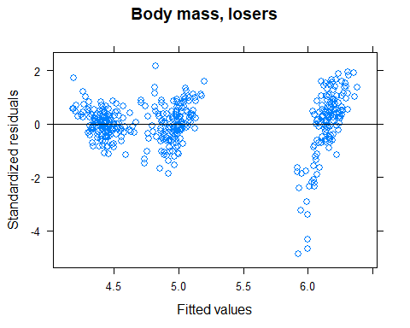
plot (M52log, resid(., type = "p") ~ fitted(.) | factor(Vaccinated), ylim=c (-5,5), abline = 0, grid = FALSE, main = "Body mass, losers")
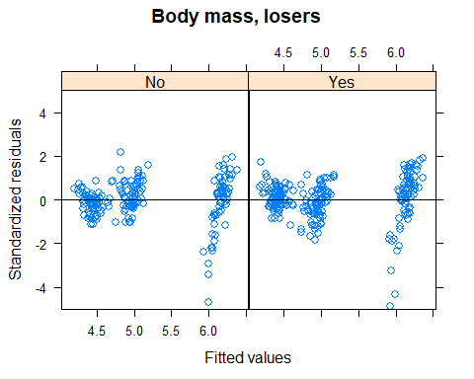
plot (M52log, resid(., type = "p") ~ fitted(.) | factor(Loser), ylim=c (-5,5), abline = 0, grid = FALSE, main = "Body mass, losers")
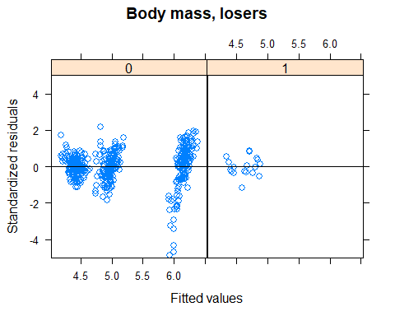
plot (M52log, resid(., type = "p") ~ fitted(.) | factor(Time), ylim=c (-5,5), abline = 0, grid = FALSE, main = "Body mass, losers")
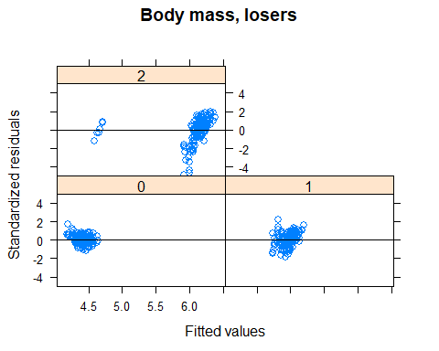
plot (M52log, resid(., type = "p") ~ fitted(.) | factor(Sex), ylim=c (-5,5), abline = 0, grid = FALSE, main = "Body mass, losers")
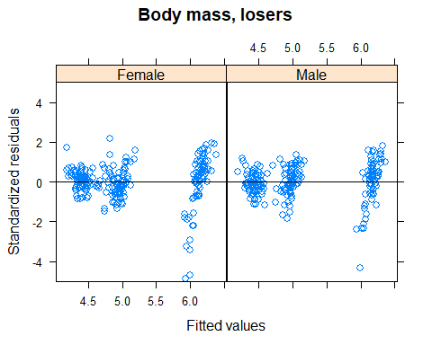
qqPlot (resid (M52log), grid = FALSE, envelope = .95, line = "quartiles") # still some left skew
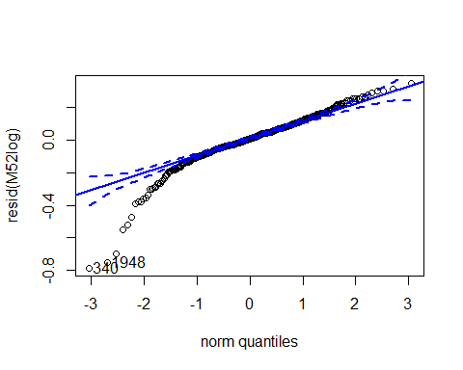
## 340 1948
## 182 93
qqPlot (resid (M52log), grid = FALSE, groups = Data22$Loser, envelope =.95, line = "quartiles")
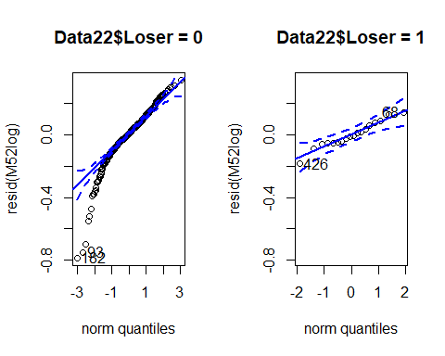
qqPlot (resid (M52log), grid = FALSE, groups = Data22$Time, envelope =.95, line = "quartiles")
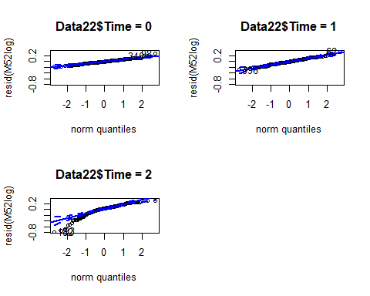
qqPlot (resid (M52log), grid = FALSE, groups = Data22$Sex, envelope =.95, line = "quartiles")
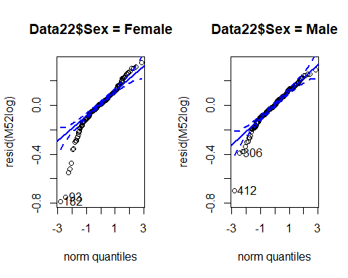
qqPlot (resid (M52log), grid = FALSE, groups = Data22$Vaccinated, envelope =.95, line = "quartiles")
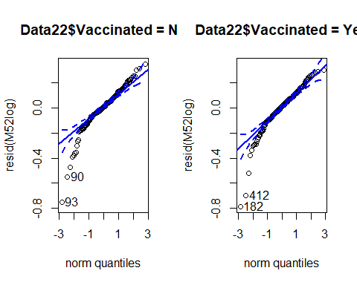
# model output
Anova (M52log, type = 3) # log transformed
## Analysis of Deviance Table (Type III tests)
##
## Response: log(Mass)
## Chisq Df Pr(>Chisq)
## (Intercept) 29973.0839 1 <2e-16 ***
## Loser 0.0004 1 0.9848
## Time 8348.4606 2 <2e-16 ***
## Sex 1.5827 1 0.2084
## Vaccinated 0.4460 1 0.5042
## Loser:Time 298.6335 2 <2e-16 ***
## ---
## Signif. codes: 0 '***' 0.001 '**' 0.01 '*' 0.05 '.' 0.1 ' ' 1
Anova (M52, type = 3) # no transformation
## Analysis of Deviance Table (Type III tests)
##
## Response: Mass
## Chisq Df Pr(>Chisq)
## (Intercept) 92.8722 1 <2e-16 ***
## Loser 0.0000 1 0.9988
## Time 3030.1404 2 <2e-16 ***
## Sex 0.6224 1 0.4302
## Vaccinated 0.0324 1 0.8571
## Loser:Time 121.8264 2 <2e-16 ***
## ---
## Signif. codes: 0 '***' 0.001 '**' 0.01 '*' 0.05 '.' 0.1 ' ' 1
r.squaredGLMM (M52log)
## R2m R2c
## [1,] 0.9296067 0.9532549
M52log_null <- lme (log (Mass) ~1, random = ~1 | Fish, method = "ML", data = Data22)
BIC(M52log, M52log_null)
## df BIC
## M52log 10 -157.7921
## M52log_null 3 989.0728
lsmeans (M52log, pairwise ~ Loser | Time, type = "response") # losers smaller in Apr 17
## $lsmeans
## Time = 0:
## Loser response SE df lower.CL upper.CL
## 0 82.8 1.41 140 80.1 85.6
## 1 82.7 6.75 140 70.3 97.2
##
## Time = 1:
## Loser response SE df lower.CL upper.CL
## 0 144.1 2.45 140 139.3 149.0
## 1 125.3 10.24 140 106.6 147.2
##
## Time = 2:
## Loser response SE df lower.CL upper.CL
## 0 469.3 7.99 140 453.7 485.3
## 1 106.0 8.66 140 90.2 124.6
##
## Results are averaged over the levels of: Sex, Vaccinated
## Degrees-of-freedom method: containment
## Confidence level used: 0.95
## Intervals are back-transformed from the log scale
##
## $contrasts
## Time = 0:
## contrast ratio SE df t.ratio p.value
## 0 / 1 1.00 0.0837 140 0.019 0.9850
##
## Time = 1:
## contrast ratio SE df t.ratio p.value
## 0 / 1 1.15 0.0960 140 1.671 0.0969
##
## Time = 2:
## contrast ratio SE df t.ratio p.value
## 0 / 1 4.43 0.3697 140 17.810 <.0001
##
## Results are averaged over the levels of: Sex, Vaccinated
## Degrees-of-freedom method: containment
## Tests are performed on the log scale
M52log.Fig <- plot_model (M52log, type = "pred", terms=c ("Time","Loser")) +
labs (title = "M47log", x = "Time", y = "Mass (g)", tag ="") +
theme (panel.background = element_rect (fill = "white", colour = "white")) +
theme (axis.line = element_line (colour = "black"))
## Model has log-transformed response. Back-transforming predictions to original response scale. Standard errors are still on the log-scale.
M52log.Fig
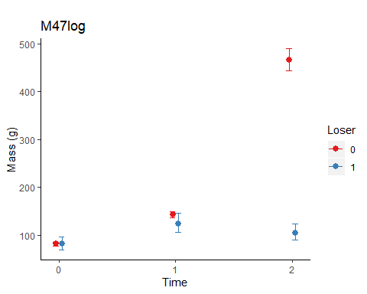
## glm within each time point
# Oct 2016
Data22b <- subset (Data22, Time==0)
M54 <- glm (Mass ~ Loser + Sex + Vaccinated, data = Data22b)
par (mfrow = c(2,2))
plot (M54)
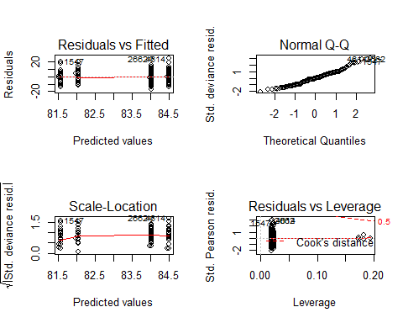
par (mfrow =c (1,1))
Anova (M54) # no loser effect
## Analysis of Deviance Table (Type II tests)
##
## Response: Mass
## LR Chisq Df Pr(>Chisq)
## Loser 0.00019 1 0.98898
## Sex 0.10789 1 0.74256
## Vaccinated 3.02011 1 0.08224 .
## ---
## Signif. codes: 0 '***' 0.001 '**' 0.01 '*' 0.05 '.' 0.1 ' ' 1
r.squaredGLMM (M54)
## R2m R2c
## [1,] 0.02118638 0.02118638
M54_null <- glm (Mass ~1, data = Data22b)
BIC (M54, M54_null) # null model is better
## df BIC
## M54 5 1042.116
## M54_null 2 1030.356
# Nov 2016
Data22c <- subset (Data22, Time==1)
M55<-glm (Mass ~ Loser + Sex + Vaccinated, data = Data22c)
par (mfrow=c (2,2))
plot (M55)
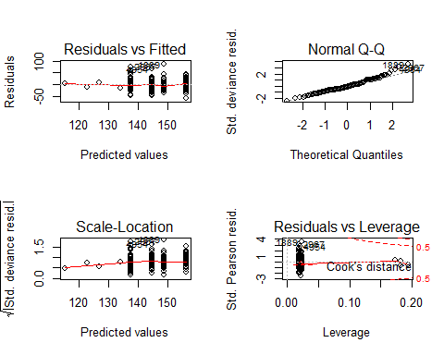
par (mfrow=c (1,1))
Anova (M55) # weak loser effect
## Analysis of Deviance Table (Type II tests)
##
## Response: Mass
## LR Chisq Df Pr(>Chisq)
## Loser 4.5988 1 0.031994 *
## Sex 3.2204 1 0.072728 .
## Vaccinated 7.6585 1 0.005651 **
## ---
## Signif. codes: 0 '***' 0.001 '**' 0.01 '*' 0.05 '.' 0.1 ' ' 1
r.squaredGLMM (M55)
## R2m R2c
## [1,] 0.09967314 0.09967314
M55_null <- glm (Mass ~1, data = Data22c)
BIC (M55, M55_null)
## df BIC
## M55 5 1350.634
## M55_null 2 1351.152
# Apr 2017
Data22d <- subset (Data22, Time==2)
M56 <- glm (Mass ~ Loser + Sex + Vaccinated, data = Data22d)
par (mfrow=c (2,2))
plot (M56)
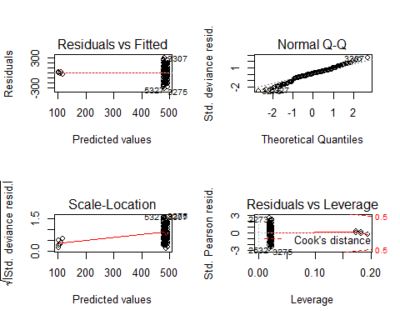
par (mfrow=c (1,1))
Anova(M56) # loser effect
## Analysis of Deviance Table (Type II tests)
##
## Response: Mass
## LR Chisq Df Pr(>Chisq)
## Loser 55.569 1 9.022e-14 ***
## Sex 0.257 1 0.6122
## Vaccinated 0.057 1 0.8120
## ---
## Signif. codes: 0 '***' 0.001 '**' 0.01 '*' 0.05 '.' 0.1 ' ' 1
r.squaredGLMM (M56)
## R2m R2c
## [1,] 0.286491 0.286491
M56_null <- glm (Mass ~1, data = Data22d)
BIC (M56, M56_null)
## df BIC
## M56 5 1809.141
## M56_null 2 1843.721
## Loser body condition
# summary table
Loser_summary_K_factor <- data_summary (Data22, varname="K_factor", groupnames=c("Loser", "Time"))
# line plots
Loser_K_factor_line <- ggplot (Loser_summary_K_factor, aes(x = Time, y = K_factor, group = Loser, color = Loser)) + PlotTheme +
geom_line (position = position_dodge (.1)) +
geom_errorbar (aes (ymin = K_factor-sd, ymax = K_factor+sd), width =.2, position = position_dodge (.1)) +
labs (title="Loser", x="Time", y = "Condition (K factor)")
Loser_K_factor_line
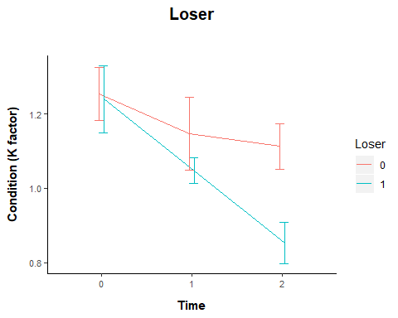
# compare models
M57 <- lme (K_factor ~ Loser * Time + Sex + Vaccinated, random = ~1 | Fish, method = "ML", data = Data22)
M58 <- lme (K_factor ~ Loser + Time + Sex + Vaccinated, random = ~1 | Fish, method = "ML", data = Data22)
BIC (M57, M58)
## df BIC
## M57 10 -955.4674
## M58 8 -933.0948
plot ((M57), grid = FALSE, main = "K_factor, losers")
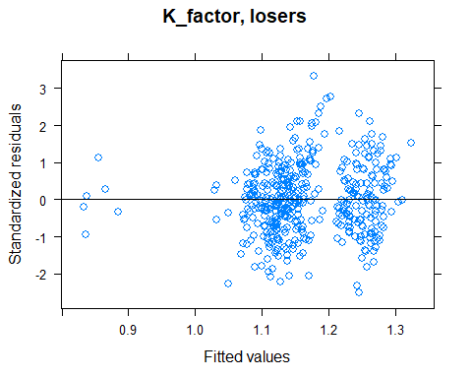
plot (M57, resid(., type = "p") ~ fitted(.) | factor(Vaccinated), ylim=c(-5,5), abline = 0, grid = FALSE, main = "K_factor, losers")
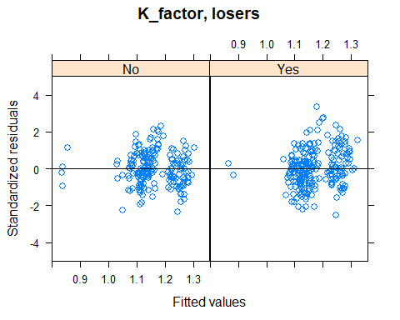
plot (M57, resid(., type = "p") ~ fitted(.) | factor(Loser), ylim=c (-5,5), abline = 0, grid = FALSE, main = "K_factor, losers")
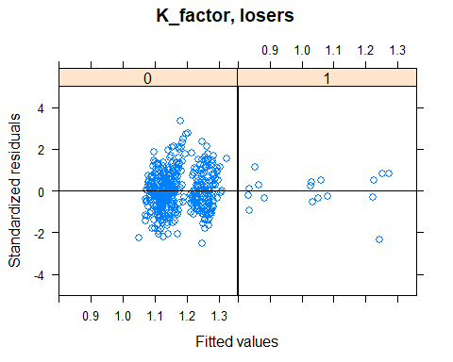
plot (M57, resid(., type = "p") ~ fitted(.) | factor(Time), ylim=c (-5,5), abline = 0, grid = FALSE, main = "K_factor, losers")
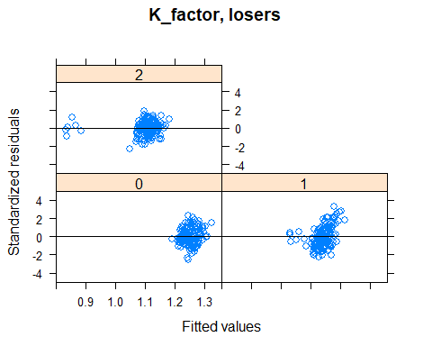
plot (M57, resid(., type = "p") ~ fitted(.) | factor(Sex), ylim=c (-5,5), abline = 0, grid = FALSE, main = "K_factor, losers")
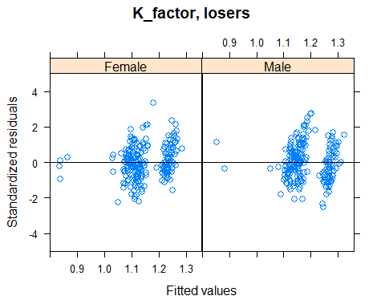
qqPlot (resid (M57), grid = FALSE, envelope = .95, line = "quartiles")
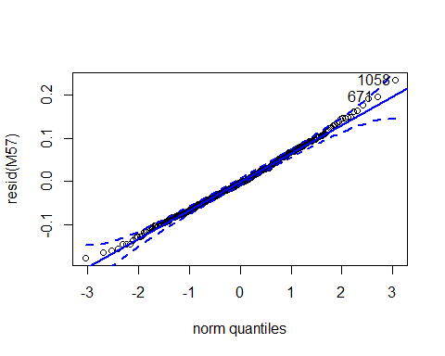
## 1058 671
## 159 368
qqPlot (resid (M57), grid = FALSE, groups = Data22$Loser, envelope =.95, line = "quartiles")
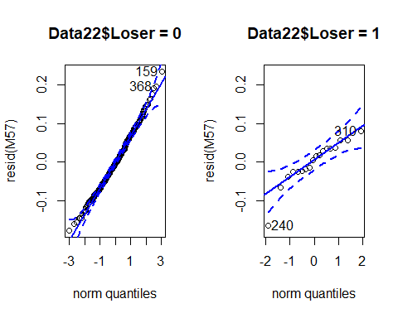
qqPlot (resid (M57), grid = FALSE, groups = Data22$Time, envelope =.95, line = "quartiles")
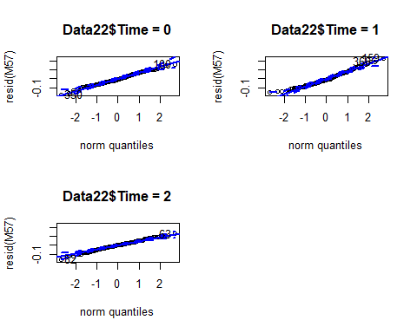
qqPlot (resid (M57), grid = FALSE, groups = Data22$Sex, envelope =.95, line = "quartiles")
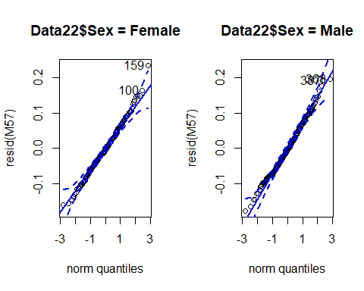
qqPlot (resid (M57), grid = FALSE, groups = Data22$Vaccinated, envelope =.95, line = "quartiles")
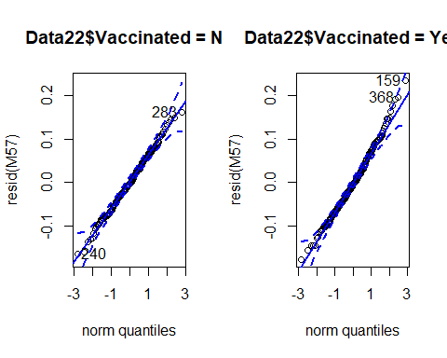
#model output
Anova (M57, type = 3)
## Analysis of Deviance Table (Type III tests)
##
## Response: K_factor
## Chisq Df Pr(>Chisq)
## (Intercept) 18649.7465 1 < 2.2e-16 ***
## Loser 0.0409 1 0.8397
## Time 308.6626 2 < 2.2e-16 ***
## Sex 17.9018 1 2.326e-05 ***
## Vaccinated 1.7059 1 0.1915
## Loser:Time 36.6620 2 1.094e-08 ***
## ---
## Signif. codes: 0 '***' 0.001 '**' 0.01 '*' 0.05 '.' 0.1 ' ' 1
r.squaredGLMM (M57)
## R2m R2c
## [1,] 0.4925146 0.5608499
M57_null <- lme (K_factor ~1, random = ~1 | Fish, method = "ML", data = Data22)
BIC(M57, M57_null)
## df BIC
## M57 10 -955.4674
## M57_null 3 -698.1067
lsmeans(M57, pairwise ~ Loser | Time) # Loser skinnier from Nov 16 onwards
## $lsmeans
## Time = 0:
## Loser lsmean SE df lower.CL upper.CL
## 0 1.25 0.00648 140 1.241 1.267
## 1 1.25 0.03109 140 1.186 1.309
##
## Time = 1:
## Loser lsmean SE df lower.CL upper.CL
## 0 1.15 0.00648 140 1.133 1.159
## 1 1.05 0.03109 140 0.993 1.116
##
## Time = 2:
## Loser lsmean SE df lower.CL upper.CL
## 0 1.11 0.00648 140 1.099 1.125
## 1 0.86 0.03109 140 0.798 0.921
##
## Results are averaged over the levels of: Sex, Vaccinated
## Degrees-of-freedom method: containment
## Confidence level used: 0.95
##
## $contrasts
## Time = 0:
## contrast estimate SE df t.ratio p.value
## 0 - 1 0.00637 0.0318 140 0.200 0.8415
##
## Time = 1:
## contrast estimate SE df t.ratio p.value
## 0 - 1 0.09140 0.0318 140 2.877 0.0047
##
## Time = 2:
## contrast estimate SE df t.ratio p.value
## 0 - 1 0.25254 0.0318 140 7.948 <.0001
##
## Results are averaged over the levels of: Sex, Vaccinated
## Degrees-of-freedom method: containment
M57.Fig <- plot_model (M57, type = "pred", terms =c("Time","Loser")) +
labs (title = "M57", x = "Time", y = "Condition (K factor)", tag ="") +
theme (panel.background = element_rect (fill = "white", colour = "white")) +
theme (axis.line = element_line (colour="black"))
M57.Fig
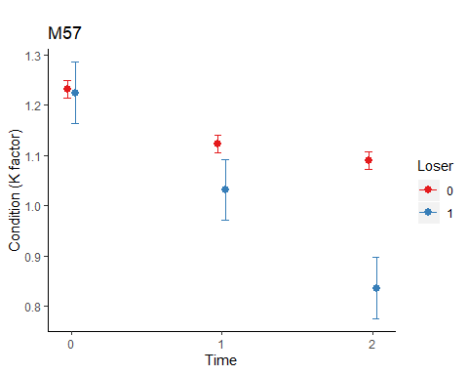
#### Blood titres ####
# extract the relevant data
Data24 <- subset (Immunity, Vaccinated=="Yes")
str (Data24)
## 'data.frame': 161 obs. of 7 variables:
## $ Vaccinated: Factor w/ 2 levels "No","Yes": 2 2 2 2 2 2 2 2 2 2 ...
## $ Sample : int 1 1 1 1 1 1 1 1 1 1 ...
## $ Week : int 2 2 2 2 2 2 2 2 2 2 ...
## $ Temp : int 12 12 12 12 12 12 12 12 12 12 ...
## $ Tank : int 7 8 1 1 1 2 2 2 2 7 ...
## $ O2 : int 60 60 100 100 100 100 100 100 100 60 ...
## $ Titer : num 6.6 6.6 6.6 6.6 6.6 6.6 6.6 6.6 6.6 6.7 ...
Data24$O2 <- factor (Data24$O2)
Data24$Temp <- factor (Data24$Temp)
Data24$Week <- factor (Data24$Week)
# plot the data
M59_dot_plot <- ggdotplot(Data24, "Week", "Titer", fill="O2", size = 0.5, facet.by= "Temp") + PlotTheme
M59_dot_plot
## `stat_bindot()` using `bins = 30`. Pick better value with `binwidth`.
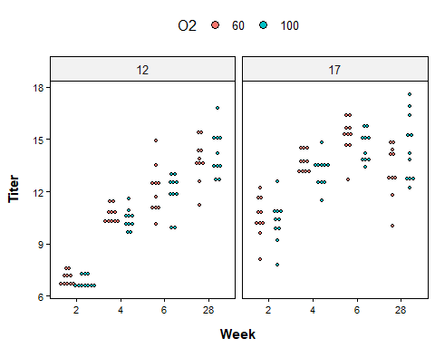
M60_dot_plot <- ggdotplot(Data24, "Week", "Titer", fill="Temp", size = 0.5, facet.by= "O2") + PlotTheme
M60_dot_plot
## `stat_bindot()` using `bins = 30`. Pick better value with `binwidth`.
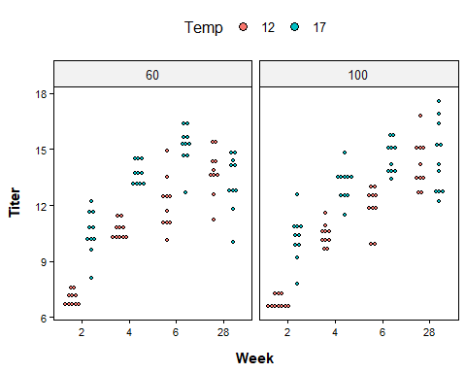
# compare models
M59 <- glm (Titer ~ O2 * Temp * Week, data = Data24)
M60 <- glm (Titer ~ O2 * Week + Temp * Week + O2 * Temp, data = Data24)
BIC (M59, M60)
## df BIC
## M59 17 558.6029
## M60 14 545.7972
par (mfrow =c(2,2))
plot (M60) # qqplot a bit ragged
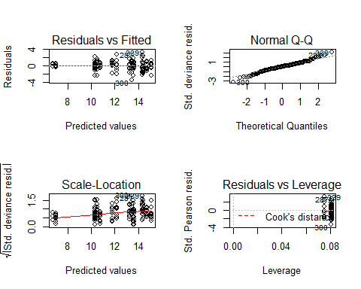
par (mfrow =c(1,1))
# try gls
Data24 <- subset (Immunity, Vaccinated=="Yes")
M59gls <- gls(Titer ~ O2 * Temp * Week, weights = varPower (), method = "ML", data = Data24)
M60gls <- gls(Titer ~ O2 * Week + Temp * Week + O2 * Temp, weights = varPower (), method = "ML", data = Data24)
BIC (M59gls, M60gls)
## df BIC
## M59gls 10 711.2604
## M60gls 9 706.8029
plot (M60gls)
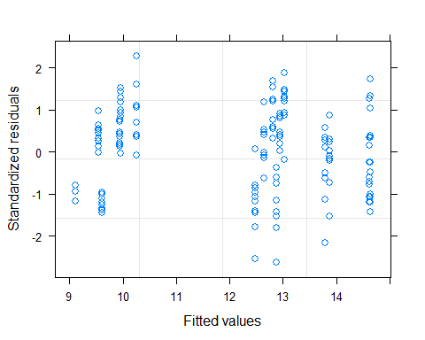
qqPlot (resid (M60gls), grid = FALSE, envelope = .95, line = "quartiles")
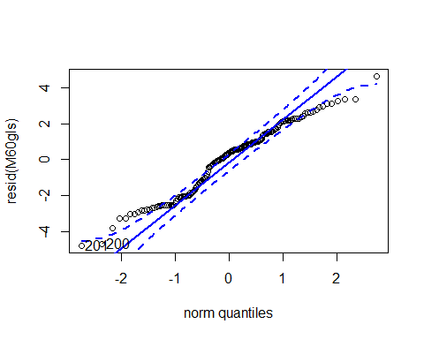
## 201 200
## 22 21
# model output
Anova (M60gls, type = 3) # gls
## Analysis of Deviance Table (Type III tests)
##
## Response: Titer
## Df Chisq Pr(>Chisq)
## (Intercept) 1 0.2561 0.612780
## O2 1 0.1791 0.672111
## Week 1 17.0064 3.725e-05 ***
## Temp 1 7.0383 0.007978 **
## O2:Week 1 3.0439 0.081043 .
## Week:Temp 1 22.1473 2.525e-06 ***
## O2:Temp 1 0.0194 0.889158
## ---
## Signif. codes: 0 '***' 0.001 '**' 0.01 '*' 0.05 '.' 0.1 ' ' 1
Anova (M60, type = 3) # glm
## Analysis of Deviance Table (Type III tests)
##
## Response: Titer
## LR Chisq Df Pr(>Chisq)
## O2 0.453 1 0.50106
## Week 262.985 3 < 2.2e-16 ***
## Temp 80.218 1 < 2.2e-16 ***
## O2:Week 9.326 3 0.02525 *
## Week:Temp 66.404 3 2.512e-14 ***
## O2:Temp 0.016 1 0.89914
## ---
## Signif. codes: 0 '***' 0.001 '**' 0.01 '*' 0.05 '.' 0.1 ' ' 1
M60gls_null <- gls (Titer ~1, weights = varPower (), data = Data24)
BIC (M60gls, M60gls_null)
## Warning in BIC.default(M60gls, M60gls_null): models are not all fitted to the
## same number of observations
## df BIC
## M60gls 9 706.8029
## M60gls_null 3 792.9274
lsmeans (M60gls, pairwise ~ Temp | Week) # temp effects weeks 2, 4 and 6
## $lsmeans
## Week = 10.1:
## Temp lsmean SE df lower.CL upper.CL
## 12 10.9 0.228 48.9 10.4 11.3
## 17 13.2 0.204 159.8 12.8 13.6
##
## Results are averaged over the levels of: O2
## Degrees-of-freedom method: satterthwaite
## Confidence level used: 0.95
##
## $contrasts
## Week = 10.1:
## contrast estimate SE df t.ratio p.value
## 12 - 17 -2.27 0.306 91.3 -7.431 <.0001
##
## Results are averaged over the levels of: O2
## Degrees-of-freedom method: satterthwaite
lsmeans (M60gls, pairwise ~ O2 | Week) # hypoxia effect week 28
## $lsmeans
## Week = 10.1:
## O2 lsmean SE df lower.CL upper.CL
## 60 12.1 0.216 99.8 11.6 12.5
## 100 12.0 0.216 87.0 11.6 12.4
##
## Results are averaged over the levels of: Temp
## Degrees-of-freedom method: satterthwaite
## Confidence level used: 0.95
##
## $contrasts
## Week = 10.1:
## contrast estimate SE df t.ratio p.value
## 60 - 100 0.0588 0.305 95.8 0.193 0.8477
##
## Results are averaged over the levels of: Temp
## Degrees-of-freedom method: satterthwaite
# remove the highly insignificant interaction
M60bgls <- gls (Titer ~ O2 * Week + Temp * Week, weights = varPower (), method = "ML", data = Data24)
BIC (M60gls, M60bgls)
## df BIC
## M60gls 9 706.8029
## M60bgls 8 701.7411
Anova(M60bgls)
## Analysis of Deviance Table (Type II tests)
##
## Response: Titer
## Df Chisq Pr(>Chisq)
## O2 1 0.0001 0.9925
## Week 1 77.8957 < 2.2e-16 ***
## Temp 1 48.9272 2.656e-12 ***
## O2:Week 1 3.0467 0.0809 .
## Week:Temp 1 22.2667 2.373e-06 ***
## ---
## Signif. codes: 0 '***' 0.001 '**' 0.01 '*' 0.05 '.' 0.1 ' ' 1
M60bgls_null <- gls (Titer ~1, weights = varPower (), method = "ML", data = Data24)
BIC(M60bgls, M60bgls_null)
## df BIC
## M60bgls 8 701.7411
## M60bgls_null 3 791.6905
lsmeans (M60bgls, pairwise ~ Temp | Week) # temp effects weeks 2, 4 and 6
## $lsmeans
## Week = 10.1:
## Temp lsmean SE df lower.CL upper.CL
## 12 10.9 0.227 53.9 10.4 11.3
## 17 13.2 0.204 160.9 12.8 13.6
##
## Results are averaged over the levels of: O2
## Degrees-of-freedom method: satterthwaite
## Confidence level used: 0.95
##
## $contrasts
## Week = 10.1:
## contrast estimate SE df t.ratio p.value
## 12 - 17 -2.27 0.305 101 -7.456 <.0001
##
## Results are averaged over the levels of: O2
## Degrees-of-freedom method: satterthwaite
lsmeans (M60bgls, pairwise ~ O2 | Week) # hypoxia effect week 28
## $lsmeans
## Week = 10.1:
## O2 lsmean SE df lower.CL upper.CL
## 60 12 0.215 116 11.6 12.5
## 100 12 0.215 104 11.6 12.4
##
## Results are averaged over the levels of: Temp
## Degrees-of-freedom method: satterthwaite
## Confidence level used: 0.95
##
## $contrasts
## Week = 10.1:
## contrast estimate SE df t.ratio p.value
## 60 - 100 0.0544 0.303 120 0.180 0.8577
##
## Results are averaged over the levels of: Temp
## Degrees-of-freedom method: satterthwaite
#### Maturation prev ####
# Vaccinated vs unvaccinated in 17C
binom.test (22, 475, 25 / 466) # all fish
##
## Exact binomial test
##
## data: 22 and 475
## number of successes = 22, number of trials = 475, p-value = 0.5415
## alternative hypothesis: true probability of success is not equal to 0.05364807
## 95 percent confidence interval:
## 0.02925010 0.06928538
## sample estimates:
## probability of success
## 0.04631579
binom.test (20, 156, 20 / 145) # only males
##
## Exact binomial test
##
## data: 20 and 156
## number of successes = 20, number of trials = 156, p-value = 0.8166
## alternative hypothesis: true probability of success is not equal to 0.137931
## 95 percent confidence interval:
## 0.08010121 0.19103790
## sample estimates:
## probability of success
## 0.1282051
# O2 effect in unvaccinated 17C
binom.test (6, 44, 7 / 42) # 60% only males
##
## Exact binomial test
##
## data: 6 and 44
## number of successes = 6, number of trials = 44, p-value = 0.6902
## alternative hypothesis: true probability of success is not equal to 0.1666667
## 95 percent confidence interval:
## 0.05173083 0.27350689
## sample estimates:
## probability of success
## 0.1363636
binom.test (6, 36, 7 / 42) # 70% only males
##
## Exact binomial test
##
## data: 6 and 36
## number of successes = 6, number of trials = 36, p-value = 1
## alternative hypothesis: true probability of success is not equal to 0.1666667
## 95 percent confidence interval:
## 0.06372013 0.32811593
## sample estimates:
## probability of success
## 0.1666667
binom.test (5, 43, 7 / 42) # 80% only males
##
## Exact binomial test
##
## data: 5 and 43
## number of successes = 5, number of trials = 43, p-value = 0.5378
## alternative hypothesis: true probability of success is not equal to 0.1666667
## 95 percent confidence interval:
## 0.03885231 0.25083243
## sample estimates:
## probability of success
## 0.1162791
# O2 effect in vaccinated 17C
binom.test (3, 39, 9 / 47) # 60% only males
##
## Exact binomial test
##
## data: 3 and 39
## number of successes = 3, number of trials = 39, p-value = 0.0691
## alternative hypothesis: true probability of success is not equal to 0.1914894
## 95 percent confidence interval:
## 0.0161533 0.2087019
## sample estimates:
## probability of success
## 0.07692308
binom.test (5, 44, 9 / 47) # 70% only males
##
## Exact binomial test
##
## data: 5 and 44
## number of successes = 5, number of trials = 44, p-value = 0.2496
## alternative hypothesis: true probability of success is not equal to 0.1914894
## 95 percent confidence interval:
## 0.03794371 0.24557678
## sample estimates:
## probability of success
## 0.1136364
binom.test (7, 44, 9 / 47) # 80% only males
##
## Exact binomial test
##
## data: 7 and 44
## number of successes = 7, number of trials = 44, p-value = 0.7036
## alternative hypothesis: true probability of success is not equal to 0.1914894
## 95 percent confidence interval:
## 0.06644346 0.30065321
## sample estimates:
## probability of success
## 0.1590909
#### Cataract prev ####
# unvaccinated vs vaccinated
binom.test (8, 932, 33 / 909)
##
## Exact binomial test
##
## data: 8 and 932
## number of successes = 8, number of trials = 932, p-value = 1.583e-07
## alternative hypothesis: true probability of success is not equal to 0.03630363
## 95 percent confidence interval:
## 0.003712903 0.016842910
## sample estimates:
## probability of success
## 0.008583691
sessionInfo()
## R version 3.6.1 (2019-07-05)
## Platform: x86_64-w64-mingw32/x64 (64-bit)
## Running under: Windows 10 x64 (build 18362)
##
## Matrix products: default
##
## locale:
## [1] LC_COLLATE=English_United States.1252
## [2] LC_CTYPE=English_United States.1252
## [3] LC_MONETARY=English_United States.1252
## [4] LC_NUMERIC=C
## [5] LC_TIME=English_United States.1252
##
## attached base packages:
## [1] stats graphics grDevices utils datasets methods base
##
## other attached packages:
## [1] plyr_1.8.5 snakecase_0.11.0 sjmisc_2.8.3 sjPlot_2.8.2
## [5] ggpubr_0.2.4 magrittr_1.5 ggplot2_3.2.1 rcompanion_2.3.21
## [9] MASS_7.3-51.5 dunn.test_1.3.5 emmeans_1.4.4 car_3.0-6
## [13] carData_3.0-3 MuMIn_1.43.15 nlme_3.1-143
##
## loaded via a namespace (and not attached):
## [1] matrixStats_0.55.0 RColorBrewer_1.1-2 insight_0.8.1
## [4] numDeriv_2016.8-1.1 tools_3.6.1 backports_1.1.5
## [7] R6_2.4.1 sjlabelled_1.1.3 nortest_1.0-4
## [10] lazyeval_0.2.2 colorspace_1.4-1 withr_2.1.2
## [13] tidyselect_0.2.5 curl_4.3 compiler_3.6.1
## [16] performance_0.4.3 expm_0.999-4 sandwich_2.5-1
## [19] labeling_0.3 bayestestR_0.5.1 scales_1.1.0
## [22] lmtest_0.9-37 mvtnorm_1.0-11 multcompView_0.1-8
## [25] stringr_1.4.0 digest_0.6.23 foreign_0.8-71
## [28] minqa_1.2.4 rmarkdown_2.1 rio_0.5.16
## [31] pkgconfig_2.0.3 htmltools_0.4.0 lme4_1.1-21
## [34] highr_0.8 rlang_0.4.3 readxl_1.3.1
## [37] farver_2.0.3 generics_0.0.2 zoo_1.8-7
## [40] dplyr_0.8.3 zip_2.0.4 modeltools_0.2-22
## [43] parameters_0.4.1 Matrix_1.2-17 Rcpp_1.0.3
## [46] DescTools_0.99.32 munsell_0.5.0 abind_1.4-5
## [49] lifecycle_0.1.0 stringi_1.4.4 multcomp_1.4-12
## [52] grid_3.6.1 parallel_3.6.1 forcats_0.4.0
## [55] crayon_1.3.4 lattice_0.20-38 ggeffects_0.14.1
## [58] haven_2.2.0 splines_3.6.1 sjstats_0.17.8
## [61] hms_0.5.3 knitr_1.27 pillar_1.4.3
## [64] EMT_1.1 boot_1.3-22 estimability_1.3
## [67] ggsignif_0.6.0 effectsize_0.1.1 reshape2_1.4.3
## [70] codetools_0.2-16 stats4_3.6.1 glue_1.3.1
## [73] evaluate_0.14 modelr_0.1.5 data.table_1.12.8
## [76] nloptr_1.2.1 vctrs_0.2.2 cellranger_1.1.0
## [79] gtable_0.3.0 purrr_0.3.3 tidyr_1.0.2
## [82] assertthat_0.2.1 xfun_0.12 openxlsx_4.1.4
## [85] coin_1.3-1 libcoin_1.0-5 xtable_1.8-4
## [88] broom_0.5.4 survival_2.44-1.1 tibble_2.1.3
## [91] TH.data_1.0-10

